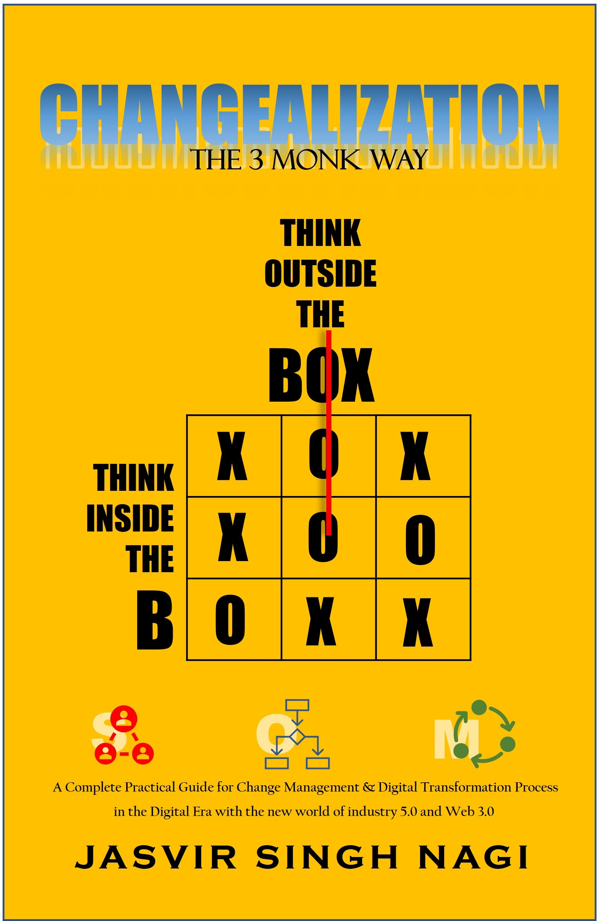



CHANGEALIZATION
THE 3 MONK WAY

JASVIR SINGH NAGI
A Complete Practical Guide for Change Management & Digital Transformation Process in the Digital Era with
the new world of industry 5.0 and Web 3.0

“
Thank you for adding this book to your collection !!
”

Changealization is part of a tri-series and the second one, in the series. The endeavor for the series was to encapsulate transformation in the change environments through personal change, organizational change, and, priming ourselves for creating environments for us to be successful in relationships, careers, and investments for a secured financial and prosperous future.
Since Changealization deals with a topic that required a regimen that is followed through a strict templatized format, which will be used repeatedly in its customized format, we have added an offer to this book for the benefit of the readers and practitioners.

……………………

- Visit us at www.risedigitalhub.com to avail of a special discounted offer. This discount is available until 31st March 2023, for the first 100 registrants in this closed circulation.

- Visit us at www.soulllp.com for our other services and references.

- Visit me at www.jasvirsinghnagi.com/ to be in touch for early releases and view my other books.

COPYRIGHT © 2022 Jasvir Singh Nagi

All rights reserved.
No part of this book may be reproduced in any form by any electronic or mechanical means, including information storage and retrieval systems, without permission in writing from the author, or publisher, except by reviewers, who may quote brief passages or sentences in a review.
This book has been compiled to provide guidelines for change management and processes for accomplishing successful changes in personal and institutional requisites. This can be used for startups, small and medium organizations as well as large conglomerates. The author is an expert in the field but has used named references wherever applicable and acknowledged the references accordingly. The intention is to provide expert guidelines that may aid in understanding, and meeting business requirements with the changing environments in a different era of its cycles.

“To improve is to change,
To be perfect is to change often”
- Winston Churchill

CONTENTS
CHPT 1 : INTRODUCTION 1
CHPT 2 : CURRENT TIMES 5
WORLD @ SPEED OF CHANGE 6
EMBRACING CHANGE 8
CHPT 3 : UNDERSTANDING CHANGE 11
CONSTITUENTS OF CHANGE 12
VARIOUS FORMS OF CHANGE 14
ORGANIZATION CHANGE 16
INDIVIDUAL CHANGE 26
TRANSFORMATION & ORGANIZATION CHANGE MANAGEMENT 31
CHPT 4 : IMPLEMENTING CHANGE MANAGEMENT 43
PRINCIPLES OF CHANGE MANAGEMENT 43
SUCCESSFUL CHANGE 48
CHANGE MANAGEMENT STRUCTURE 52
CHANGE MANAGEMENT STRATEGIES 53
CHPT 5 : CHANGE GOVERNANCE 64
BEST PRACTICES IN GOVERNANCE 64
CHPT 6 : PRACTICAL LESSONS LEARNT 79
WHY DOES CHANGE MANAGEMENT AND TRANSFORMATIONS FAIL? 80
EXAMPLES OF SUCCESSFUL TRANSFORMATION PROJECTS 84
CHPT 7 : CHANGE MANAGEMENT IN THE FUTURE 92
FUTURE ORGANIZATION 92
LEADERSHIP OF THE FUTURE 99
CHPT 8 : GO BACK TO RISE UP TO THE FUTURE NOW 105
CHPT 9 : REFERENCE TOOLS & TEMPLATES 111
ABOUT THE AUTHOR 119
REFERENCES 121

ACKNOWLEDGEMENT

I would like to thank almighty, family and friends to provide me with critical inputs at every stage of writing this book until its completion and for providing me the support and encouragement to bring this book to fruition. I would like to thank the designers and editors who participated in providing their respective services and finishing touches to the book.

Let me also extend my gratitude towards my mentors and leaders, from whom I garnered practical learnings to except and adapt to ever changing situations in the most adept manner possible, with least resistance, making the cause potent for greater good.

My special thanks to the real life TIB, TOB and SOM ( who didn’t want their names disclosed ) for knowingly and unknowingly sharing tremendous knowledge. This helped in thinking and putting strategic portions of the book in the most practical way that will help individuals and organizations alike to implement them during their transformation journey.

CHPT 1 : INTRODUCTION
Change, as we know is the only constant and inevitable in our life. The world is more connected and interconnected than ever before due to technological developments, globalization, and competition due to faster communication and dissemination of information.
We have blurring lines between Information age and Digital age being used interweavingly while definition for Industry 4.0 is still coming to terms, we have Industry 5.0 shining on us with some of its outcome already in main stream. With all things moving at the speed of change, we have access to collective intelligence of the world on demand and are thus, exposed to more ideas and resources than ever before. Those ideas are resulting into an accelerated innovation system which can be compared to the Red Queen effect. The Red Queen effect, is a theory which suggests that organisms must continually adapt, evolve, and grow not merely to gain reproductive advantage, but also to endure while opposed against ever-evolving rival organisms in a changing environment. This is giving rise to severe competition amongst individuals and their peers as well as for competing organizations. Organizations and their businesses keep on ploughing resources to realize that they exist to survive and not really to win due to ever changing environment and technology. So, thinking out of the box by envisaging the future, but thinking inside the box to know what are the current resources that can be expended, becomes of paramount importance before a change or a transformation journey takes place to adapt to the new changing paradigm.
The new changing paradigm due to internet and faster, better communication has resulted into digital nomads of the new world, living by their own terms. The remote work culture is appearing to stay forever, and smaller businesses, solopreneurs and individuals have sprung up faster and quicker than ever before to adapt and run their passion with newer business models to produce more efficient outcomes. This is showing the effect of rising consciousness and a global mind shift in the way we work, communicate, and relate to our changing environments. This shift in individual behavior is enforcing larger organizations to adapt to the new paradigm by changing or transforming:
- Employment models and Human Resource policies
- Training and schooling systems
- Healthcare provisioning
- Environment for mindfulness
- Technology systems
People, Processes, and Systems along with their Purpose are the key elements of any operation. Processes are usually used to create systems which in turn use technology to enable people to work faster with better efficacy. Hence change usually occurs in the way people and the way they think, adapt and work in the new systems. These systems usually comprise of processes and technology, where technology plays the part of executing the processes for better efficacy. So, the anticipated change comes about in people with the advent of newer faster technologies and their adaptation in a new system.
The change can be defined as tactical steps towards and ideal short-term goal. In large organizations this happens tactically with progressive steps through process changes using technology which is followed by training humans to adapt to those new processes by using the underlying technology. When series of such changes are applied strategically to change in form, nature or appearance is termed as transformation.
Transformation in Humans could be a state of change in one’s appearance, change of emotional state, or a change in behavior. In case of organizations or businesses it could be a change in the business model or a change in management strategy which can be any repositioning, shift, or fundamental change in business operations.
To achieve such transformational goals at organization level, it is usually bucketized in form of Human-based change management and Technology-based change management. A collective approach to meet organization goals, in both these buckets result in an Organization Transformation.
Research has suggested that almost 70% of all transformations fail due to various reasons, some are known others can be questioned. A transformation journey requires deep tenets for its successful effectiveness. To carry out this journey through small incremental changes requires immaculate execution. Each change usually results in expanding an inclusive participation by various stakeholders with various unknown mind sets and with other unknown variables, for instance, increase in budgets and timelines compared to the original plan. Hence it requires dedicated teams and offices being created for achieving successful transformation goals. To be successful, specific principles would be required to be institutionalized for an inclusive participation and communication. Principles of change management and best practices usually require five tenets consisting of, Thinking, Planning, Executing, Management and Analysis.
One of the best practices suggested herewith is to establish a Strategic Operations Management (SOM) team. This team should focus on following a TSRS methodology namely Timelines, Specificity, Regulation and Sandbox. Timeline focusses on creating a time plan for each sub-changes with defined timeline and create a sense of urgency. Specificity to be laser focused on the problem area and the outcome required in the simplest and clearest way possible. Regulation deals with the methodology used along with the program resources identified collectively for each change and change area. Sandboxes are the pilots that will run before a full-blown execution to avoid resource and time leakage.
Like human life, businesses go through various cycles. These cycles consist of a Starting phase followed by a Growth phase leading to Stability and Maturity ending in Degrowth or Decline. Though humans go through cycles in their limited time span and choose to adapt and transform as per their goals, businesses can continue to go through their cycles in repetition for a longer life span defined by themselves, if managed appropriately with changing times.
Success can be defined as progressive steps to achieve ideal goals. Change should have a defined outcome to be successful. A series of smaller changes result into larger transformation. A successful transformation that follows, as a result of such iterative changes, is defined by specific business goals largely consisting of:
- Achieving top line and bottom line with a long sustainability of their competitive edge
- Relationships with their stakeholders, partners, and the environment.
Same goes for humans in general. A series of successful changes, that each individual brings about to transform themselves should have an outcome in form of achieving their goals. These goals comprise of the following :
- To rise above their current state of being. This could be both inward and outward
- Having healthy relationships with family, friends, and their environment
With this philosophy of change and transformation, this book refers to an ideology using 3 monks as a metaphor representing 3 systems consisting of methodologies and techniques that are essential to bring about change and transformations in the fast-changing new world, we live in.
Their conversations dig deeper and expound change principles, its execution, and the management of change. This change could be internal on a personal front or at an institutionalized level for organizations, in various phases of growth, maturity and decline.
These monks are named as TIB, TOB and SOM and stand for Think-Inside-the-Box, Think-Outside-the-Box and Strategic Operations Management, respectively. These are most adept and competent in their respective areas of description. They share their experiences in personal growth and in dealing with three phases of an organization called SOUL ( Shaping Opportunities Unlimited LLC ) represented by “G” as Mr. Grow, “S” as Mr. Stable and “D” as Mr. Decline.

This book can assist changes and transformations in organizations seeking or improving current systems and methodologies for identifying their current cycles of growth, stability, and decline. The practical techniques and best practices, mentioned in the book can accelerate and successfully implement and manage changes and transformations through a defined system, for competitive advancements and achieving goals to meet the challenges of this new era of ever-heightened changing environments.
This can be of help for individuals who find themselves missing out on a larger purpose while they are serving their journey on earth. The systems and methods can be used to find their purpose and create ideal goals in a systematic way to achieve what they have set out themselves to achieve, for a peaceful life with progressive and ideal goals.

The narrative initiates with G travelling from Dallas to Austin for work from his current organization. He notices a Buddhist monk sitting in the opposite bench, while waiting at the airport. G noticed that the monk had been regularly greeted by various people in manner of touching his feet, which he had been regularly avoiding by holding them by their shoulder followed by holding their hands in a manner of clasping with his own. It appeared that the monk was a popular figure and was an important person in the commune. He had a sort of a peaceful smile and his act showed glimpses of extreme humbleness.

CHPT 2 : CURRENT TIMES

“Standing still is the fastest way of moving backwards
in a rapidly changing world”
– Lauren Bacall

G took up the courage to go and sit next to the monk and introduced himself and presented his visiting card. The monk nodded his head in response and took the card. G went on to say that he works for an air conditioning company and lived in Dallas. The Monk acknowledged again with a nod. This was a one-sided conversation for now and yet G, who usually is an introvert and is used to usually keeping to himself, was very comfortable doing this monologue with this monk, .
G further mentioned “I couldn’t help notice the way people were greeting you and the way you have been responding, this has really built up a sense of curiosity to understand what makes you different than the other monks”. At this point the monk responded with a smile and as though he came out of his deep thinking and meditative mode to respond.
The monk mentioned “I noticed the curiosity when you were sitting on the opposite bench, I would have come and met you as soon as I would have finished my meditative mantras, which I just did”. G was taken aback, not even once did he notice that the monk had seen or noticed him. It just occurred to him that monks usually have a very high level of consciousness due to steady state of their meditation.
The monk introduced himself as “TIB” and mentioned that he runs and manages monasteries handed over to him by his ancestors and was in Dallas to participate in the annual event with his fellow monks. G responded, “I never knew there is an event for monks as well”. TIB mentioned that he was on a mission to have one million monks rise in their emotional state by being in a constant state of highest vibration. While this was TIB’s personal goal, he was himself going through enhancing his vibrational state to its highest state. He further mentioned “My goal is currently not defined since I have not given a particular timeframe in which I would like to achieve this goal since, I am not very clear for now. I hold these events to see and gauge my progress in form of pilots with smaller group of monks. These events help me to interchange my thoughts with my dear friend’s “SOM” and “TOB” who have also helped me in accelerating and crystalizing my plan to formulate my goal. My larger vision is to prepare my fellow monks to take the vision, believe in it and make it their own, and in the process of doing so, manage monasteries all over to help the human race in achieving their goals and make this legacy continue to form a better world around us. I think of my monasteries as self-running systems using best practices in management, like great organizations do. My fellow monks, that are chosen, have run their own businesses and multi-million-dollar organizations, and have now moved in the direction to help others in achieving their own goals. This itself has given them prosperity and I have witnessed them grow as individuals and their businesses have been prospering in their absence due to the systems they have put in place. All this became possible once they changed their thinking and laid down clear goals to be achieved in their determined time”. TIB’s larger purpose is to help and grow his monasteries in the most efficient way to meet the challenges of changes in the world and give the most conducive environments to his fellow monks to grow and prosper in current times and continue the legacy in the future.
This made G start thinking, What are his own goals? What is changing around us, that TIB is laying his emphasis on? .
With this thinking they went on to their respective boarding gates. While G got comfortable in his seat and started checking his mails, he saw a text file pop up with a few attachments. This text was from TIB. The contents of the attachment were so timely, as though TIB had heard G asking his questions. In the attachment, TIB had sent the excerpts from his event that explained the pace of change, the things that are changing our world and a few suggestions to understand and cope up with these changes. The file was named as world @ speed of change.

WORLD @ SPEED OF CHANGE
The emergence of Industry 1.0 was circa 1784, industrial production began to change significantly with the development of mechanical production infrastructure using water and steam-powered machines. Industry 2.0 started its evolution in 1870 with the concept of electric power and assembly line production and focused primarily on mass production with workload distribution for better productivity. Industry 3.0 is known to have evolved in 1969 with the use of engineered electronics, for partial automation and the use of information technologies. Industry 4.0 followed its evolution in 2011 with the use of smart manufacturing to maximize productivity using emerging technologies of the future for achieving mass production and scale. The last two industry evolution took almost a century. But the fourth revolution has taken only 40 years which showcases the speed of change at 2.5X.
Industry 5.0 is dawning with its future evolution with various use cases in its prototypes that deal with the coexistence of human creativity along with smart machines having very high proficiency and accuracy. This human and machine coexistence has given rise to smart Co-bots ( collaborative robots ) and Human-bots ( robots with near human cognitive skills ), that perform tasks at great speeds, with high accuracy and predictive outcome at fractional costs.
Industry 4.0 standard has revolutionized manufacturing by integrating several smart technologies,
including the Internet of Things (IoT), artificial intelligence (AI), cyber-physical systems (CPSs), cloud, and cognitive computing. The key objectives were to make manufacturing smart, by interconnecting machines, and devices that can control each other throughout the life cycle using process automation, thereby reducing human intervention. It focuses on improving mass productivity and performance by provisioning intelligence between devices and applications using technologies like machine learning and other respective smart technologies.
Along with industry revolutions and its enhanced smartness, Web 3.0 has dawned with its highly capable and matured usage for the interconnected world. It focuses primarily on Artificial Intelligence with principles of decentralized data architecture and edge computing infrastructure. All these technologies have grown exponentially in its maturity in very short cycles, which has made it challenging to anticipate and determine timelines of the change and adoption.
The above technology changes have resulted into some distinct trends which are a combination of
- Hyper connectivity
- Lower cost of transactions
- Unprecedented Engineering and Automation
- Variating demographics
This shift at rapid pace has forced individuals and organizations to think differently and to cope with such rapid changes with a focus back on key elements:
- Purpose
- Value
- Culture
The evolution of future prospects of individual skills with cognitive efficiency and capability of using machines for repetitive tasks becomes paramount, This will create competency in delivering globally dispersed projects with accurate outcomes. The speed of change along with the recent pandemic has accelerated the pace of learning, remote work culture and skill enhancing habits, to create digital nomads that now evolute the gig economy. They work from home, remote or from exotic locations with an object to deliver projects accurately at lower costs with highest predictive timelines. This change will force organizations to think differently in the way they operate to inculcate at least the following three tenets:
- Extremely Flat Structures
- Prompt Decision Making
- Talent retention as the highest priority
This will be possible by :
- Accelerating Organization Learning Methodologies and Systems
- Creating Technology Platforms of tommorrow with Powerful Data related capabilities
- Creating an Ecosystem of high bonding with partners, employees, and other stakeholders
As businesses moves from an outlook of adapting to one of contending, with the passage of time, the best organizations and individuals will jump right into this extraordinary thawing chance before them to envision and create new frameworks and methods of association that are more adaptable, incorporated, strong, and eventually, more human. This speed of change along with their interweaved ecosystems will see themselves as interconnected frameworks that try to continually explore, fall flat, learn, develop, and begin the cycle again when the world changes next.

G continued with the next attachment which was titled “embracing change”, he assumed that this topic relates to embrace the speed and the changes that are happening around us.

EMBRACING CHANGE
The fundamental acknowledgment that top organizations embrace is that the resources will be depleting, and value of various resources will be changing continuously, in manner that cannot be tapped exclusively by an organization's conventional business regime. Organizations that take a holistic view of systems in operations and approach it with a level of fluidity that blurs boundaries between tactical approaches to meet their end goals, will be successful in adapting to the speed of change and embracing it for the next one. Sources and resources might be differently available due to such rapid changes and will be scattered globally. Organizations will need to be fluid to capture such resources, wherever they are available without any inhibitions of geographies and distances.
To do this effectively, organizations should adapt to the following four principles of culture with a systemic approach:
- Hybrid Work Model
- Outcome based work culture
- Flex work – How, where, when of work culture to ensure timely deliverables
- Trust building through better communication and team building with remote capabilities
These approaches will enable employees to show their highest potential to produce their deliverables and will feel responsible and contributing to the larger purpose of the organization. A self-assessment routine will help these employees to learn fast and take calculated risks with loyalty to their employers with an independent entrepreneurial approach.
As similar approach for solopreneurs and self-employed individuals will require them to embrace the fast-changing scenarios by four adaptations :
- Fast paced learning of various core skills
- High efficiency and ethics for work delivery responses
- Technology capabilities and update with times of change
- Open and collaborative attitude
Organization and individuals at work should encourage mindfulness and physical health enhancement as an everyday routine. Sustainability and caring for our environment by becoming greener should be at the core of our value system. Humans take time to adapt as a response to their stimuli due to their complex biology and their brain to sense reactions. Being inherently lazy is prevalent in every human being due to our limbic system, our reptile brain, if you will. Our reptilian brain inculcates, the central structures found in a reptile's brain, the brainstem, and the cerebellum. The reptilian brain is reliable but tends to be somewhat inflexible and habitual. This causes challenges for us to adapt to newer environments and adopt new habits in our changing ecosystem. Hence when we try hard coping with our forceful intent, a lot many complexities are caused at the mind and brain level. If these are approached with mindfulness and awareness by training our mind, body, and spirit to respond appropriately as per individual capacities, the change, and the habits eases into our system with any adverse effects. Meditation, yoga, and similar physical and mindful activities can help us humans develop effectiveness in our systems to cope with all the changes around us to embrace such changes.

At this point G, was astonished to learn the pace of technology and the speed of its adoption which has caused rethinking by the world to get back to their drawing boards and rewrite their goals as individuals and for management of organizations as a whole.
The explanation on the change around us, the speed of change and the ways to embrace and adapt to these changes helped G understand the answer to his first question. This newly acquired understanding and his astonishment gave a sense of motivation for G to think through and write down his own goals and what does he as an individual would want to achieve within a defined timeframe. He gave himself time until he reaches home to think through his goals and establish a timeline for achieving these goals.
G wrote back to TIB with a thank you note and mentioned that he was really motivated with his inputs and the conversation to think deeper for himself and his goals. G immediately received TIB’s reply, this time with a scan of a card called the Goal Card, with a small foot note mentioning, “I keep this with me all the time” , and it mentioned two points:
- Make 1Mn people adapt to RISE UP and prosper in next 5 years.
- Support SOM and TOB and make monastery partners adapt to RISE UP
G realized the importance of a goal and its repetition to remind him repeatedly - where is he heading ?. But TIB’s goal card raised more questions at the same time. G now wondered, why is “RISE UP” in caps? .

CHPT 3 : UNDERSTANDING CHANGE

“Be the change
You wish to see in the world”
– Mahatma Gandhi

G reached home and was able to think through his own goals well within his decided timeframe. While deriving his goals, he realized that he already had these goals dwelling within for some time and TIB had just triggered them to concretize them by writing it on a card and repeatedly reading it back as a reminder.
G had always imagined of getting away from his 9 to 5 and to start something of his own. He had spent a little under a decade in the air conditioning industry and was well aware of the technicalities and basic know-how of running his own show. He had joined his current organization when it was a small startup and had grown to a multinational over these times. He was always at the core of this growth being one of the earlier members in the technical team and now managing a part of the business. He was also aware of the pitfalls within the organization but never knew the reasons. TIB’s conversation and his excerpts on technology and its speed of change gave him a eureka moment of sorts to understand why things were going south for his current organization. This further inspired him to create and action his own goals.
He wrote down the following goals :
- I will start, grow, and run a $10 Mn air conditioning manufacturing and services company
- I will grow my current relationships with my fellow industry colleagues and become their top 3 partners
Feeling enthusiastic about his action plan, he thought of sending his goals to TIB to let him know how motivated he was with their conversation. G received a response from TIB promptly, congratulating him on the clarity of G’s goals followed by a note mentioning “A goal is incomplete without a timeline”, “happy transforming”.
G now added a 3rd point to his goals:
- I will start, grow and run a $10 Mn air conditioning manufacturing and services company
- I will grow my current relationships with my fellow industry colleagues and become their top 3 partners
- I will do this in next three years by October of 2025.
With his Goal card ready with him in its laminated form and a big placard on the wall of his study room, he was all set to start his new entrepreneurial journey.
Next few weeks will see G working on his business plan and contacting his industry colleagues to garner support, followed by his resignation in the current organization, while he forms his own.
He started putting the nuances of the current pitfalls and the issues with his current organization, where he is employed, by thinking what he would change to ensure his organization meets its own goals. He started by putting in the constituents of the current anticipated changes along with the possible action and systems that he would incorporate to make his own new organization more astute for growth.
G updated TIB and wanted his inputs for understanding key ingredients of change and what influences these changes. He also requested TIB if there are different types of changes that one should be aware of to adhere to them in an informed way.
TIB’s reply was, like always, very prompt. He mentioned that the information that he is providing is at an individual level as well as at a business and organization level, and that, G should not get overwhelmed, but relate to what best works for G for his improvisations.
TIB explained:

CONSTITUENTS OF CHANGE
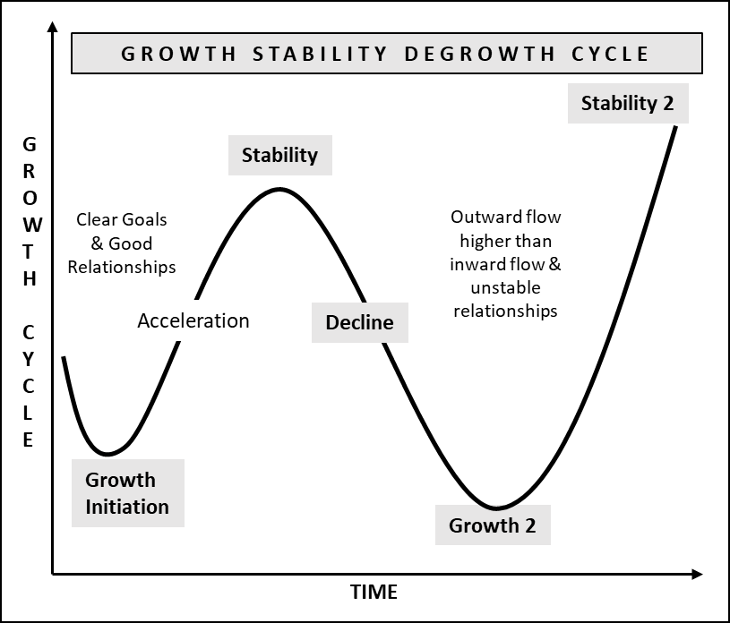
Change being the new normal, the jury is still out there to figure out the speed of change. We, however, have seen that it is getting increasingly challenging to cope up with the changes around us. The usual cycle of GROWTH, STABILITY or maturity and DECLINE or degrowth has been observed repeatedly occurring in history for individuals, nations and even civilizations and these have been witnessed to follow quicker cycles than ever before as is the growth in technology.
Two reasons that come into existence for a possible decline of individuals or nations is when :
- The borrowings increase for more spending than the earnings
- Poor relationships with the environment and the ecosystem
This is true at individual levels as well as at the level of a nation in its entirety. We have seen unprecedented increase in demand due to faster and enhanced connectivity and communication. People have become more demanding, with accessibility and choice in variety of things available to enjoy and to spend time on indefinitely. The choice of gadgets, food, clothing, entertainment etc. give rise to more GOD ( get-on-demand ) satisfaction for instant gratification. A repeated on-demand, momentary satisfaction, gives rise to formation of an addictive habit, unknowingly. This habit can lead to forced spending more than is earned which further creates debt and inequality in have and have nots. When this happens at a macro level or at even larger scale, it results into inequal distribution of wealth amongst rich and poor facilitated by the omnipresent middle class. This proliferation of habit causes rise in instability and decline of individuals and nations. When such declining cycles begin, they become the reason to CHANGE at individual level or as a nation.
A typical Growth cycle starts when people and nations work towards growing themselves to become successful and prosper as per their goals stipulated in the timeframes that have been decided. A consistent repetition of smaller cycle of such events brings in stability due to their consistent results.
The results thus achieved are usually in form of consistent growth followed by monetary gain in the form of various riches and living standards. With this new found confidence soon moves into the over confidence mode, assuming things will remain the same forever. We are now officially in a Stability cycle.
In this mode people, businesses and nations are usually found to be divulging over their current means. This results in concentration on enjoying the riches and materialistic pleasures or sheer overambitious zeal as a habit or emotions which then results in over-borrowing to satisfy this habit and emotions further for oneself and the people who were given this without much effort in their current mode of overconfidence and over indulgence. We now are in a Decline cycle
During a Decline cycle, these vitiations result in complacency, resulting in a drop in productivity and innovation which results in a decline of an individual, an organization, a state, or a nation in its entirety.
Recognizing these three cycles early can help individuals, organizations or nations make astute decisions to focus on areas of change that require immediate resolution and manage such changes to lead to their desired goals through a structured Change Management process.
This is a typical cycle of Change. Such changes can be bucketized as ORGANIZATION CHANGE and INDIVIDUAL CHANGE. A series of such changes for a larger goal requires a TRANSFORMATION program that requires to follow a deeper, more erudite, and structured approach following a Change Management Process framework.

INFLUENCERS OF CHANGE
Change is unpredictable and often unmanageable, yet an organization’s success depends upon its ability to predict and control change. The two types of factors that influence change can be classified as :
- External Influencers
- Internal Influencers
External influences are characterized by demographic traits, economic factors, technological advancements, market shifts and sociopolitical demands. These affect the operating environment in an organization in one way or another to bring about changes within to enhance the organization competitive advantages.
Internal influences arise from human issues including managerial behavior, their decisions and policies which effect internal operating conditions, culture of the organization, boiling down to the treatment that employees receive at their workplace.
The Internal and External influences of change are interrelated in one way or the other and need to be considered collectively while planning and implementing a change process of an organization. Employees should be an inclusive factor in bringing about any change by constantly assessing the current and future state. This inclusivity will assist the leaders, change agents and the process with least resistance.

VARIOUS FORMS OF CHANGE
Various forms of change can be defined under six categories. Each form requires a different approach strategic plan for an effective outcome. Understanding the nature of change aids in formulating appropriate strategy for their implementation. The main forms of changes are as follows:
- Unplanned
- Planned
- Incremental
- Developmental
- Transitional
- Transformational

Unplanned Change
This type of change is also known as emergent or reactive change. They are generally imposed due external factors or internal aspects which are beyond the control of the management. A typical example for such a change could be an event of an unanticipated mass resignation. This could be due to an entry of a better, larger, or influential organization in the geography, that has attracted talent with better opportunities or better work environment.

Planned Change
A deliberate, conscious, and preplanned change is termed as a planned change. Being qualitative in nature, communication of its vision is paramount for the success of such a change with an intricately curated plan for high inclusivity of its participants. A typical example of such a change would be release of an automated platform of a sub process within a unit or a sub unit of an organization.

Incremental Change
Such changes are smaller components of planned changes or transformations. As is titled they are incremental in nature and do not affect as adversely compared to other forms of changes. However, they are essential for achieving sub part of the overall goal during successive incremental changes. A typical example would be the automation of an outward payable system, from its manual legacy system, in a finance division of an organization which is going through a digital transformation at an overall level, through its various divisions.

Developmental Changes
As the name suggests, such changes are essential for creating a competitive advantage in the operations or an organization or an individual. These changes improve and mend existing aspects of an organization. These usually undergo efficacy related changes including process improvement, performance standards and technological enhancements for proficiency in operations. A typical example is a migration process from a legacy ERP system to a completely new version of the same ERP, which is hosted on a cloud.

Transitional Change
These changes come into existence while replacing current processes with some of the latest best practices or technological innovations, not existing earlier as part of the operational system. Implementing transitional change is more challenging usually than a developmental change. An example would be introduction of an ERP system in an organization aligning selected divisions of an organization, while the organization is going through a digitalization journey.

Transformational Change
Transformational change is also referred to as a quantum change, sometimes. These changes have longer implanting periods and usually includes the entire organization. These changes originate from the change in vision, mission, and cultural aspects of an organization to innovate its current business models, due to external forces or disrupting internal work elements. Such changes inculcate rest of the five changes during its implementation cycles. A typical example is when an organization goes through a digitalization process. A digitalization process is when an organization goes through a digital transformation.

G now started breaking down the areas of change which are affected during a change process. A little help from his colleagues in the industry who had gone through large organization changes, sent him a few excerpts from various sources. G started to put together his own thoughts post his understanding in the context of his current organization where he was employed. He thought this clarity will help him put systems and processes in his new venture to make it future ready. The following were his notes for his own understanding and clarifications, derived from various sources.

ORGANIZATION CHANGE
There are typically two areas of incremental or transformational change that needs to be incorporated in an organization and is often based on the current state of affairs with a future outlook, in order to improve the existing way of doing our work or as per the demand of the markets and the respective stakeholders. The two areas that undergo incremental or transformational changes are :
- Human Change
- Technology Change
Human side of change deals with employees adopting new environments that have changed in form of processes and systems. This leads to change of habits, inculcating mindset changes, and adaptations to these changes. The Technology side of changes deal with automation of processes and systems for better productivity, efficiency or change in business models. The Human side of changes thus becomes central to enable all the changes in an organization.
When organizations go through a large transformation process while going through changes in vision, business model, products or services and other such strategic endeavors, a series of such incremental changes need to take place in succession, that eventually lead to a larger culture change. Such smaller changes on regular intervals, causes larger disruption in adaptation and adoption of such transformations by the employees and other partners and stakeholders of the organization. The complexity involved in culture change is often why it is easier to change the change than it is to change the culture. Such changes require principles of change management and discipline of project management activities to complement each other. A practical, less disruptive change management process thus becomes imperative to enable such transformations and produce successful results as envisaged for the outcome.

HUMAN CHANGE
The common element to achieve success for all change initiatives is people. This is what makes any change more complex, since we need to deal with mindsets that have a rational side consisting of logic and intellect, and the emotional side to deal with for any change activations. People who devise change processes need to be clear of the objectives and the direction for the change or the larger transformation. Lack of clarity causes people going through the change to get deluded which results in exhaustion and resistance.
Human reactions to various situations are result of the fact that, our Observations result into Thoughts, our Thoughts result in our Beliefs, Beliefs in various situations result in our Experiences, our Experiences result in our Reaction. Our Reactions and their results create Wisdom for us to react in similar futuristic situations and seek answers therein if results are different than our earlier experiences. This becomes the basis of resistance while going through a change process which includes various individuals. their intellect, emotions, experiences and wisdom if used appropriately can result in a successful change process or can get averse, otherwise.
Hence, it is essential to identify right stakeholders and understand their emotional state, earlier on and during the change process to navigate incremental changes as well as the transformations in different phases of their process.

STAKEHOLDER IDENTIFICATION
For human side of change management, it is important to identify individual stakeholders that would participate in the change management process. They could be internal as well as external stakeholders. The internal stakeholders are usually the employees of the organization, while the external stakeholders are the contractors, partners, customers, and other respective alliances. The internal and external stakeholders can be bucketized in five different buckets and can be placed in a matrix against trust and agreement. The five distinct buckets are :
- Buddies
- Confederates
- Challengers
- Rivals
- Neutral

Buddies:
This bucket consists of high agreement and low trust of all stakeholders with following specifications:
- Can provide inputs to the process
- Agree on the vision and goals for the change
- Would have conferred interest in the results

Confederates:
This bucket consists of high agreement and high trust of all stakeholders with following specifications:
- Have critical resources, skills, and capabilities
- Share the same vision and goals
- Strong belongingness to the team

Challengers:
This bucket consists of low agreement and high trust of all stakeholders with following specifications:
- Can provide inputs and resources to the process
- Conflicting vision and goals for the change but with trusted relationship for inputs
- Can challenge efforts and results to help achieve better outcome

Rivals:
This bucket consists low agreement and low trust of all stakeholders with following specifications:
- Can provide inputs to the process
- Disagree the visions and goals
- Strongly oppose on agreeing to the change

Neutral:
This bucket consists neutral agreement and neutral trust of all stakeholders with following specifications:
- Can provide inputs to the process
- Non-committal or unaware of the visions and goals
- Have a neutral stand towards change
With these classifications and bucketizing activities it is essential to understand emotions of individuals during the Change or transformation process. These emotions can be identified and compartmentalized and derived from the Kubler Ross Model.

Emotional States:
According to the Kubler Ross Model, there are six distinct emotions that individuals go through at different times. The emotional states display various varied energy levels as a response to their stage. It is imperative for leaders to identify these states of emotions and energy level during the Change process and react accordingly to avoid any hindrance during the process. These stages include:
- Denial
- Anger
- Bargaining
- Depression
- Acceptance
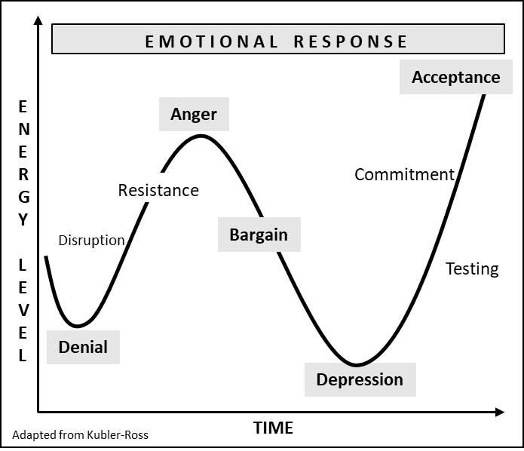
Usually, people move through their emotional journey at different pace at each stage of change and sometimes these are not even sequential in nature. However, some go through this journey very quickly with least resistance to reach the acceptance level during a change process, while some are left out midway, since they get stuck along the way for various reasons. It is not unusual for an individual to return back to a prior stage as the next wave of change comes about. People have to go through each of the stages in order to let go of the past and move forward for an effective outcome of the emotional change process while the larger change journey is at play. It is important for the leaders and various stakeholders to understand these cycles that an individual goes through to ensure least resistance during a change management cycle and to find way and alternatives to deal with it to keep change management process timelines and budget intact. .

TECHNOLOGY CHANGE
The Digital era has forced companies to change their technological adoption at the speed of technological innovations, to be relevant and competitive. The larger purpose for such change is to utilize the ever-increasing omniscient data which needs to be used for increasing eﬃciencies, make operations agile, and improve bottom lines and top lines.
Technology change management primarily identifies relevant technological advancements, finds the current gaps for its consumption in improving productivity and profitability of an organization and manages the adoption. A planned change with clear scope when communicated proficiently reduces resistance, improves cohesiveness, and addresses the challenges inherent in major change.
Various surveys including the ones from McKinsey and BCG suggest a failure rate of approximately 70% for all digital transformations, while 75% do not deliver the anticipated results.
Typical reasons observed for such results are owed to two factors:
- Definition of Goals
- Poor Communication
Instead of adopting benefits, there is resistance, misalignments and competing concerns without common goals. As mentioned in the emotional response chart, these factors result into denial and lividity, leading to frustration, which in turn lead to unconceded goals.
For large transformations, organizations will have to prepare themselves for technology related readiness, which would include their current assessed IT infrastructure, IT strategy, Business and IT integration points and IT adoptability.

4 Node Model
In order to prepare for becoming the technology oriented future organization, a 4 Node Model is used as one of the Best Practices and can help in preparing the journey for Technology Transformation change management process.
The 4 Node model helps in preparing organizations for the future for its technology advancements by orienting itself with basic principle that technology will be driving the future business. This itself is a paradigm shift in preparing for the future organization and requires reimagining the role of technology through technology-led business models.
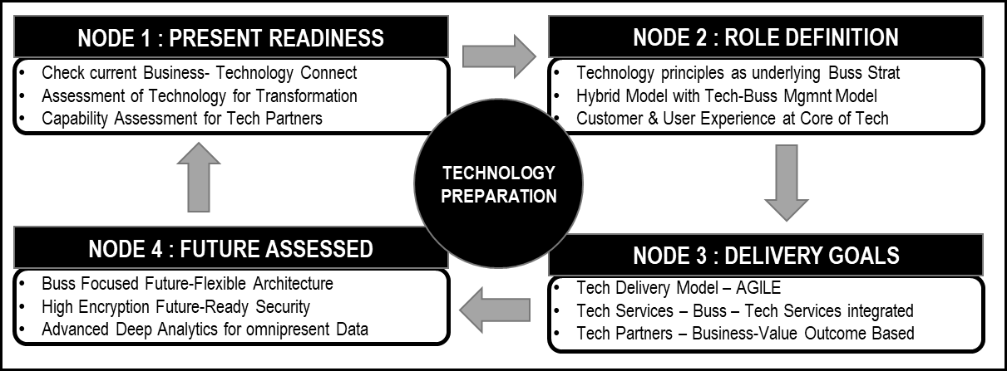
Node 1 helps in checking the current preparedness of the organization and its capability to adopt new technologies by internal assessment of the infrastructure, technologies in use, level of automation and technology capabilities of the external stakeholders.

Node 2 leads to the role definition of technology integration with business strategy on the premise that future of business will be led by technology adoption and its respective funding requisites, which will require a hybrid model operating on a custom technology platform for business and technology management. This is required to run as a common thread in the functions such as marketing, sales, and operations given its modernization in technology and the agility that it will bring during technology transformations. This role for technology develops over time as the Nodes 3 and 4 begin delivering value while the technology function grows. However, this objective for technology to drive business value must be explicitly defined up front during Node 1 or the results might not give the envisaged outcome.
Node 3 is defined to prepare for the technology changes and its deliverables. Using latest technologies, methodologies, and frameworks like Agile methodologies by deploying ITIL 4, technology teams focus on and carry out activities that have the highest potential for realizing sought-after gains. This node also prepares for business-oriented services and technology services delivered through a common platform. This platform can be a choice from an external business and technology platform which has the latest technology capabilities with business-oriented domain specialization to derive a value-based outcome.
In Node 4 the architecture of the system should be designed with loosely coupled components of service to provide microservices with a future flexible system. This is done by incorporating newer design principles of connecting various systems through an API (application programmable interface). These connections will enable large data sets which can then be deeply analyzed through an analytics engine or software for providing customer insights and employee preferences to enrich user experiences. The system that is designed should have the highest encryption level known to create security systems that are future ready.
Technology change in the digital era is incomplete without the understanding of Digitalization and its effect on business. Digitalization is necessary to survive the current age, be it, information age, knowledge age, digital age, or any other definition out there. In the advent of doing things, on demand, faster, seamlessly and in the most economical way, digitalization has been the harbinger of a technology model to drive businesses providing exceptional user experience and delivering value with various competitive advantages.

DIGITALIZATION
With the assertion that technology will be driving the future business, organizations of the future are preparing now to engrain business strategies and operational proficiencies within technology systems to drive their business forward. To ensure this principle is applied in all the changes of their endeavors in the transformation, the organizations and governments are digitizing their services to a point of becoming completely paperless.
Digitalization also known as Digital Transformation is the use of digital technologies for transforming business models to improve eﬃciencies for better top and bottom lines in the process of creating a highly efficient ecosystem.
Digitalization is necessary in the current stage of the digital era to maintain a competitive edge, since digitalization will help organizations to:
- Promptly change business models to accommodate the changes ushered in by digitalization
- Manage large ecosystems that emerge due to Digitalization
- Enhance user experience
- Increase their services or products portfolio to cover a large user group, quickly
A Digitalization journey follows the 4 Node principles and starts by raising key questions before moving to the Node2.
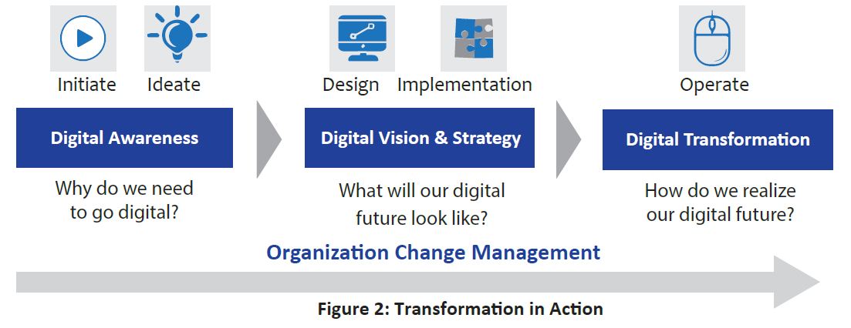
The Node 1 for a digitalization journey needs to address 3 specific questions:
- Digital Awareness: Why do we need digitalization ?
- Digital Vision & Strategy: What will our digital future look like ?
- Digital Transformation: How do we realize our digital future ?
These questions raised in Node1 help assimilate key principles for change and readiness towards a Digitalization journey. The assessment usually covers People, Processes & Product or the 3 M of an Organization namely: Men & Machine, Material & Methods, and Market & Money. This helps in the next stage - Node2.
Node2 is about perceiving the end goal and the process to do so. This node inculcates the strategic aspects like vision, mission, strategy, culture, competitive advantage, competition and key partners and the effect of digitalization on both internal and external stakeholders. One of the typical goals of digitalization is to create an inherent eco space for the organization which has the capability of quickly turning around its processes to accommodate newer business models with least disruption. This eco space should be able to integrate, incubate and start newer line of businesses using common systems and processes for quick adoption.
In the Node3 stage, subsequently, the function-based automation and degree of change is assimilated as a blue print with details of latest frameworks, methodologies, and systems to be used for execution. Using latest systems enables the maturity to adopt and adapt newer business models and service lines for both organic and inorganic growth at faster pace using latest integration technologies.
In the Node 4 the design is then implemented function-wise and driven by an Organization Change Management initiative, championed by the senior leadership.
Function wise digitization will be required to be achieved as per the enterprise digitization framework to achieve the necessary digitalization roadmap and hence creation of an ecosystem.
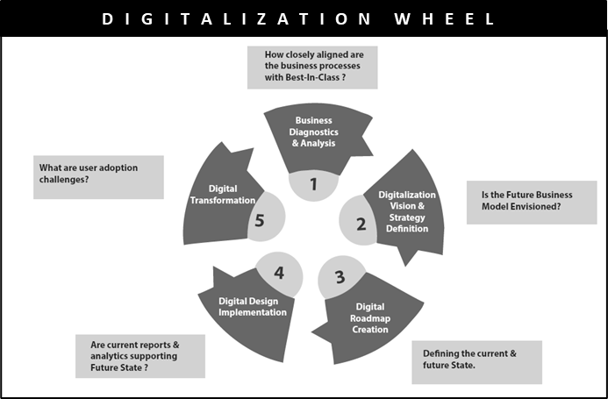
Digitalization preparation and readiness require deep planning and assessments to draw the right strategy that can be used for implementing the plan. However, the end goal should be clear while the plans are discussed and drawn to its conclusion.

Typical Digitalization Journey
A typical Digitalization journey starts by digitizing each division or unit of an organization. This is followed by sequential iteration by optimizing software and hardware infrastructure, for creating the architectural requirements to meet business requirement goals.
The iterations include digitizing archives of historical data for better accessibility and insights and creation of a common platform for better user experience of the digitized units or functions. Followed by governance of the digitalized environment while creating a self-contained ecosystem.
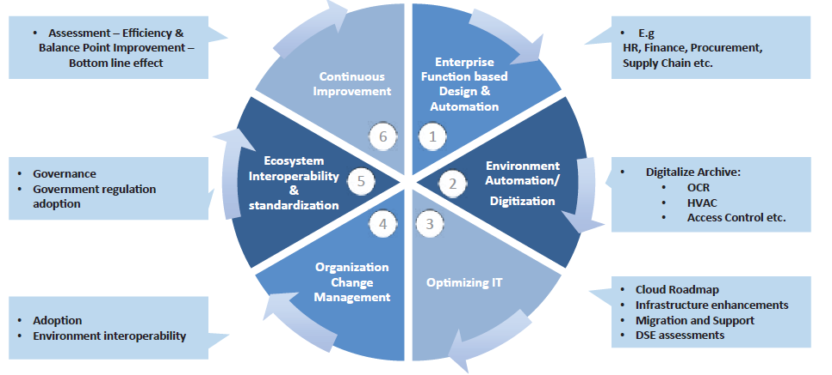
Bitcoin is an example of such an ecosystem. This means the supply and demand model begins to blur; the supply side or demand side of these ecosystems can be a single enterprise or a group of enterprises, and they can be supplying and demanding at the same time. The supply of Bitcoin determines the number of units in circulation and thus its scarcity in the market. The demand of Bitcoin is mainly defined by transaction demand as a medium of exchange. The criterion for a digital ecosystem is to inculcate digitization for both supply and demand.
Some of the use cases and technology uses while planning for digitalization of an organization can be observed with the following function-based digitization requirements.
Customer Experience
Since digitalization is the key for enhancing customer experience, the framework should incorporate one of its goals to enhance customer experience. Current products and services need to be assimilated with current customer experiences. For instance, in a business to consumer business model, using CRM (customer relationship management) and similar technologies, companies can identify historically purchased products, competitive landscape, and emotions aﬃliated to these products or services. Social media analysis can provide answers to questions, sentiment analysis, like, why did complementary products become as an upsell and how have they been perceived, which audience has similar purchasing history and the average purchase size of these customers etc. Tools for understanding web and social media presence for enhancing customer experience are now well matured and can provide deeper insights for improving customer experiences to gain loyalty. These further supports carrying out targeted marketing campaigns to penetrate deeper in the customer ecosystem.
Products and Services
Organizations increasingly realize that they can no longer focus on just selling products; they need to sell an experience. A futuristic example of such an event can be seen in the automobile industry in the context of an EV.
A customer walks into an online showroom, where he can chat with a salesperson and even take the car for a virtual test drive. Once the customer decides to order his customized car for the shape and size, he can use an app on his mobile device to track the car’s movement through the entire manufacturing process, making him feel connected to the whole experience. Once he owns the car, IOT(Internet of Things) elements can kick in via the installed sensors – which alert both the customer and the car manufacturer when certain parts need replacement or servicing, enabling the customer or manufacturer to act before a problem occurs. This creates a seamless experience for the customer right from the time when he decides to buy a custom developed car to the time when he needs a service.
Operations
Advanced digital technology, powered by the SMAC( Social, Mobile, Analytics & Cloud ) Stack and aided by IOT, can improve business processes in several ways. For example, big data analytics can help in-bound logistics run more smoothly by tracking product movements through various IOT based sensors and guided through robotics; the cloud can be used to create uniform business processing platforms; and mobile platforms can enable employees to perform their work anytime, anywhere and on any device. The end customers or partner companies can track their goods and supplies along with approximate times of delivery, enhancing customer experience and so the loyalty which can be publicized through the social platforms.
All the above followed by the automation of key backend functions using ERP systems encompassing, Finance, HR, SCM etc., are included in the phase of transformation, where the organization is functionally digitized. This provides enterprise related work flows and data, promptly, to aid decision support systems which help in making the organization more agile. This agility aids in changing business models through their agile private ecosystems, which are used to enhance customer experience even further and hence impact the top and bottom lines favorably.

INDIVIDUAL CHANGE
Individual change management is the process of helping employees to understand them where they are in the change process and managing that change effectively. This change management is related to starting at the bottom of the pyramid of the employee structure. It is based on a one-on-one interchange. Each individual is given emphasis because they are the one who bring in and adapt themselves to the change. The focus for individual change management should be on the tools and techniques to enrich employees through the transition.
As has been seen in the emotional response chart, each individual goes through a series of emotions at different phases of life, change management process or transformations. It is the role of the leader to understand, manage and empathize these emotions during a change process to ensure a smooth change or a transformation in case of an employee. While the organization goes through large transformations there are collective emotions at play.
Individuals who go through personal transformations also follow a similar path. The difference is that they become their own leader who have to be clear on their goals and then find various ways to get them, while internal and external forces are at play. Some fortunate ones have a mentor who helps them through various emotional vibrations, while various vagaries of life are thrown at them.

At this point G had some more questions on individual change and requested TIB for his help. He wrote – “TIB I have gained momentum in understanding change and its various forms . I have understood the organization change and its elements, but for individual change management I have a quick question for you”
“Why are some people vulnerable to the vagaries thrown by life at them, whereas others more resilient?”
As usual prompt came the reply from TIB, he wrote:
“This is a question that becomes central to all the activities carried out by psychologist, psychoanalyst, neuroscientists, and various other science fraternity.
Every human being reacts differently to adversities and at times needs to take decisions for themselves, for their families or in their profession during such adversities.
These decisions could be right or wrong, but for an emotionally astute person, such decisions come into effect naturally. A decision, that usually tends to be correct, is the one that they would have had taken even during a normal day in life, with or without out adversities.
The environment around us keeps changing our brains and its transmission, consistently, due to the forces that enact at different junctures and situations. We don’t know what these forces could be and so we don’t have any control on these forces, but they keep on shaping our brains wittingly or unwittingly. We however, with some practice, can manage our mind and cope with the changes in our brain.” TIB further mentioned that “I am attaching a note that was handed over to me regarding our brain, mind and relationships and how each have a connect and have their respective effect on each other, it will be of use in your endeavors”.
He had attached a few notes to his response :

Consequence of our Changing Brains
Some of the consequences and examples, of our brains being changed unsuspectingly are:
- Absent Mindedness: With a study conducted almost a decade ago suggests that almost 50% of the waking time is spent inattentively. This number would have grown much higher by now due to effects of social media. This gives rise to ADHD (attention deficit hyperactivity disorder).
- Solitude: This impacts our mind and body giving rise to mortality and other medical disorder in our lives. Depression being the largest diagnosed disease in all ages.
- Hopelessness: Depression further increases a loss of purpose in life which culminates into suicidal tendencies. Such deteriorating psychological health issues create early mortality rates at all ages.
Such emotional states of mind results into poor decision-making skills, creating further deterioration in environments where the decisions are made and harms other fellow human beings. Hence this requires a need for meta-awareness or experiential consciousness. In simple terms it is a simulation of attention that will require us to be focused on the present moment or situation.
It has been demonstrated by various scientists in the world that our brains are not hard wired but is adaptable, bringing us the concept of neuro plasticity. With this pretext, we can train our mind with various techniques through procedural learning to transform our mind and thinking, to achieve emotional states for effective decision making. Training with systemic practice can endure our brains and mind leading to an increased emotional intelligence.

Components of a Healthy Mind
For learning a particular behavior, we would require knowing our end state or more so the state of our mind while we train it to achieve the goals that are predetermined.
It is an established fact that a wandering mind is an unhappy mind. A normal human being has over 50,000 thoughts in their mind during the day, about 90% of these thoughts are from the past and the same thoughts continue for years. – known as default mode of brain networking as per psychology. In such a mode, neither can we concentrate, nor can we be conscious of our present state. The components of a healthy mind include 4 specific areas namely Consciousness, Linkages, Perception, Determination.
Consciousness:
Being present in the moment for the task at hand. This requires some effort for individuals to become more conscious about themselves and their environment. Mindfulness activities like, yoga, breathing exercises and a healthy social environment helps in gaining higher levels of consciousness.
Linkages:
Harmonious interpersonal relationship encouraging qualities like empathy, compassion, appreciation, love, kindness that have a positive outcome can help in shaping a healthy brain. These are linked with happy thoughts and healthy relationships, which in turn create a healthy mind and pure thoughts.
Perception:
To have positive belief of one’s self with high self-esteem that produces positive thoughts and outcome
Determination:
Having a sense of purpose in life creates happy hormones, which in turn creates health relationships, and a healthy mind to excel in all spheres of life.

Elements affecting our Emotions
As has been described above our decision-making capabilities are affected by our emotions and its intelligence.
The key elements for emotional intelligence can be segregated into Individual and Societal skills. A detailed view of the components of emotional intelligence has been classified by Daniel Goleman and other psychologists, which now forms the basis of a mature study. Individual skills can be further classified as personal awareness, personal control, and personal drive. And Societal skills can be classified as compassion and relationship management.

Individual Skills
Individual skills encompass knowing one’s self, well, managing personal evolvement to control unregulated behavior and the effects it has on our decision-making capabilities. Knowing one’s self creates a motivational ecosystem, which helps in our social behavior by self-regulation.
Personal Awareness:
To know one’s self, emotionally, is to understand our emotions and their evolution during various circumstances. This leads to a true assessment of our emotions and reactions of our mind in those circumstances. What you know, can turn into your strength in form of a boost to one’s self-confidence and morale.
Personal Regulation:
If you are aware, you can regulate. With an awareness of your emotions a sense of control will take birth to control your emotions in an appropriate manner. This will give rise to trusting your decisions and methodically carrying them out as required in different occasions. This will in turn help one adapt to their circumstances intrinsically as well as extrinsically. A maturity in this behavior will further evolve as and when newer or different circumstances arise.
Personal Drive:
Maturity in our behavior to regulate ourselves in different circumstances and situations, gives us a personal drive. It motivates us to commit to our goals, prepare for newer opportunities, enacts optimism and resilience.

Societal Skills
Societal skills determine our capabilities to interact with others to build strong and meaningful relationships. Emotional intelligence would inculcate how we understand others emotionally and our reactions towards them in different circumstances.
Compassion
The capacity to be aware of emotions and express your own in a way that's measured, useful and appropriate with a desire to help others can be termed as compassion. With our emotionally intelligent skills at individual levels and our regulated behavior, we also need to inculcate our skills to understand others. We can do this by understanding diverse cultures, by providing altruistic service to our community and by knowing and respecting the local laws. Compassion being an intrinsic skill takes its time to be learnt. Large portion of being compassion is to be empathetic. You can truly show compassion once you understand other people’s emotional state and feelings.
Being a good listener is a good starting point followed by relating to others feelings and respecting them. Avoid being judgmental and condescending towards your fellow beings, to improve your emotional intelligence.

“To understand other person, you must swim in the same waters
that drowned them”
- TIB
Relationship Management
Being compassionate and empathetic towards others help in maintaining good relationships.
To create and maintain good relationships, one should possess six personal traits:
- Be a good listener
- Be Empathetic
- Develop Shared Value
- Praise the worthy
- Communicate effectively
- Be participative altruistically
These traits will help in becoming more charismatic and attractive towards others. They help in easing out conflicts which would further help in enhancing your leadership capabilities to help build resilient bonds and relationship with the community at large. When used at your workplace with your team members and peer teams, these traits, will garner respect and appreciate your leadership skills, attracting better talent in your team to boost productivity. All these capabilities will help you take effective decisions which will be respected and followed through by all your associates

G was more than satisfied with the answer he had received to his question. He continued with his research while going through the material his colleagues had sent him. He wrote down his understanding of change for his reference :
Managing one’s emotions and understanding the skills required to manage one’s emotions can help individuals, employees and leaders to cope through various change activities on a personal as well as on an organization level. If the goals to be achieved are clear, defined with a clear timeline and the relationships are managed with empathy then any change or a transformation on personal or at an organization level can be managed in the most efficient way possible for the successful outcome.
G further found out that, one of the key frameworks used in an organization during large transformations is called ADKAR. ADKAR is an acronym for Awareness, Desire, Knowledge, Ability, Reinforcement and follows the philosophy of applying change at individual level to manage a collective change in form of a transformation at the organization level. ADKAR combined with an AGILE model of delivery for technology is a good combination while implementing a large transformation program.
After understanding change in general G was curious to understand how is Transformation different than change itself ?
He again turned to TIB and asked him “TIB, how is transformation different than change”?
Prompt came the reply with another attachment. G got right into it and started reading the below note on transformation.

TRANSFORMATION & ORGANIZATION CHANGE MANAGEMENT
Unlike change management, Transformational change doesn’t focus on a few discrete, well-defined shifts, but rather on a portfolio of initiatives, which are interdependent or intersecting to meet the larger strategic goal. With technology taking the center stage for all organizations, knowledge and computing become the key reason to transform for being relevant to their industry and creating a competitive edge.
The key business trends that are forcing organizations to go through large transformations in the current scenario, as per McKinsey are:
- Growth due to adoption of newer business models. This is in contrast to cost reductions, as has been observed from previous decades.
- ESG ( Environment, Social, Governance ) which includes sustainability and AD&I ( All in diversity and inclusion )
- Culture changes in the new environment that have enforced to change key areas including, learning, training, work ( remote ), health and adaptability.
The key transformation trends and its implementation that have been surveyed in the same context include, inculcation of the following constants:
- Change Democratization: This is due to the scale of change required in organizations. The research indicates that individuals drive only one or two successful initiatives. For large transformational changes, hundreds and thousands of people will be required in such larger transformation effort. Organizing such a level of workforce enforces democratizing the change.
- Execution Engine: An execution engine will be required to manage such large transformation changes to manage the process from the time of ideating to achieving the envisaged goal. The effect on the bottom-line with effective communication with the key stakeholders become some of the key components of such a goal.
- Realistic Goal Setting: Given the scale and various variables during the transformation process, incremental goals need to be set with practical outcome. These should be broken down with realistic time lines to under promise and over deliver the practical goals of the transformation program.
With these trends and the constants that are required during large transformation programs where the human side as well as the technology side of changes take place simultaneously, a new framework needs to be derived which incorporates some of the best from both the worlds and includes key change processes and methodologies for executing large transformations, successfully.

At this point G was wondering that whatever he has been made to understand, along with his own research, has given a very different meaning to what is happening in the world and what needs to be done. He was not aware of any of these in his current organization and started reasoning with himself, as to why his current organization was not meeting its goals in spite of being in the business for a very long time with high levels of stability, system, and operations.
He then started pondering over TIB’s note on deriving a custom model to match the speed and ever-changing world around us. G wanted to incorporate his findings into his new venture with a model framework that can be used currently and is future ready for changes, transformations and is easily adaptable. He started deriving it with all the details and was eager to run it by TIB. So, he wrote back to TIB to let him know what his thoughts were and wanted TIB’s input before he could start his derivation of the framework.
He asked TIB in his note “ TIB, what is the framework that you have been using for the transformations that you have recently carried out ? I am in the process of defining my operational framework, which is future ready for any change, any input will be of help”.
Prompt came the reply- “This is the framework I have derived and matured over time and have been using recently. Please see the attachment. We are calling it as EPIC”
The framework suggested for large transformation is executed in 4 phases and is called EPIC. EPIC is an acronym for Evaluation, Preparation, Implementation and Continuous improvement.

THE EPIC FRAMEWORK
The 4 phased approach for a large transformation will consist of methodologies and techniques derived through best practices, to achieve transformation results, successfully.
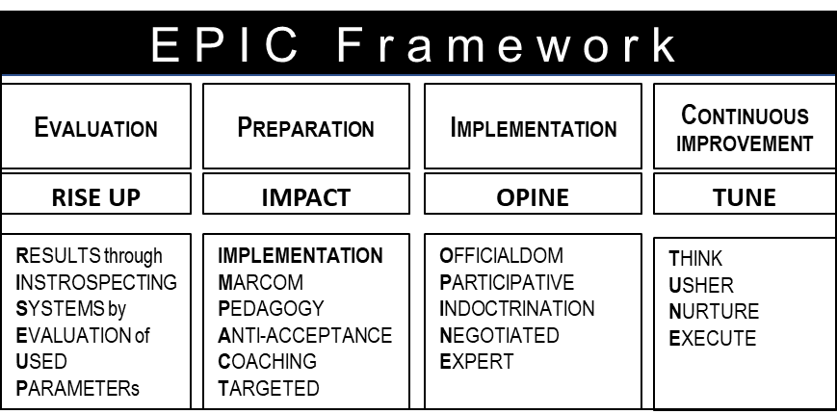

Evaluation – E of EPIC
This is the initial phase of the transformation. The larger purpose of this phase is to evaluate the present state of the organization which include various parameters that culminate towards the present goals which include:
- Business Goals
- Relationship Goals
- Timelines in achieving both
To assimilate the present goals the organization follows a process to evaluate key parameters, resources that the organization uses in its current processes and systems. These include all the divisions of the organization, broken down to its last sub unit and the parameters they use in form of Resources and systems which broadly include people and financials.
A typical example would be of the sales division within a large organization, which also has to undergo a transformation as part of the larger organization goal of digitalization. The sales operation runs across continents and cities and include people and the systems that they use to perform sales operation. The division would include all the sales employees, the CRM(customer relationship management) system for running the operation and a fulfillment engine through an attached ERP which communicates through an email workflow. The RESULT expected from sales divisions would be to improve the topline with the key attributes being of attracting new customers and maintaining the current ones. The current pipeline and csat(customer satisfaction) scores could be INTROSPECTED through the current SYSTEMS (CRM) and by EVALUATING the customer experience of the customers of the respective sales teams USING key PARAMETER’s including strategy, customer communication and customer centricity.
This methodology is christened as RISE UP (an acronym for - Getting desired RESULTS through INSTROSPECTING current SYSTEMS by EVALUATION of USED PARAMETERs)
This methodology of deriving respective outcome can be conducted for all divisions including the overlapping ones. A collection of these results will lead to a collective outcome of each resource leading to the topline and the bottom line against the anticipated goals in the suggested timeline when it was planned. This will further give insights to the relationship with the ecosystem against the perceived goals measured in form of CSAT(Customer Satisfaction), ESAT (Employee satisfaction ) and PSAT (Partner satisfaction). The results will also show the gaps and discrepancies in the respective goals, in its current state compared to its original state.
The results thus received will become the starting point to create a gap analysis and the impact analysis for the future anticipated state. The attributes of the future state will also consist of:
- Business Goals (these could be qualitative or quantitative)
- Relationship Goals
- Timeline in achieving both
When the impact analysis of such changes and transformation are deciphered for Human and Technology transformations and if they are within the means of the organization with minimal impact the transformation moves to the next step of Preparation within the EPIC framework.

Preparation – P of EPIC
The second phase after Evaluation is the Preparation phase. This phase follows methodologies derived from ADKAR model and AGILE based model in preparation for the transformation at the organization level including human and technology related changes. This is a crucial phase and requires thorough detailing of the transformation process and its overall strategy before it is put into execution and implementation phase. The transformation preparation phase should choose strategies based on the principles using best practices based on ADKAR methodology and AGILE processes. These principles include :
- Creating awareness and desire to change
- Choosing key Stakeholders, Change champions and leaders and their structure
- Knowledge dissipation and ability to use new systems
- Bring progressive small changes simultaneously with iteratively at constant frequencies
- Continuous feedback and visibility of the progress
- Eliminate unwanted processes or services of low impact value
- Automate as much as possible
- Follow Agile methodologies for continuous improvement during the transformation process
Following these principles, a preparation methodology that is derived and is used effectively for large transformation has been christened IMPACT. This acronym has been derived from Implementation, Marcom, Pedagogy, Anti-Acceptance, Coaching and Targeted. The above-mentioned principles require each of the IMPACT related strategies to get finalized and initiated for its planning. Each of these strategies may use various methodologies and techniques based on inter-related requirements. These requirements and their methodologies along with their respective timelines, need to be finalized during this phase.
Preparation using IMPACT
- Implementation strategy plan based on the transformation desired. There are eight different models that can be used while devising a suitable and a viable strategy in various scenarios.
- MarCom strategy : Internal marketing and communication needs to be set up for creating an impactful communication with key messages using various mediums. This will keep the employees and key stakeholders engaged to create a sense of belonging to the change and the transformation in general.
- Pedagogy -Training Strategy to use the new systems A training strategy will need to be devised for employees to use the transformed processes and the systems that have automated them.
- Anti-Acceptance Management Strategy. A well thought of strategy needs to be devised that deals with resistances that are created due to various emotions, behavior and attitudinal issues during the transformation management process, to ensure successful outcome.
- Coaching for continuous change through champions and leaders. There needs to be internal coaches and champions to be created during the transformation process to continuously participate in the reiteration and continuous improvement activities, post transformation.
- Targeted continuous improvement Strategy. This deals with central or distributed continuous improvement offices or units created to ensure a reiteration process post transformational deployment, through change management champions.
Post the preparation phase, the next step in the process is to initiate Implementation of the transformation program in its phased manner.

Implementation - I of EPIC
Change management strategies can be defined in 5 broad categories and can be used as per the given scenario of change or transformation. Since these strategies can be used independently or through a hybrid model of a mix or all applied collectively for the required outcome. A collection of these strategies is christened as OPINE which stands for Officialdom, Participative, Indoctrination, Negotiated, Expert.
Officialdom Strategy
This strategy uses the authority of the manager or the leader for directing the change or the transformation program.
This strategy is usually used by the top-level management with minimum involvement of others. Advantage: This strategy requires comparatively fewer people and can be implemented quickly.
Disadvantage: The disadvantage of this strategy is that it is self-opinionated and does not consider the opinion of others who are involved or affected by these changes. Since the changes are imposed upon the employees without any discussion or their preparedness it usually causes resentment among them.
This strategy is apt for comparatively smaller organizations, following a top-down management and a hierarchical structure.
Participative Strategy
As the name suggests it is based on the contributions of all individuals participating in the change or the transformation process. Though the decisions are taken by the top-level management, discussions and opinion of all participants are taken into consideration before planning and implementing the change or transformation. The views of the experts and consultants are also inculcated during the formulation and usage of this strategy.
Advantage: The major advantage of this strategy is the fact that, due to the participation and involvement of all stakeholders, the transformation process has less resistance and brings a sense of belongingness with an inclusive behavior. It gives individuals an opportunity to increase their skills and knowledge about the organization and its functions. This strategy is most apt for large transformations in highly diversified conglomerates.
Disadvantage: The main disadvantage of the strategy is that it takes longer than the other strategies and has a slower implementation timeframe and needs larger budgets.
This strategy has complex structures and management, requiring more resources and hence, budgets.
Indoctrination Strategy
This strategy is based upon re-establishing people’s norms and values, thus motivating them to support the transformation and the change process. This strategy focuses on the people involved in the process. The principle behind this strategy instills the fact that behavior and mindset are governed by social norms and values. To change these social norms first, the existing norms and values must be changed and redefined. Education, training, and consultation is thus required to imbibe such changes.
Advantage: Due to its inclusive and positive commitments, this approach brings the
support and participation of the individuals in the organization.
Disadvantage: The major drawback of this strategy is the time taken to implement due to the number of stakeholders involved in the process.

Negotiated Strategy
This strategy is applicable when the top management needs to negotiate and or bargain to implement the envisaged transformation or change process. The top management garners the confidence of various stakeholders and convinces them of the transformation and or change through a negotiation process, to achieve the outcome that is envisaged.
Advantage: All stakeholders are involved in the change process creating minimum resistance during the process.
Disadvantage: Since this strategy undergoes modifications and changes during the negotiation activities to come to a common norm with various stakeholders. It usually is challenging to predict all the possible outcomes.
The outcome of this strategy does not produce the same outcome as envisaged per the expectations. Since the managers go through renegotiations during the process there could be changes that create delays in the transformation timelines. The implementation strategies are more applicable in federated management, organizations, or institutions.
Expert Strategy
An expert strategy drives its principles of problem-solving and hence seeks the expertise of an experienced specialist in the field. These strategies are applied when the organization seeks help from external, lateral, or outsourced stakeholders or partners, to bring about the envisaged changes. Such strategies have minimal involvement of those who are affected by these changes.
Advantage: Key benefit of this strategy is a predefined, tested, experiential implementation brought about by the expert partners. This helps in quicker implementations and faster outcomes of the end state due to a guided approach.
Disadvantage: The key disadvantage of such a strategy is the unknown underlying knowledge of the culture, key stakeholders, and employees of the organization. This can lead to unknown resistance causing delays and sometimes negotiated or different outcomes.
All these strategies are nonexclusive and can be effectively merged and mixed depending on the organization’s culture, operational nuances, and employee emotions. They can also be applied serially for an effective outcome.

BEST PRACTICES DURING IMPLEMENTATION
Planning as per IMPACT needs to execute as directed during the Preparation stage (P of EPIC).
While implementing the derivation from the preparation stage, the methodologies that will be used, should follow best practices as mentioned below:
- Create a team and a structure
- Put a team and structure in form of a change management office
- Mobilize active and visible executive sponsorship in form of evangelists
- Dedicate change management resources
- Engage with and support middle managers with technology, human and change management skills
- Engage with front-line employees
- Resistance Planning: engage and integrate with project management
- Strategy Application: Apply a structured change management approach
- Communicate Regularly: communicate frequently, openly, and transparently
- Ensure iterative process and continuous improvement
In continuation to following up from continuous improvement, some of the best practices that need to continue and imbibed as principles of lasting change should follow 4 V’s. Following 4V’s have been effective and was mentioned in the study done by the Berkley university, based on active research:
- Visibility – The office for change management should be visible, available, and interested in the employees, even post go live. This will keep the employees feel supported and valued
- Variability – Manage and allow for varying emotional reactions from employees and allow more flexibility at work to take care of themselves until these reactions are eased.
- Ventilation – provide platforms and grievance offices for employees to express their feelings. Though the productivity will be low initially but allow these ventilations will help them bounce back and expedite their focus on work.
- Validation – provide visual accolades and acknowledge employees for their contributions. Give special recognitions and verbal encouragements, these will go a long way during challenging times.

Continuous Improvement – C of EPIC
In the C phase for Continues Improvement a methodology christened as TUNE - THINK, USHER, NURTURE, EXECUTE is applied in pre-decided frequency of running these cycles.
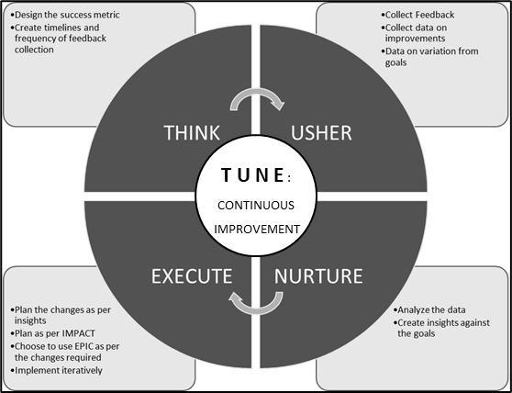

THINK
While thinking and planning for the first cycle of continuous improvement the initial step is to create a success metric. This metric should consist of key success factors that were determined during the P of EPIC phase and should always be evaluated against the individual goals at sub group level culminating to the strategic goal. The Next step is to create timelines and frequency of collecting feedbacks from all concerned. The success metric along with timelines are then moved to the USHER cycle.

USHER
In the USHER cycle the planned exercise of the success metric is executed by :
- Collecting Feedback
- Collecting Data on improvements
- Collecting Data on variation from goals and the reason for the same
These feedbacks are collated in a structured format against the success metrics and passed on to the NURTURE phase for further assimilation.

NURTURE
During the NURTURE phase the data is further analyzed for detailed insights to create an action plan for executing the change cycle for further improvements. This is done by the following three steps
- Analyze the data
- Create insights against the goals
- Create an action plan for the iterative goals in the success metric
This leads to the next phase – EXECUTE.

EXECUTE
During the EXECUTE phase, the action plan suggested from the NURTURE phase is assimilated for its practicality and communicated to the respective stakeholders. Based on the plan and the timelines therein, four steps are carried out as follows:
- Plan the changes as per insights
- Plan as per IMPACT
- Choose to use I of EPIC as per the changes required
- Implement iteratively in the planned timelines
This cycle is then repeated on a predetermined frequency to maintain and achieve the outcome envisaged during the transformation or change cycles originally.
Every organization will need to build a change management office internally. Change management capability is a long-term investment that enables organizations to manage change, more effectively, at a faster pace, and at a lower cost. And you rely less on external trainers and consultants as the capability grows. Like any investment, the returns can grow and compound over time when the investments are managed wisely.
In house change management capability requires deploying change management systemically into roles, structures, processes, projects, and leadership competencies. Despite the larger upfront commitment, the outcomes yield returns that outweigh the investment:
- All stakeholders get on the same equilibrium
- Employees embrace and adopt changes more quickly
- There are Productivity gains from Technological automation
- Negative effects of change saturation are mitigated
- Long-term objectives are met or exceeded with Strategic organizational initiatives
- Financial performances increase
- Cumulative benefits are delivered from projects harmonization
- Market opportunities are capitalized due to speed and agility with better control

G was surprised once again. He received a complete transformation plan which was more than perfect or anything that he would have had ever made himself. He had decided to use this framework to start working on his plan of setting up his organization. He realized that since his will be a startup, this might not be entirely relevant. Hence decided to put the details of his current organization to evaluate the E of EPIC using RISEUP and derive the element he would change and use as his own to set up his startup operations. Since he had spent enough time with the organization, G was very clear on what to use and what change to bring about in some processes. He was very quick in deriving the results he wanted from E of EPIC.
Since G was clear on the goal, he had derived for his startup earlier on, he immediately moved to the P of EPIC and put the IMPACT methodology at play in deriving its outcome for his Startup. This led to his business plan for three years.
G had an old colleague, who had retired from his current organization and was running his own financial services, help him with finalizing his business plan and a yearly revenue run rate to manage his derived cashflows.
It was now, the time to move into the implementation phase of his startup with all the derivations of operational activities and goals for meeting revenue numbers with the help of his strategic partnerships, that he was able to garner due to his old connects, and contractors to help with his assemblies, marketing, and sales.
G’s friend had also suggested a common colleague called “S”, who was specialized in technology related services. G had heard of S and his capabilities in technology which had won “S” many accolades. G invited S to become his partner, since the future organization that he was creating, required to have technology at its center and imbibed in the business itself for all the functions in its operations.
Seeing G’s preparation and clarity, lead S to take his invitation and became his partner for the new venture – SOUL (Shaping Opportunities Unlimited LLC).
G shared his thoughts with TIB and told him about his plan and momentum to move into the implementation of his plans and his goals.
TIB responded promptly and replied :“Congratulations for the progress and for finding a new partner. I am glad to see that the framework was of help, let me know if you would require further insights and details for moving ahead with your implementation of the business plan to achieve your goals. You are culling out the best processes from your current organization to implement them in your start up as per your plan and fitting them in to meet your goals. Since you are aware of the shortfall of your current organization and know that it has not been able to fix it, this itself is a change management for you personally and so the newer version of your current organization, but in its startup mode or incubation mode, if you will.”
G responded: “Yes please, this is when the rubber hits the road, any sort of help and guidance will be of tremendous help”
TIB: “I am sending you a detailed overview on implementation of change management processes and how the best practices are shaping these up in the current times. You can evaluate it against your current organization and choose what is right for your plan for the startup and its goals. I have also requested my friend TOB to give his inputs for your scenario since he is an expert in the current environments of the world and its changes that are creating a paradigm shift in doing business in the current era. I will be sending you a collated document shortly”

CHPT 4 : IMPLEMENTING CHANGE MANAGEMENT

“Secret of change
is to focus all your energy not on fighting the old,
but on building the new”
- Socrates

TIB responded with a detailed note as an attachment to G, by collating inputs from TOB (thinking out of the box) another monk and a close friend and associate of TIB. TIB had added a note in his email with another attachment which was named 3M Strategy. TIB mentioned that “I have attached another strategy which I and my friends TOB and SOM have designed, and feel will be the most apt for the current era of consistent changes we are living in. This framework has the blue print for various models and strategy that can be applied in cognizance with each other. This can give a near perfect solution for an individual or a very large conglomerate going through a change process. It can be effective in your scenario as well since you will go through a personal change and your startup will need to be prepared for the phases it would go through, when it moves from being a startup to a growth organization followed by stability, which usually leads to a decline cycle. You might want to lay the foundations or the practices of this while planning your operations”

PRINCIPLES OF CHANGE MANAGEMENT
Why are some people vulnerable to the vagaries thrown by life at them, whereas others more resilient? A question that becomes central to all the activities carried out by psychologist, psychoanalyst, neuroscientists, and various other science fraternity.
Every human being reacts differently to adversities and at times needs to take decisions for themselves, for their families or in their profession during such adversities.
Similarly, no organization or association can work the same way for eternity. Whether it is a quickly developing startup with deftness in its DNA or a decades-old organization responding to business sector shifts, it needs to conform to advance and get to the next change. How well organizations or individuals can do that relies on how change management is approached. Some of the key principles for change are essential of individuals and organizations of all sizes.
Key elemental principles for change should include:
Understand Change
Productive execution expects that those driving the change completely comprehend the goals and objectives of change. It is of prime importance to understand the effects of change and the primary reasons for the change. As described previously in the EPIC framework, E of EPIC along with RISE UP methodology can be used to understand the change completely, to answer three questions:
- The Problem Statement
- Change Objective
- Change Benefits
Create a Change Structure
Every large change or transformation requires a central structure with a focused objective to serve its office as a Change Management / Transformation Office. The change /transformation office requires both leadership and management objectives with dedicated resources to executive change/ transformation as per the need. To execute and effective change in an organization, there is a need to have combined strengths of administrative, authoritative and execution skills. This requires technical skills to manage projects, planning and oversee deliverables, skills with high EQ ( emotional quotient) for erudite decision making and to communicate the vision, inspire action and empathize with concerns.
An innovation change-supervisory team requires a unique mix of abilities and characters. Tap into the people who have leadership skills, understand the requirement for change, and can connect with and reassure others. Spread administration obligations on a level plane to keep all departments and offices connected and engaged. Collect a group that can adjust to evolving circumstances, gain from difficulties, and changes rapidly. Make the group multigenerational, since experienced and young representatives approach innovation in different ways, so it's vital to have a mix of both for innovative solutions during roadblocks.
Plan Change
It is imperative to get representation across the organization at each phase of a change interaction right from challenge discovery and arranging enhancements to execution and reflection.
When a few people decide on the change, it usually results in an incomplete understanding of everyone’s sphere of change for effective implementation of change. You additionally pass up a chance to get them on board, so they're anxious to invite change when it comes. The broader organization needs to be on board since they are most affected by the change process and need to adjust their processes and activities daily for accommodating changes. P of EPIC can be used for this and further entrusted using IMPACT as a methodology to plan the change activities through.
Organization leaders are careful of enormous changes. An approach of using a MVP ( minimal viable product ) to make iterative changes for a larger transformation is one of the best practices which large change management activities adopt. This iterative approach prioritizes activities in generating value, gathering criticism, and adjusting in incremental stages to deliver an ideal outcome. An MVP permits an organization to test ideations without superfluous risks, optimize and get to change activities at the earliest. This reduces stress in the system, creates a mindset to change and reduces resistance to change.
Overcoming resistance is key during the change process. Use different strategies for internal and external adoption. A startup goes through similar mindset and adoption, while building the business.
Internal Adoption:
- Give customary preparation. Make an information base and prepare recordings, have gatherings, or present a web-based help manual.
- Reward early adopters. Use gamification and organization advantages like company perks.
- Change should be an ongoing activity. Have gatherings and instructional meetings and urge workers to take part in such discussions.
- Solicit employee feedback. Incorporating employee ideas promotes ownership and adoption.
External Adoption:
- Offer rewards to external stakeholders for early adopters
- Educate external stakeholders using various media elements using social, mobile, and platform-based approaches for adoption.
- Request client criticism and feedback through one-on-ones, overviews, or discussion forums.
Implement Change
This is one of the most crucial principles since, change impacts real people, real people who often prefer a status quo. Hence, I of EPIC can be used by following OPINE methodology for a successful change implementation.
An effective implementation follows best practices in communicating the As-is and the To-be state along with incremental changes that are showcased, discussed, and followed through with feedback. The strategy or strategies that is chosen for implementation of a change or a transformation should be carefully studied for implementation as per the cultural aspects of the organization with end goal in mind. This will ensure that the change process doesn’t affect the culture of the organization, unless that is the very reason a change is coming about.
Communication for Change
Changes and transformation goals should be aligned with company goals to make changes meaningful. The vision for the company and so the change should be percolated throughout the organization to make the vision a mission to be accomplished in unison by the entire organization to avoid the least resistance during the change process.
If people in the organization are involved in identifying challenges and recommending improvements, there is an inclusive behavior to understand the reasoning behind changed processes and new initiatives and thus be invested in improvements and the organization’s goals. This will make them eager to take the steps needed to implement and sustain the changes that move the organization forward.
These elements should be instilled in all the communications in the organization with clear and precise articulation on a constant basis. The communication to the employees and external stakeholders should be in form of marketing campaigns which has a run-up, launch, iterative progress, and success, in a manner that everybody feels a part of the change and is participating in its acceleration to meet the end goal. Hence the goals should be part of all communication.
One of the best practices is to give a unique name, such as a slogan, to the Change/Transformation Program so that it remains even after the completion for a continuous improvement process and its sustainability.

TENETS
The change process should follow some tenets in form of experiential outcome from successful change programs as well as from the unsuccessful one, keeping best practices in mind.
There are some Do’s and Don’ts that should be practiced during the implementation phase. These have been derived from various sources including a research study from Berkley University, McKinney’s survey with top successful change projects, successful projects that I have led and from industry best practices though various other consulting firms. They are described below:
DO's | DO’s - Description | DO Not's | DO Not’s - Description
Transparency in information sharing | - Communicate information of what you know, and what you don’t and when to expect updates.  - Employees need all available information to make realistic assessments and effective plans.  - Share what information you have when you have it: what is changing, what is not, what is known, what is unknown, when to expect updates. | Don’t hold information in any form | - Employees need all the information for making realistic assessments for themselves for their effective planning.  - Share what information you do have, when you have it even if the information you have is not complete.
Positive Attitude | - Display a positive attitude – As the leader, you are in a position of great influence.  - Even if you are not yet fully onboard with the change, display to your team an attitude that is unbiased and welcoming of feedback. | Don’t express cynicism | - Employees look for a role model and need your support and constructive guidance.
Stay Connected | - Stay connected to your team – Focus on team goals, foster support, monitor functioning, and celebrate achievements. | Don’t be impractically positive | - Acknowledge challenging times and suggest ways to embrace them
Value the people | - Attract and recruit people – Reiterate to each team member their value, and your desire to have them remain on the team and support the change. | Don’t detach yourself | - Just by making oneself accessible keeps the employees feel supported. Use employees’ cues to know when to become more involved and when to back off.
Demonstrate compassion | - Surface issues and concerns – Show empathy; help employees reframe their personal response to the change so they can effectively manage their own personal resistance | Don’t expect uniform reaction at the same time | - Humans go through various emotional states at different times and require respective support accordingly and unknowingly
Communicate prioritization and objectives | - Provide more structure to the communications – Define short-term objectives, time frames, priorities, and standards to help your team regain its equilibrium | Don’t enable resistance | - Enabling is an action one takes, that protects the employee from consequences of his/her actions and aids employee to immobilize themselves through the change process.
High Service standards | - Protect quality and so the service standards. They must remain high to demonstrate organization seriousness towards the program | Covering Up | - Providing alibis, making excuses, or even doing someone’s work for them rather than confronting the issue that they are not meeting expectations.
Delegate | - Delegate – Continue delegating work tasks while remaining mindful of each employee’s emotional stage and providing them relevant support. | Rationalize | - Developing reasons why the individual’s behavior is understandable or acceptable.
Empower | - Empower – As appropriate, give employees more influence in day-to-day decisions.  - Determine the appropriate level of authority to assign by considering an employee’s current emotional stage, level of experience, capability, and the task itself. | Withdraw/ Avoid | - Avoiding contact with the individual whose behavior is problematic.
Challenge | - Raise the bar – Provide challenging assignments and coach employees to grow and develop their skills | Blaming | - Blaming yourself for the individuals continued challenging behavior or being livid at the individual for not trying hard enough to improve their behavior or to get help.
Rewards and Recognition | - Recognition during change is especially important to show appreciation and provide acknowledgement for work well done, to keep a motivated environment. | Controlling | - Taking responsibility for the person by significantly changing their environment or trying to minimize the impact by moving them to a less important job.
Honest Communication | - 2-way communication – Be honest about what you can’t say or don’t know and be open to hearing feedback. | Threatening | - Mentioning an action being taken (i.e., formal disciplinary action) if the employee doesn’t improve, but not following through.
Two-way Top-down feedback | - Inform/update higher management – Provide candid feedback on the change as it relates to the work and its impact on the people. This ensures leadership has the information needed to make informed decisions | Get carried away | - You as a leader also needs to feel energized and motivate yourself, while listening to people's issue. Don’t get carried away with people's issues. Take some time out to energize and come back to help them

SUCCESSFUL CHANGE
The common thread in surveys by well-known consulting companies and the companies I have been dealing with for successful transformations, show that ownership, accountability, prioritization, resources, and capabilities are the key success elements during the process.
Successful transformations typically reinforce ownership through clear accountability for specific targets built in the KPI and individual incentives for key players that are strongly aligned to success and the final goal.

KEY ELEMENTS FOR SUCCESSFUL CHANGE AND TRANSFORMATION

Organization leader with ownership and commitment
Leadership Qualities during the process
Leadership plays an important role for successful change management. Key leadership skills for the process require deep understanding of the desired change and the purpose with clear goals. These qualities followed by self-accountability, transparency in communication, empathy and dedication for the purpose creates higher aspirations for the organization and its people to imbibe the change in their daily routine. Key qualities of the leadership that should be responsible for the change management process should include:
- Commitment
- Accountability and transparency
- Empathy towards the stakeholders
- Dedication toward the goal
Communication as a marketing campaign
A well thought out communication plan followed by key updates in thoughtful frequencies help leaders methodically cascade a compelling change narrative throughout the organization. The communication should inculcate a mix of broad messages for the masses as well as be personal to the specific relevant stakeholders. These could be directed as a campaign in phased manner to the relevant audience going through their specific changes.
Importance of a Project Management Office
A Project Management Office ( PMO ) should report directly into the senior leadership and should be empowered in the hands of a seasoned senior leader. It has helped to have a lateral hand for this position to avoid bias and training on the job, given the sensitivity of the PMO. Though as a best practice, the lateral leader of the PMO should be assisted by an internal well nurtured senior leader from the organization to support the change process from a cultural standpoint and is capable of learning on the job to take a future senior or a C-suite role.

Setting Priorities
Priorities play an important role in the transformation or change process. Two key elements of setting the right priorities include understanding risks and mitigating them. Hence the scope of prioritization process must be broad and should be capable of inculcating mitigations along the way.
Risk
It is imperative to understand the key change elements and the effectivity of these changes to various areas of importance within the organization and its stakeholders. With this understanding and giving each small element its importance, will help in creating a risk matrix that define these risks, its causes ways to mitigate them, and a risk metric.
The metric should include near and far-fetched areas of effect due to the change. These could include compliances, attrition, and various incentive-based leaks. This will avoid overlooking of challenges and the delusion of following pet projects or being biased towards only the larger elements of change.
Mitigating and re-ranking
The Risk matrix and Risk metrics should consist of contingencies and other factors of mitigation built into their process. The risk metric will enable a decision support system for the leadership on key junctures during the change process. An informed decision and its maturity will be key ingredient for the change process and its long-term sustenance.
One of the ways to create and manage risk and its prioritization will be to run pilot projects tightly before an institutionalized system of change. This will derive the lessons learnt, which can be imbibed in the institutional change and will further help in informed decisions during the process.

Capabilities and Resource build
The surveys suggest that the successful change management projects have a well-defined capability matrix while incubating a change management office. The matrix included the skills that were necessary for the change and the cultural attitude of the personnel that would be deployed in the respective role within the structure.
This followed by a well-defined KRA (Key Results Area) and KPI’s (Key Performance Indices) which are incentivized based on the performance against key goals.
This office should not be considered as a ground to inculcate people, “since they are free from their current projects”, instead a clear skill match should exist against each role. This becomes one of the main areas of resource drain for change projects with longer term implications on performance of both the change office as well as the employee.
A good match will create future leaders for continuous improvement and adoption of future changes at much more rapid time frames with higher success probabilities.
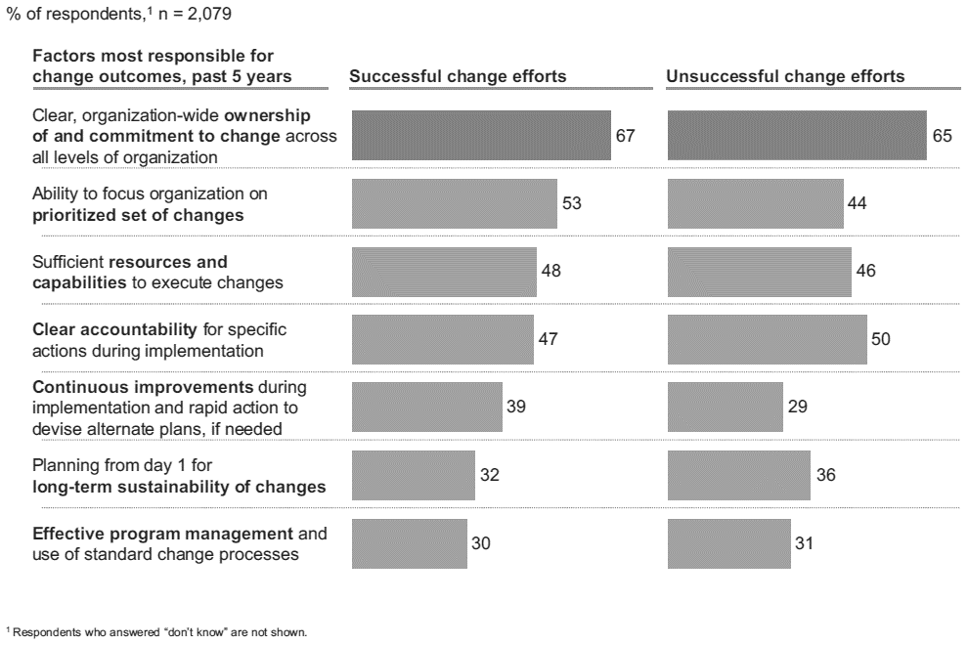
Following graph is demonstrating an outcome of a survey conducted by McKinsey and Company showing successful and unsuccessful transformational change efforts and their outcome against each factor of change since the year 2016:
Courtesy McKinsey and Co. survey

Implementation practices
Based on the change or transformation required one of the best practices is to draw standard operating procedures (SOP) for all the processes for human and technology side of changes. Each process should have an owner with well-defined KRA and KPI.
One of the key areas of faulter has been time management during the implementation process. This should be dealt with well-defined time estimates against each process broken down as a project and its owner. A well incentivized compensation along with above HR practices can result in a well-defined mechanism for carrying out implementation of the change management process with predictive results within time, delivered by motivated resources, both internally and externally.
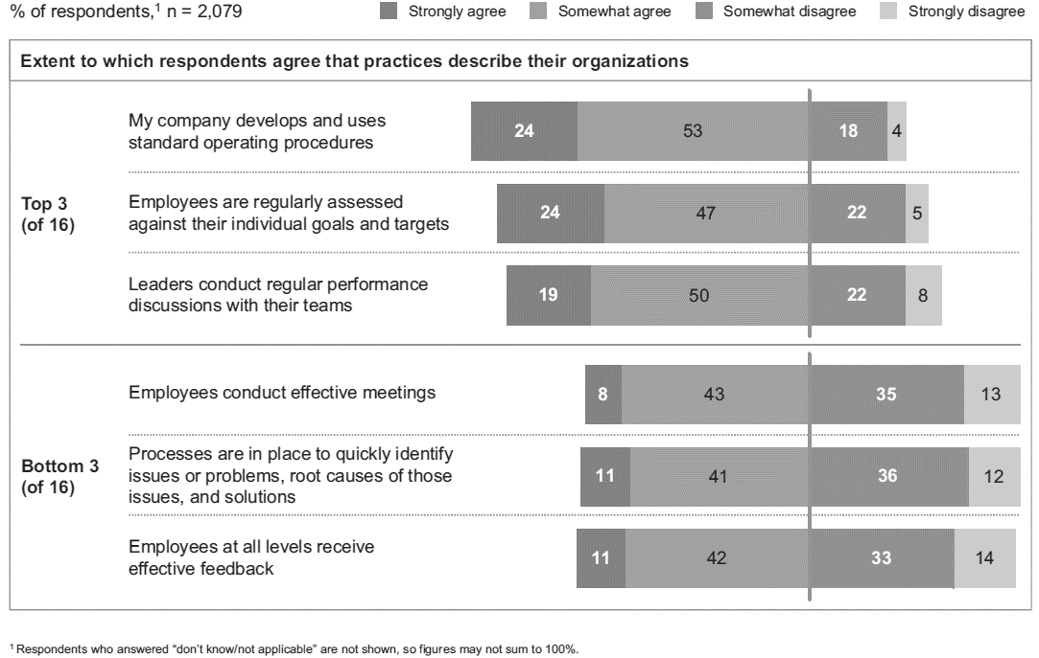
Following chart is demonstrating an outcome of a survey conducted by McKinsey and Company showing top 3 and bottom 3 practices that are used by organizations for a change management process.
Courtesy McKinsey and Co. survey

LESSONS LEARNT FROM THE INDUSTRY
While implementing the change or transformation processes, various unsuccessful projects have seen the following common reasons for being unsuccessful.
- Making things complex instead of simple
- Loose management in permeating the vision throughout
- Consensus building failure
- Lack of focus on the corporate culture
- Lack of communication in demonstrating the vision
- Misunderstood knowledge for the underlying vision
- Under planning for demonstrating short term wins
- Less focus on continuous iterative improvement compared to early victory declaration

CHANGE MANAGEMENT STRUCTURE
Establishing a central office for change management is one of the best practices for large transformations or changes with an intention of continuous improvement. Such an office should consist of three layers – (SPE) Strategy, Planning and Execution.
A typical Change/Transformation Office – SPE ( Strategy, Planning, Execution) :

The three-layered structure should consist of a Strategy Layer that is supported by a Planning layer which in turn is further supported by an Execution layer. As a thumb rule, 20% of the strength deployed in the structure should consist of the strategy and planning layer, which is supported by 80% strength consisting of the Execution layer.
A typical Change/Transformation office should have a Chief Change/Transformation Officer (or a CDO – Chief Digital Officer in the digital era) who is supported by a Team Leader for human side of changes and a Team Leader for Technology side of changes. Each of these are further supported by a communication leader, a grievance cum rewards and recognition leader and a training and Coaching Leader.
The human and technology team leaders will be supported with their respective structures for carrying human and technology related changes as the need be. The skills for the technical team could vary from software engineering skills like ML, AI etc., Cloud, IOT and networking related skills. These along with technical business domain skills like ERP which would further include, Finance, HR, Supply Chain management, and other Operations. The PMO (Project Management Office) serves the project management office for implementing the technical solutions as part of the transformation or automation of processes for iterative changes, which usually follow an AGILE methodology.
The architects in the technical structure provide the overall solution for the technologies and the automation of processes which would include the hardware and software elements in the overall solution architecture. Analyst in the structure is required to provide business related analysis for the requisite processes in use and the automation that can be interpreted as per the technical requirements.
Both the human and technical change leaders should follow the ITIL4.0 framework for service-oriented activities in unison. The mentioned positions in the structure diagram can be positioned as per the organization plan and processes to execute the change/transformation function. These positions can be christened as per the organization bands, levels, and designation structure, but the structure should work in a flat formation bands, levels, and designation structure, but the structure should work in a flat format.
This team should work in absolute unison with each person in the team defined with his/her role with clear KRA’s, KPI’s, with key timelines for each result and incentives built into their respective compensations.
One of the best practices is to have the senior most leader, for instance the Change Management Officer have their compensations attached to a balance score card along with the other leaders of the organization. The balance score card itself should have a component of the change management attribute, that formulates organization goals. This will help in collective decision making with the rest of the leaders of the organization as key stakeholders. It will further help the organization in accepting changes with a top-down approach and have the leaders from the rest of the organization to have their skin in the game for the change process, while the change managers and change agents take the bottom-up approach.

CHANGE MANAGEMENT STRATEGIES
A strategy can be chosen from OPINE through the I of EPIC framework, based on the culture, goals and leadership style of an individual or an organization to carry on its change management process. Based on these strategies a model and its methodologies can be chosen from seven well known models as standalone or in a hybrid mode by colliding two or more of these models, that are most suited for the process. I have also derived a custom model that is applicable to large or small, human, or technical or both change management programs. It has been derived by using the best practices of the industry and learnings from various successful global projects in the current era. It imbibes the principal of KISS ( Keep It Simple and Specific ) and being relevant to the context of current digital era. It is called the 3M (3 Monks) Strategy. 3M also tries to cover the shortfall in the other 7 models and can be used independently for all sizes of change management or transformation process. Since it covers both the human and technology sides of change management requisites, it has taken the best from both the worlds to collate and use ideal principles of each and applied in harmony. With appropriate structure and governance, followed through with the EPIC framework using RIOT ( Rise Up, Impact, Opine, Tune), this model can provide an appropriate solution with enforced success.

MODELS & METHODOLOGIES
There are various change management models that have been operational for some time. All have their respective benefits and advantages. There might not be one single model that fits best for all.
Based on the strategies adopted for the change management or transformation program, some of the models can be used in combination with others to suffice the need of an organization going through the change process. Some of these are suited best for larger programs others could be used for less complex environments and some at individual small changes.
There are 7 models that have been described here for a better understanding of how each work, so that it can be assimilated for its respective use.
- Lewin’s Change Management Model
- McKinsey 7-S Model
- Nudge Theory
- The ADKAR Change Management Model
- Kübler-Ross Change Curve
- Kotter’s 8-Step Theory
- Maurer 3 Levels of Resistance and Change Model
- 3M Strategy

Lewin’s Change Management Model
Lewin’s 3-Stage Model of Change, developed by Kurt Lewin focusses on breaking down the program into a tri-phased approach by breaking the program into three manageable sub programs. These programs include
- Unfreeze
- Change
- Refreeze
Lewin’s Model Of Change
As a first step, “unfreeze” your current process and analyze how it can be improved so that everyone affected understands the need for the change. Then make your changes and guide employees throughout the transition. Once changes have been deployed and tweaked according to employee feedback, solidify or “refreeze” the new process for a status quo. This is used for organization wide changes with a strong support from the senior management, where time is not necessarily of an essence. With only 3 phases in operation, it makes this model simple but not necessarily providing fast transitions. The Lewin’s Model often requires extending out the “change” phase over a long period of time to overcome resistance and provide adequate training.

McKinsey 7-S Model
This is a complex model and is suited for large and complex matrix organization. The essence of this model is to identify weaknesses by linking the seven elements and assessing their relationships. These 7 elements need not be applied in a particular succession but more in a relational aspect. The seven elements include:
- Strategy
- Structure
- Systems
- Shared Values
- Style
- Staff
- Skills
The model can be divided into two elements, namely hard and soft. Strategy, Structure and System are categorized under the hard element. Shared Values, Style, Staff, and Skills are categorized under the

Soft element. The four soft elements are usually very subjective in nature and are influenced by the company’s culture, organizations leadership style, its values and are hence subject to continuous changes. This model addresses harmonization of seven elements by analyzing how they interact with and affect each other.
This is a good model when the organization shows signs of weakness in these elements and their relationships. The identified changes are then executed with the seven S’s as the guiding principles for balancing the organization equilibrium with the virtue of the relationships between the hard and soft elements.

Nudge Theory
Nudge theory relies on subtle, indirect suggestions that are backed up by evidence so that employees will be nudged in the direction of change that you desire. The premise is that “nudging” change is more effective than strictly enforcing change.
Nudge theory follows the principle of nudging changes rather than enforcing a change. These changes depend on evidenced indirect suggestion in order to nudge employees in the direction of the change. The nudge theory can be categorized into 7 distinct principles:
- Define changes
- Consider employee point of view
- Provide evidence to show the best options
- Present change as a choice
- Listen to employee feedback
- Limit options
- Solidify change with short-term wins
Present the
change
Show the best option with evidence
Change from your employee's pint of view
Listen to feedback
Limit obstacles
Define your changes
Keep short term wins to keep the momentum up

The nudge theory emphasizes on getting full support of the employees by making them integral to the process by giving them choices, making the employees to see the need for change for themselves and influence how it is made, hence making resistance less likely. This model needs to be applied in cognizance with other models for a successful change process.

The ADKAR Change Management Model
ADKAR as discussed previously is a bottom-up approach with a focus on people. It is an acronym for awareness, desire, knowledge, ability and reinforcement. The model doesn’t follow a sequential approach, but each element is a goal to be achieved
A
D
K
A
R
AWARENESS
For the need to change
DESIRE
To support the change
KNOWLEDGE
Of how to
change
ABILITY
To demonstrate skills & behaviors
REINFORCEMENT
To keep the change in place
Since this model focusses on people, it starts with a conversation to make employees aware of the need for change. The benefits that employees receive from the change, once realized, it creates less resistance and quicker adoption. This works in line with the principles of the nudge theory and is effective for small incremental changes with a people centric approach.

Kübler-Ross Change Curve
As discussed in the previous chapters, this model was defined by the psychiatrist Elisabeth Kübler-Ross and has five stages of emotions of an individual. It helps leaders to identify the stages of emotions of individuals during the change process. The five emotions sequentially are:
- Denial
- Anger
- Bargaining
- Depression
- Acceptance
Employees may move through these stages in random order and even repeat stages. It is essential to communicate and empathize with the employees, so that they feel that they are acknowledged for their emotions throughout the journey towards acceptance.
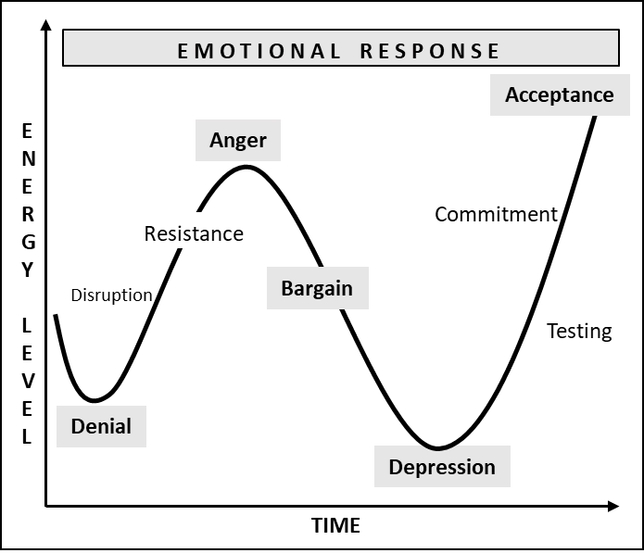
This is suited for small changes and better used for understanding emotions. It can be used in conjunction with other models for a larger implementation of change processes.

Kotter’s Change Management Theory
The Kotter’s theory is one of the largely used models for change. Professor John P. Kotter of Harvard
KOTTERS THEORY
OF
CHANGE MANAGEMENT

Business School, divided the change process into eight stages:
- Create a sense of urgency
- Build the change team
- Form a strategic vision
- Communicate the vision
- Remove barriers to change
- Focus on short-term wins
- Maintain momentum
- Institute change
This model helps in building enthusiasm and awareness of the need for change, by building a guided approach.
Kotter’s change management theory, however, doesn’t include a feedback mechanism which increases the risk of resistance during the process. This model works well in larger organizations which has a strict top-down approach but might not be as viable for smaller ones. This model, however, can be used in conjunction with another model like the Kubler-Ross model for working with employee emotions and feedback to be more effective and to mitigate the resistance risks.

Maurer 3 Levels of Resistance and Change Model
This model focuses on the reasons for failure and works on the principle of three critical levels of resistance:
- I don’t get it
- I don’t like it
- I don’t like you
This model was created by Rick Maurer, who believes that up to two-thirds of significant changes will fail due to lack of information, negative emotional reactions to change, or lack of trust and confidence in the person or people trying to implement the change.
The three levels of resistance are interpreted as follows:
“I don’t get it.”
The information flow is a necessity to ensure the need for the change, by employees. People simply reject what they don’t understand. This leads to resistance and eventually a failure
“I don’t like it.”
If employees are fearful or just frustrated with the change, they are likely to resist it. Emotional reactions can be a huge barrier for implementing change and preparing all concerned to avoid resistance.
“I don’t like you.”
If the stakeholders do not respect the judgment or the expertise for the change, they usually resist in ways that would be unknown. It is important to take all stakeholders in confidence to ensure a smooth, resistance-free change.
Maurer’s 3 Levels of Resistance and Change Model is best combined with another model that lacks stakeholder feedback mechanism and lacks anticipating and knowing forms of resistance. The combination of the two compensating models can be of extreme value for a change management process.

TIB had another attachment to the email he had responded to G, with. This attachment was named as 3M Strategy. G was very curious for this one since it was specifically mentioned by TIB.

3M (The 3 Monks) Strategy
This strategy uses EPIC (Evaluation, Preparation, Implementation, Continuous Improvement) Framework that is supported by RIOT (RISE UP, IMPACT, OPINE, TUNE) methodologies.
These work in conjunction with a 3 layered structure of a change office - SPE (Strategy, Planning, Execution). This structure has S as the strategy layer, comprising of three specific units TIB (Thinking inside the Box), TOB (Thinking Outside the Box) and SOM (Strategic Operations Management). These three units work with the Chief Change/Transformation/Digitalization Officer to carry on the specific functions detailed below.
TIB
SOM
TOB
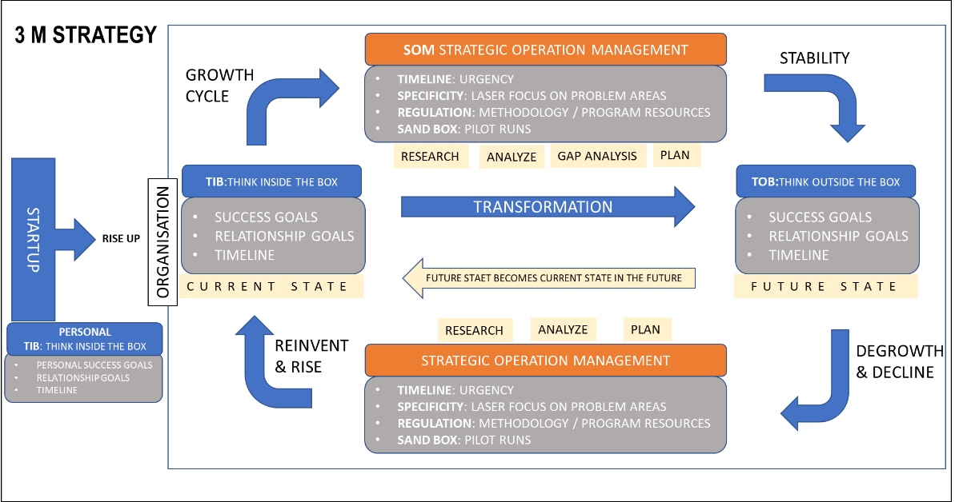
This strategy can be applied at different phases of one’s life or of an organization. The chart demonstrates various phases of an organization growth and how TIB, TOB and SOM play the role during each cycle.

TIB (Think inside the Box)
The purpose of TIB is to evaluate internal attributes of the organization in the current state in terms of:
- Company’s/Personal success goals
- Internal and External relationship goals
- Timeline envisaged and the time taken in achieving the two
TOB (Think outside the Box)
The purpose of TOB is to evaluate outward attributes that are affecting the organization’s competitive edge and its ecosystem. TOB further suggests the “To-Be” goals for the organization in its future state. These goals are derived in order to remain competitive and grow faster than its competition or peer by adopting and being relevant to the envisaged future in a researched timeline.
- Company’s/Personal future success goals
- Internal and External future relationship goals
- Timeline envisaged and the time taken in achieving the two

SOM (Strategic Operations Management)
SOM is the central unit for the strategy layer of SPE structure and works on AGILE principles. It has dual function:
- To verify details from TIB
- To verify details from TOB
- Plan for execution
To do this it has 4 specific functions :
- Research internal and external details provided by TIB and TOB for further perfection
- Analyze provided data on regular basis
- Perform Gap Analysis between current and futures state along with regulatory and compliance plans, followed with resource usage and reusage
- Create a Plan for execution
SOM works along with the planning and execution layer while supporting TIB and TOB. The key outcome of SOM is to crystalize the plan for execution based on inputs received from TIB and TOB, research and analyze it further, allocate resources, and run pilots . SOM has following functions:
- Timeline : Each plan that is created, comes with aggressive timeline that create a sense of exigency
- Specificity: Prepare a laser sharp focused plan and its scope in a simple and easy to understandable format
- Regulation: Allocate resources for each phase of change management activities using latest change principles and communication protocol definitions along with key change principles and compliances for creating a least resistance path.
- Sand Box: Run initial pilots along with the execution team to refine, modify and crystallize the pilots into institutionalized plans
This strategy is applicable individually for human, technology or both sides of change or transformations. It can be adopted by large organizations and in its minimal version can be applied to an individual going through personal changes due to internal or external situations. The only difference is that the scale for both is different and contextually could apply to its respective environments.
TIB for an individual can be viewed as internal elements e.g., current goals for career, relationships, financial etc. and achieving them in their respective time frames. TOB is the future aspiration due to the changed environments and personal aspirations. SOM imaginary mind that plays the part of providing the path to do that by aligning clear, thoughtfully planned goals to be achieved in the specific time by devising a regulated plan which has iterative smaller steps, fine-tuned along the way to reach the larger goal.
3M became the blue print for G and S both at their personal level as well as for their startup. Though G and S had different personalities it seems that both could adopt 3M due to its simplicity and use.

G being an introvert had ambitions for growing fast, with a logical mindset which had the tendency to behave irrationally sometimes and the aggression that is triggered when motivated. His hunger for growth and motivation was demonstrated when he had been able to draw a clear business plan so quickly as though it was residing in his mind already before the thought of startup was put into action.
S on the other hand is patient, satisfied and content as a personality, with technical skills. He has a mindset of being rational and practical with a tendency of enjoying and suiting a stable environment. A candidate suitable for managing operations in the most effective manner.
G was very enthusiastic by now since he had all the relevant inputs and knew how to get started. However, S raised a question – “How will the governance of such a framework or strategy work?”.
For G this was all new, hence he turned back to TIB and raised his question. He wrote to TIB – “Hi TIB, the 3M framework has become our blueprint for operation. Both S and I are very enthused to implement it at our personal levels as well as for our startup. But we have a question for you. How do we govern this whole process for our startup or when we go through a change process in the future? We want to put those levers in our system already, so that we can disrupt our operations at its minimum level during the drastic changes of our growth cycles”.
As usual TIB replied promptly. He replied “G, good to feel your enthusiasm. I am reaching out to SOM my friend and colleague, who is a monk as well and helps us with our strategic operations to get you the details of the governance used with best practices in the current times and could be applicable in the future as well, give me a day or two”

CHPT 5 : CHANGE GOVERNANCE

“People don’t resist change,
They resist being changed”
- Peter Senge
TIB replied after two days. He wrote “I had briefed SOM about your situation and let him know of you and S along with your purpose and goals. SOM has tried to combine technology and human side of change related governance along with best practices to govern large change management projects and its effect on the organization. His inputs can help you put some of these practices in your startup as well and determine the correlations for its success as per the culture and environment you intend to create. Pls see the attachment received from SOM”
G opened the attachment and started browsing through the content :

BEST PRACTICES IN GOVERNANCE
An effective transformation or a change management program requires principled governance, to be successful. This is most often a skipped activity during a change process and more than often a cause for delays and irrational outcomes. Governance of the change program should have one of the highest priorities for an organization to set afoot on a journey of transformation. Effective governance will synchronize and funnel all the moving parts in the change management program to enable efficacy, acceleration, and defined success in the change management program.

KEY PRINCIPLES FOR GOVERNANCE – 5C’s
A Change Management program should be governed by a governing body from the change management structure. Governance of the change management program should carry well-thought-out principles to imbibe the best practices that are required for a successful transformation journey. The key principles for the governance of the change management program can be defined under 5C’s:
- Course of Action
- Critical Path for Risk Management
- Communication principles
- Cultural principles
- Creed in form of a manifest

Course of Action
To set the course of action for the change management program the governing body needs to define two specific elements:
- Objectives
- Strategy
Set clear objectives that encapsulate the goals and the key outcomes of the program. There needs to be a well-defined strategy which details the path to achieve those objectives. With clear objectives and a well-defined strategy, the change management program will be well on its course to meet its end goal along with other parameters. These objectives and strategy should include governing details with the escalation matrix, role and outcome of each layer of the structure and the frequency of communication for the intended report with its frequency for the change management process.

Critical Path for Risk Management
An effective risk management starts with enlisting the causes for the anticipated risks. This will help assimilate the possibilities and the effective levels or severity that can derail the program. With this clarity a technique of critical path method can be used to determine scheduling the flexibilities and leeway to mitigate risks. A critical path in the change management usually entails governing longest sequence of tasks that need to be finished on time to meet respective timelines and deadlines to meet the end objective.

Communication Principles
Communication is at the heart of all change management programs. The principles for defining a communication protocol and its effectivity should consist of 7 elements:
- Efficiency:
All communication should serve the purpose of being effective with the relevant audience and should meet the exact timelines that has been planned for the relevant communications
- Comprehensive:
The information communicated should be sufficient and complete in all respect. It should be comprehensive to the extent of including all the relevant information in its most detailed format with the intention of keeping the relevant audience abreast of the progress and the progress of the process
- Simplicity & Transparency:
Should be clear and concise to convey what is perceived. The language used and the enthusiasm in the narration should be given its due consideration to be simple and transparent.
- Thoughtful and personalized:
This may require constructing different message formats for different roles and grades, while maintaining all the above attributes and elements.
- Consistent and unison:
The communication remains logical, well-planned, and self-reinforcing. It should show consistency in the language and messaging to show a uniform approach towards the larger outcome.
- Defined and Perseverant Timeline:
Should be done at appropriate time and timelines with the appropriate level of influence and urgency, as per the communication plan, derived during the planning process.
- Feedback effectivity:
Effective communication will require an effective feedback mechanism. This will require to confirm that the communication has been effective to resolve queries. Allow challenges in the feedback and communicate back to clarify actions that were taken within the parameters of the principles.
These elements should be imbibed in all communications inward and outward during the transformation programs to ensure a smooth task flow specifically in dealing with external stakeholders and employees.

Cultural Principles
Research shows that companies that use informal emotional approaches to influencing behavior are significantly more likely to experience change that lasts.
Cultural principles for change management program should primarily imbibe the organization culture. These should form as the core elements of the cultural principles unless the transformation is for changing the culture of the organization itself. In that case the approach needs to disrupt the current organization by specifying key areas of cultural change and then working on creating specific principles for the same.
In either case, the key is to focus on the critical few. When we work on smaller number of critical behavioral changes that have a larger impact, it becomes easier to be managed and gauged. Determine a few things people do throughout the company that have positive effect on the business performance. A simple example could be the way we conduct meetings and interact with external customers, small changes of a different way of initiating and concluding these meetings could have a lasting effect. When we put these critical changes into practice by a substantial number of people, a larger influence at faster pace becomes a reality.

Creed and Manifesto
All the four principles mentioned as principles for governance should be included in form of a manifesto that formulates into a creed. These should be highlighted and visible on a daily routine with deep inclusion in all communications. This will help maintain the overall principles in effect and help all understand various reactions that would otherwise require explanations. The governing body plays an important role in infusing these in the larger governing parameters.
These 5C’s should formulate the seven key parameters required for Governing the change management program. These parameters should be defined by the governing body, or the core team selected for running the change management program and are part of the Strategy & Planning layer of a structure.

KEY GOVERNANCE PARAMETERS
- Objective Definition
- Structure
- Roles and Responsibilities
- SOP and Workflows
- Risk Management Metrics
- Communication Framework
- Culture definition
Objective Definition
The purpose of the Change Management process governance is to control the lifecycle of the change management process during the transformation or change activities, enabling valuable changes to be made with minimum disruption in the planned time frame. To do this the governance body draws out specific goals as objective for the change management process. These goals should have 3 parameters
- Success Goals
- Relationship Goals
- Timelines to achieve for the above two points
Success goals means the business objectives that the organization has set itself for the change or the transformation. These goals include business related activities like meeting topline , bottom-line objectives, or improving shareholder value, introducing new products, increasing market share etc. Relationship goal means the relationship of the organization with their stakeholders both internal and external. This goal includes cultural behavioral aspect within the organization which results into better operations due to employee relationships with the organization, or strategic relationship improvement with the ecosystem of partners, government, and nature with sustainability objectives for increasing the organization competitive edge. These goals need to be achieved in the defined timelines to be effective and will be included in the detailed plan that follows through. These goals will have secondary and tertiary subplans as an offshoot of the larger objective to be achieved and should be included in the deciphered time lines.
These goals are also applicable for individuals to be achieved and those who are going through a personal transformation. Their objectives will also remain the same and the time that they would want to allocate for smaller changes on the journey to meet the end objective of their transformation.
Structure
The structure of the change management governance process team should consist of at least three layers depending on the size of the transformation or the extent of change. These layers are:
- Strategy
- Planning
- Execution
Strategy & Planning
Planning & Execution
Execution
CHANGE/ TRANSFORMATION OFFICE (CHIEF CHANGE OFFICER)
COMMUNICATION LEAD
GRIEVANCE AND REWARDS & RECOGNITION LEAD
TRAINING & COACHING
TEAM LEADER (HUMAN CHANGE)
CHANGE MANAGER
CHANGE AGENTS
CHANGE MANAGER
CHANGE AGENTS
TEAM LEADER (TECHNICAL CHANGE)
CHANGE MANAGER
CHANGE AGENTS
PMO
TECH SKILLS
ARCHITECTS
ANAYLYST

These layers will overlap for effective execution. For instance, Strategy and planning layers will work in unison to derive the change management process plan, planning and execution teams will work in unison to execute the process, though each element of the structure will have their respective KRA and KPI’s (key performance indices) for the outcome.
Roles & Responsibilities
The three-band structure should have key roles with their respective responsibilities and desired outcome from each, that should be quantitatively and qualitatively measured through their respective key performance indices (KPI).
The key roles in the strategy layer should include the senior leadership and is usually the change management officer of similar roles. The planning layer consists of at least four distinct roles consisting of communication lead, training lead, team lead for human related changes and a team lead for technical changes. The execution layer consists of the change managers and change agents as per the program requisites. It is always recommended to have a PMO ( project management office) setup for the technical changes team to manage individual and collective technology related projects.
SOP and Workflows
The structure needs to follow certain processes internally for an effective governance of the overall change management program. To do this, standard operating procedures(SOP) and internal communications needs to be devised for smooth workflow and relationships between the roles to meet the overall objective of the program. The planning team with an approval from the strategy teams usually will be tasked to execute these before the program initiates. SOP and workflows differ for each program and hence should be highly flexible in natures but with an avid view on the objective of the workflows.
Risk Management Metrics
A risk metric enables a decision support system during the change process. An informed decision and its maturity will be key ingredient for the change management process and its long-term activities. The Risk matrix and Risk metrics should consist of contingencies and its respective parameters for assessing the level of risk at every stage. A mitigation plan should be a part of the risk assessment through the metrics. Using a critical path methodology should be used as a part of the mitigation plan. An early assessment of risk and its mitigation plan can help in maintaining key timelines for the change management process.
Communication Framework
Key to a successful change management implementation is the communication framework both internally and externally with the key stakeholders and the workforce. Based on the principle of communication that is decided by the governance body, a framework of communication for the nature of transformation or change management needs to be created. This will be based on the cultural aspect and the longevity of the change management process. The communication framework should consist of:
- Source of communication
- Message quality
- Medium and channel for distribution
- Receiving audience ( within, internal or external stakeholders, seniority, and general public)
- Feedback mechanism
- Context and Expectation setting (based on the feedback)
Culture definition
The governing body of the change management process set the cultural aspect for the change management using the principles of culture prevailing in the organization and contextualized for the change management process. While defining the cultural aspect, if the transformation is not necessarily to change the culture of the organization itself, should use four basic ideologies to maintain a healthy change management activity. The ideologies should consist of:
- Transparency
- Respect for all
- Empathy and Compassion
- Trust and Flexibility within risk parameters
If the organization is working towards changing the culture of the organization, then the approach towards change management takes a modified approach. The approach in such a case requires to follow the same ideologies but the newer elements of cultural aspect get added as change elements to replace the current prevailing ones. The prevailing ones would be the ones that itself have led to carrying out the change management process.

KPI’S FOR GOVERNANCE
For governance to take its effect during the change management all the layers in the structure need to have thorough clarity for their roles, responsibilities, and their relationships with other stakeholders for a steady workflow during operations. To put this clarity in perspective for its smooth functioning, each role in the respective layer of the structure should have Key Performance Indices (KPI) along with their respective Key result areas(KRA) defined before putting in the structure for performing the change management activities.
KPI’s for each of the three layers, namely, Strategy Layer, Planning Layer and the Execution Layer should flow top to bottom. This means that the KPI’s for the Strategy layer should get rolled into the Planning layer, with its broken-down version for performing each role and its function, to get the key results that get imbibed into the Strategy Layer. The same goes for the execution layer, details would flow into the execution layer from the planning layer in its broken-down version to get the results which get imbibed into the planning layer.
Referring to the structure once again in the figure below, which shows the three layers of strategy, planning and execution, their respective KPI are details subsequently.
Strategy & Planning
Planning & Execution
Execution
CHANGE/ TRANSFORMATION OFFICE (CHIEF CHANGE OFFICER)
COMMUNICATION LEAD
GRIEVANCE AND REWARDS & RECOGNITION LEAD
TRAINING & COACHING
TEAM LEADER (HUMAN CHANGE)
CHANGE MANAGER
CHANGE AGENTS
CHANGE MANAGER
CHANGE AGENTS
TEAM LEADER (TECHNICAL CHANGE)
CHANGE MANAGER
CHANGE AGENTS
PMO
TECH SKILLS
ARCHITECTS
ANAYLYST

KPI’s for the Strategy Layer
This layer has to show the eventual results as the outcome that was discussed before setting up the structure and performing the change management activities. This layer should carry a Change Management Scorecard as their KPI, which consists of the outcome based on the 5C principles discussed earlier.
The five KPI’s, that this layer carries include:
- Goals:
Achievement of the organization goals and the key objectives for the change management process.
- Risk Management :
Risk Management of the Change Management program to run the process within time and budget
- Communication:
Communication goals based on the feedback from the internal and external stakeholders
- Cultural:
Cultural effectiveness with minimal disruption and dissatisfaction
- Creed
Formation of a creed with all the principles detailed out in form of manifesto to be referred, showcased, and repeated, as desired.
The KPI’s are measured through a detailed KRA list which is populated based on the feedback from 3 specific criteria from their respective audiences. These 3 criteria include :
- Customer Satisfaction (CSAT)Survey
- Employee Satisfaction (ESAT)Survey
- Stakeholder Satisfaction (SSAT)Survey
The frequency of these survey depends on the length and the time duration of the change management process. Basic thumb rule is to either have it quarterly or half yearly at least, but depends on the extent of the change management process or transformation program to help course correct the risks or the divergence that is analyzed through these feedbacks.
KPI’s for the Planning Layer
The Planning layer decodes and details the objectives of the planning layer under their guidance and consist of 12 criteria’s to be measured. These 12 criteria include the KRA’s with quality and quantity as their criteria’s to be measured:
- Communication effectiveness
- Grievance redressals
- Trainings provided – quantitative and qualitative
- Change adoption effectivity
- User awareness for the Change
- Champion trained as coaches
- Network of Champions and their effectivity
- Budget overruns
- Project Delays
- Resistance Management
- Efficiency in receiving and managing feedbacks
- Satisfaction survey reporting
KPI’s for the Execution Layer
This layer as the name suggests, consists of the foot on the ground like soldiers of the battlefield. The execution layer ensures the plans put in place for the change management process are executed within time and budget with least minimal disruption within the principles and the guidelines laid out by the strategy and the planning layers.
There are 4 KPI’s that will be measured both qualitatively and quantitatively for their KRA. These KRA refer to both Human side and the Technical side of change management. They include:
- Execution of all the indices of the Planning layer ( 12 criteria)
- Timely delivery of the subtasks given to the respective roles as per their project plans
- Timely delivery of the change management sub processes objectives within time and budget
- Carry satisfaction survey as per the planned frequency with measures of resurrection in time
With these KPI’s and their respective KRA’s with its measure at frequent intervals will help maintain a healthy Change Management Score Card. This score should be evaluated at frequent interval for corrective actions based on the outcome from feedbacks, survey analysis and its deep insights.

CHANGE SCORE CARD
A change score card assists in following best practices for a successful transformation or change process. A Change Management Score Card(CMS) represents the heath of the change management program and its progress. With a frequent evaluation of the CMS, ideally on quarterly basis can help mitigate risks and drive or change its course to align with organization requirements and the perceived goals.
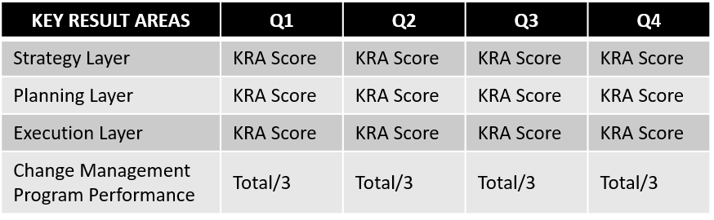
CMS consists of a matrix similar to that of a balance score card maintained by an organization to determine its health. CMS consists of a matrix of 5X5 and is evaluated quarterly. At the end of the year an annual score is determined by adding the scores from the previous quarters. The annual score from the CMS should be one of the KRA’s of all three layers ( or at least the Strategy and the Planning Layer depending on the size and the seniority of the team) and should carry incentives against its results. Following figure demonstrates a typical CMS.
CHANGE MANAGEMENT SCORECARD

TOOLS & TEMPLATES
There are various templates required for executing the change management process. Some of them are mentioned in this section. Based on the size and kind of the change management process, there is always a need for customized templates based on organizational and the change management requisites.

Tools
There are many tools that can be used to automate certain tasks for the change management process. These help in automating the workflows, communication, directing stakeholder engagement and integrating feedback systems currently used in the organization. Depending on the size and requirements of the project and the adapted strategy to be executed, determines the tool to be used. Following is a list of some of the tools that are currently in use for change management programs.
- BMC Remedy Change Management
- The Change Compass
- The Change Shop
- StarTeam by MicroFocus
- Viima
- jTask Pulse
- Scribe
- Gensuite
- Rocket Aldon
- Giva eChangeManager
- OrgMapper Influence
- ServiceNow Change and Release Management Application
- Freshservice
- ChangeGear Change Manager
- Howspace
Templates
Besides the tools there are various templates that will be required during the execution of a change management program. Following list can be used as a reference for keeping some of these templates available during the planning exercise to develop similar ones based on the workflow that has been decided for each standard operating procedure.
- Governance template
- Change Management Road
- Change management execution plan
- Resistance Management template
- Communication plan
- Issue Analysis
- Feedback Template
- Training Template
Some of the common templates and tools and their details are mentioned in the chapter for tools and templates.

CHANGE MANAGEMENT GAMES
Before a major change management process implementation begins, there should be a run up to the date of implementation. The run up should include communication on the purpose, vision, and time frames for initiating the change process. This communication should include the benefits each stakeholder would benefit from this change and what would the organization achieve in the process.
Besides these frequent communications while the planning is on parallelly, there should be group sessions to educate people on the change management process and for them to gear up. This exercise sets the organization psychologically to create a mindset towards the change, since the inertia developed for some would cause resistance which can spread amongst all those who are complacent, in their comfort zones or indolent.
One of the ways to make the communications effective is to compliment them with interactive sessions which include interactive change management events. Some of the events could be in form of group discussions and unit wise interactive exercises than can be gamified. Following are some of the ideations that can help and provide insights for further ideations to modify and use as per the organization cultural requisites.
- Fishbowl Game
- Tug of War Change Game
- Switch Change Game
  - Creation of RACI
  - Creating 4P’s
  - Fishbone & Kaizen

Fishbowl Game
A fishbowl discussion has proven to be very effective for training and teaching to get inclusive outcome with better learning and insights for the topics discussed. A similar setup can be used for discussions with the selected few with multiple units under change process activities to get better insights for the change required in those units.

Objective of Fishbowl Discussions:
The objective of this discussion will be to get a transparent communication with all required stakeholders and gather deeper insights for their respective units for the change under question, and in the process get inclusive decision making for the suggested changes.
Process:
- Start with a roundtable and have two group consisting of key stakeholders. Keep another group of stakeholders to witness the discussion.
- The format should be such that everybody should provide their individual inputs while questioning the key change planning and executing owners.
- A roundtable with approximately 10 chairs can be suggested but can be more or less depending on the size of the planned change and its effectivity that includes respective stakeholders. Eight participants are the key stakeholders who will be the discussion participants. Two or more chairs can be kept vacant, depending on the audience one is catering, and the observers line up behind the roundtable.
- A brief demonstration can be provided, and details of the topic and rules can be suggested as the discussion initiates. There should be scribers for this discussion to take key outcome and insights.
- The discussion amongst the stakeholders is initiated with the key change points briefed before the roundtable started.
- An observer takes the vacant chair to present a view that was observed, during the stakeholder discussion, if they have one.
- In case there are no further observations the moderator might ask for further inputs as the final round from the observers, by the moderator during the final last 10-15 minutes of the pre-allocated time for the discussion.
- The format and the participants could be modified to suit the cultural behavior of respective organization going through the change management process.

Tug of War Change Game
This game is based on the force-field analysis theory to follow a structured decision-making process for a successful change management implementation.

Objective of the Tug of War Change Game:
A change draws various Resistances and Driving Forces during the change process. The key objective for this game is to balance the Resistances against the Driving Forces in order to get the Driving Forces to be in excess of the Resistances.
Process:
- Keep two teams at play the ones that can represent resistances and the other team with the driving forces for change
- A topic for change can be decided as per the unit or for the organization in general, depending on the size of change under question.
- A scoring system is maintained while the two team take turns through represented individuals for at least 10 points of resistance and driving forces
- Based on the inputs and points received a vote is passed for a score (from 0-5) based on their overall impact on the change.
- The 10 points are than tallied and the changes suggested to ensure the driving forces get at least a 33% inclusive lead due to the mitigation of the resistance points presented.
- This format can be modified as per individual usage.

Switch Change Game
This game presents new perspective for the resistances and the driving forces with a simple switch exercise. Acquiring a new perspective tends to reduce resistance. This is a simple change management exercise that can be used with the key members to provide a different perspective and gain more understanding and viewpoints of respective members represented by stakeholders.
Objective of the game:
This game dwells on the fact that everybody can be encouraged to leave their comfort zones and explore new perspectives. By changing places repeatedly, a demonstration of change being a continuous process comes into existence and tends to improve performances in the new paradigm.
Process:
- Switch the teams of tug of war
- Add a new topic for change from the list of topics on both the resistance and driving forces
- Switch again with another topic of change in the list
- Take note of the insights to improve the driving forces with these changes. The insights will give rise to key elements and perspectives that needs to be inculcated during the planning exercise of the change management process.
Various uses of the games
- These games can also be used for creating a RACI(Responsible, Accountable, Consulted, and Informed) matrix by gathering the stakeholders and using the RACI topics for filling up a matrix against each element of the RACI. This will give clarity for the roles further and responsibilities with any mitigations against the risk for each task.
- Similarly, a 4P (Project, Purpose, Particulars, and People) chart can be created to aid the planning layer using the game.
- These games can also be used for filling up a fishbone analysis or a Kaizen chart for deeper analysis of the change topics. This will help participants avoid jumping to solutions on their own, since deeper thoughts and insights from the game provide inclusive inputs for smooth change management process. The teams in this case get to the root cause with deeper insights and reasons how they can affect the resistance and the driving forces positively.

G sent a thank you note to TIB and asked him to pass the same to TOB for his inputs. G further wrote “TOB’s note was very insightful and relevant to the current times. Both S and I were wondering, if we could get into a call with you and TOB to understand some practical nuances of the change management that you had experienced both in corporate companies that TOB consults, your monasteries, in individuals and amongst your fellow monks. We just want to ensure we cover all the elements in our startup to be cautious since everything changes so fast, and future might be even faster. We don’t want to get caught up unaware and start our cycles then”.
TIB replied “G, since you are a startup, my suggestion is, you should start asap. You are in the rhythm and have created a mindset for yourself, don’t let it bog you down with the details to the T at this stage. Things will evolve, but I understand yours and S’s curiosity for perfection by being cautious. I will request TOB and we shall get on a call with you and S soon”

CHPT 6 : PRACTICAL LESSONS LEARNT

“If you change the way you look at things,
The things you look at change”
- Wayne Dyer
TIB had replied and both TIB and TOB agreed for a common video call. Both of them with their happy and content self, appeared as vibrant as anybody would wish. G was aware that both of them were going through large transformations themselves at their monasteries spread all over. But the persona that appeared showed confidence, relaxed and peaceful body language with authority in whatever they were speaking.
G asked – “So how do you and your fellow monks mitigate change fatigue, keep the unknowns and fear at bay to keep all engaged and energized”?
TIB and TOB answered in unison :
“By doing two things:
- We celebrate life in a bigger fashion by identifying early successes, so that it wipes the bad experiences and replaces it with a good one
- Use that experience as a milestone in support of the next one for cultural experiences that supports the vision “
TIB went on to say “G, this is the reason I have requested you to get going with you startup asap, get the right experiences in place. Be prepared to fail, this way, your experience of failing will only be a learning lesson, which will make you more determined and the experience you garner will create a lasting determination”
The conversations continued with some practical inputs of individuals, organizations and personal experiences and ended with TOB, who gave his insights for the reasons of failure and how to avoid them.
TOB said “I will be sending you a detailed note on our conversation so that you can refer to them as and when you feel the need to. And all the best for your startup, I hope we see you with your startup in action and beating your goals every quarter”.

TOB’s note came in promptly and read:
The key reasons that cause organization resistance towards change is the thought of the disruption in a personal way of working and if there was a previous ill experience from the transformation that took place in the organization or a transformation that didn’t go well in one’s life. And if it was a traumatic experience with endless quest of failure, that experience is stored in the conscious part of the mind. Experiences like these are the ones that cause fatigue even before the next change cycle is initiated, giving rise to unrelenting resistance.
Any critical change which has major implications for transformation in an organization can cost dearly if the outcome results in its failure. Large transformations like restructuring, expanding in a new geography, integration with an acquired company, can drain resources, and deplete time and increases fatigue, if planned, executed, and managed poorly.
What needs be done to be successful? This could best be understood by determining the reasons , why transformation efforts fail. With several surveys, personal interviews and practical industry led projects for change management 7 specific reasons have been sighted to cause unsuccessful attempt in transformation and change management processes.

WHY DOES CHANGE MANAGEMENT AND TRANSFORMATIONS FAIL?
There are 7 key reasons that have been observed for failure of change and adaptation to the changed environment. The 7 reasons are Lack of purpose, Misalignment, Poor communication, Lack of importance for the feedback received, Misunderstanding of the resistance due to individual behaviors, Lack of training and inadequate systems.

PURPOSE
When a change comes with a lack of purpose or the overall goal to change, there are delays and failures causing dissipated timelines and budget overruns. There could be 4 reasons for this:
  - No compelling purpose of transformation : People tend to become cynical and resistant to change when they don't understand why it is necessary. A large-scale change must have a compelling justification for all key stakeholders, even if it is justified from a financial standpoint. The rest of the story will never be told if critical groups of people are not educated about why change is necessary and how it will affect them. The implications for and impact of change will always be of interest to people, even when they have a solid intellectual rationale for the change.
  - Lack of vision : Without a clear, precise, and simple vision the purpose then becomes that of only an aspiration. This further creates unclear reasons for change and more resistance down the line for executing any change.
  - Strategic Shortcomings: Every transformation requires a strategically, well thought out plan in cognizance with the envisioned future and present culture. These strategic plan needs to be worked to its utmost details including tactical elements which can affect the process and its timelines.
  - Underestimating scale and scope: Based on the plan for transformational changes, enough contingencies need to be built in the plan itself. Any underestimated scope and hence the scale will cause a snowballing effect, especially in the early stages of the change process.

ALIGNMENT
Another reason for budget overrun, delays and failures is misalignment between internal and external stakeholders. This is due to 3 reasons:
- Lack of stakeholder alignment : All stakeholders should be in alignment for the purpose and outcome that the change will serve. Respective stakeholders should understand the effect it will have on them during and after the process to meet the envisaged outcome. A transformation must have a persuasive validation for all key participants. The insinuations of change will always be of immense curiosity to people, even when there is a clear rationale for the change.
- Neglecting stakeholder importance: Key stakeholders, who are understood otherwise, can be easily overlooked if main objectives of the change are not clear for the change management process, given its scale and scope. It requires deep planning and thought process to detail out the internal and external resources, who will get affected with the outcome of the change and so should be part of the process much earlier in the cycle.
- Lack of aligning and cocreating : Organizational transformation consulting is a thriving business given the current climate. However, given the high failure Most don't fulfill their promise of value, as evidenced by their low rates. Specifically, this is the case for consultants who practice what we call the "doctor-patient model"; they diagnose the problem and prescribe the cure without involving the patient, without giving them a say in the process. In co-creation culture, data is used to provide accurate and relevant information for critical discussions, and multiple options are assessed against a clear set of success criteria and reached through open, collective assessment of the options.

COMMUNICATION
As emphasized earlier communication and the lack of it can cause failures, delays, and misalignments beyond repair. All communication principles should be at play during any process, be it change or a startup.
- Poor communication which is lacking in commitment and less engaging, can derail processes and progress, as the case may be. Communication is one of the nerve cells of large change management programs. A one-way communication is not enough to engage employees for becoming willing change agents, even if it is supported by the best of designed and supported material. To do this effectively, leadership should know that during the change or transformation journey, the processes will cause disruptions and is a part and parcel of the activity. Hence, they should be engaged through intensive, authentic engagement with the employees in making the transformation succeed.

FEEDBACK
Poor feedback responses and resolutions can give rise to resistance with internal and external stakeholders.
- Lack of committed leadership and feedback mechanism: In spite of its importance, senior team alignment is insufficient. While running the business, the team should remain fully engaged throughout the transformation process. Leaders often abdicate their responsibility for actively leading, directing and monitoring transformations in light of the considerable competitive and operational pressures they face. Organizations' rewarding systems often reinforce this, by incentivizing a short-term, operational focus. In the absence of such commitment the inputs of employees and the respective stakeholders for the change process as an adequate feedback mechanism is overlooked, causing resistance in the system for change.

RESISTANCE
If resistances are not managed appropriately, they have a snowballing effect. Hence all elements mentioned for failure needs to be addressed to avoid resistance at every level. The resistance at individual level need to be dealt with compassion and discrete interaction. Individual resistances could be due to:
  - Lack of buy in : A collective buy-in is required into the change management process by all stakeholders, vertically, horizontally, and externally to avoid future resistance and culture clashes
  - Inertia : In the current times, change as discussed seems to be the only constant. But it is very common for humans to get comfortable doing things a certain way, specifically if it is done for a longer time in the same way. This creates inertia and an inability to change or resist change.
  - Lack of endurance: Larger the transformation higher the time and probably higher the creep in time lines as has been observed in its practical outcome. Hence it is imperative to build considerable details in the plan to ensure enough endurance in the system to cope with the slip and absorb its monotonous delays patiently.
  - Inadequate focus on culture: It is hard to work on culture, directly. Since culture is the behavioral aspect of the larger science of maintaining it. Culture requires a clearly defined agenda addressing, what behaviors are necessary for driving the changes at large. This can be followed by determining the levers that can help in successfully altering them to maintain the cultural aspect of change.

TRAINING
Training plays an important part in adoption of the changed environment. A planned training exercise with a follow on to create champions and a train the trainer approach can help and assist in continuous improvement.
- Training and coaching are an integral part of any change, big or small, personal, or institutionalized. Any large transformation or small changes require to build a robust training system including a personal coaching for adequate stakeholders on regular basis. These are one of the key elements that can overcome failure of a change process.

SYSTEMS
An adequate system needs to be in place to avoid failure of a change management process. This system consists of the best practices mentioned earlier and the principles of change. A typical system would consist of a change structure, a framework, methodologies, and key people driving the system, which runs and matures on its own with time. However, even with an adequate system, some of the elements that can cause functional issues with the system include:
- Lack of tooling: In absence of a single source of truth including documented change process and its repeated iteration, can cause misinterpretation and loss of such perceived knowledge elements. A plan that began with the right footing can soon go askew without the right tools to support it.
- Continuous improvement: The system should have a matured model of continuous improvement in order to manage the collected knowledge and mature it over period of time for quicker change processes and avoiding repeated mistakes and shortfalls. A lack of continuous improvement best practices can cause the change process to faulter with time.
- Failure to create and sustain momentum: The system should have enough resource power and buzz to create a certain momentum as per the planned timelines and sustain it over the period of change and beyond. The inhibitions of people being unsuccessful in the new change should be addressed during the building of the momentum, so that it has a snowballing effect. Else monotony, fatigue and resistance can cause the systems to fail and provide the outcome in its planned due course of time.

Following are some practical examples of successful change and transformation projects that inculcated the right principles of winning and avoiding the ones from unsuccessful programs based on learnings from failures in the Change Management process.

EXAMPLES OF SUCCESSFUL TRANSFORMATION PROJECTS

WALMART
Walmart has its mighty presence in 11,766 locations worldwide with over $500 billion in annual revenues, it is the largest private employer in the United States, with over 1.5 million and 2 million worldwide.
Disruption
Walmart realized that with the changing environment in the digital era, the annual revenue was affected and was decreasing over time to approximately 60% from over a decade ago. This was particularly due to the rise in eCommerce and people’s behavior toward buying things online. Most of these behavioral changes can be owed to Amazon and similar large format players.
These behavioral changes were creating disruptions across the value chain in the retail industry. This digital transformation was creating newer jobs and changing the nature of jobs in the hierarchy. The new era required reskilling of employees and hard choices, in an uncertain environment, in order to deploy its capital adequately, given the size of Walmart.
They particularly noticed that the revenue at Walmart’s “supercenters” (larger stores that offer value-added services) increased by approximately 16%. This meant that the other formats were resulting in decreasing revenue at much higher levels.

The Transformation Decision
When Walmart realized that it was missing its business goals repeatedly and hence it initiated a transformation process by focusing on four areas to achieve its goals, including, first working on the cultural aspect of change in the company.
- CULTURE DECISION Walmart focused on being a tech company besides being a retail giant in the new era. Since Technology was becoming central to its business activities.
- STRATEGIC BUSINESS DECISION Closing unprofitable business format and increase the formats of the ones that are growing
- TECHNOLOGY ADOPTION DECISION Investments in e-commerce infrastructure and focus on technological innovations including use of robots and in-house incubation of technological automation became a key decision point. This included organic and inorganic activities.
- HUMAN CHANGE DECISION Changes in its employee training and support to reskill and adapt to new changed environment and continuous improvement for the growth goals that company had undertaken.

Culture Adoption
To get through its transformation journey, Walmart first focused on its culture and its direction on creating a mindset to adopt the new way of working and adapting. Walmart focused on being a tech company as much as a retail company in its digital journey and saw the nature of job changing at entry as well as higher levels. These were the key change and resistance zones which were identified and required group training, self-learning and incentivization to culturally fall in line, for the changes that were envisaged.

Strategic Business Change
- First decision that was taken was to Increase the supercenters and closing of other formats
- Create a seamless customer experience by using an omnichannel strategy. Improved e-commerce and automation using digital technology, both on the floor and in back-office roles.

Technology Change
- To improve its e-commerce infrastructure, Walmart acquired jet.com for $3.3 billion in 2016, Further investments were done in adopting robot-based technologies for repeatable regular tasks like unloading trucks, scrubbing floors, scanning shelves, and getting items out of storage for curbside deliveries.
- Digital era brought about a gig economy that disrupted end mile service deliveries. Walmart had to also undergo changes in its partner ecosystem, for which it reached out by partnering with platforms including Doordash, Postmates, Uber, and Lyft for package and grocery delivery.

Human Change
- Walmart focused on building long-term, transferable skills using a program called Pathways. This was a program that teaches associates about the retail business model and explains the purpose and the deliveries of the work they are asked to do. This helped develop soft skills that are useful in any field. This was however not as popular as envisaged and had to be reoriented.
- Walmart introduced a program in 2018 that offered workers the opportunity to enroll in an online business degree program for $1 a day. This became an incentive for people to learn and adapt to their environment, while, at the same time, achieve getting a debt-free college degree.
These changes helped Walmart to get back in its growth zone which was reflected in its enhanced quarterly results.

LEGO
Local competition, depleting revenue, and complacency forced LEGO to transform itself. It did this over two waves. The first wave was the technology enablement for automating standard processes and the collection of data for analytical decision-making. This was followed by creating an engagement platform for interacting and creating a community of external and internal stakeholders to innovate and grow in the digital era. In the process of doing this, they reskilled their employees and partners for getting adapted to the new culture. They imbibed themselves with a digitalization journey to become a digital company.

The Transformation Decision
Lego had never posted a loss since 1932, but by 2003, it was in debt with no new portfolio for over a decade and depleting sales at over 30% year on year. It had realized that physical products were not going to have interest with their followers in the future with the advent of the digital era rising on the horizon.
In the first cycle, they went through an inward journey to strengthen internal processes by using technology and automating their processes using an ERP system.
In the second cycle, they then followed their outward journey to create an ecosystem of collaborating with their stakeholders using an engagement platform. This enabled them to get in touch, on a real-time basis, with their customers and partners alike.
They parallelly, then followed through to reskill their workforce to meet the internal and external demands of the digital era and reinvigorated digital transformation to prime itself in the digital era.
- CULTURE DECISION to become a digital company driven by the CEO This showed the highest level of commitment for LEGO in its decision to transform and is most essential during large transformation projects.
- STRATEGIC BUSINESS DECISION to strengthen internal processes for the analytical decision-making process and globally collaborate with the internal and external stakeholders using technology to be future ready.
- TECHNOLOGY ADOPTION DECISION to automate current processes using ERP(Enterprise Resource Planning software platform) and PLM(Product Lifecycle Management software), MDM(Master Data Management) systems, was key for its technology adoption. Using the analytical data from these systems for decision-making process and creating a Digital Engagement platform and digital social presence for global collaboration to promote innovation was another example using technology to reach and automate its internal and external processes for continuous improvement and be future ready.
- HUMAN CHANGE DECISION by reskilling the workforce to adapt and use the new technology platform and system was another key decision for human side of changes. This was done by setting up boot camps and hackathons besides the digital learning platforms, which were automated system for self-learning.

Culture Decision
- Based on the decision by the CEO Jogen Vig Knudstorp, LEGO decided to culturally transform itself into that a digital economy from its current distributed manufacturing company culture.

Strategic Business Decision
- Distributed manufacturing with over 14000 SKUs was considerably reduced to become a strategic few. These served the business requirements for fast turnaround, based on automated demand forecasting and inventory management, besides serving digital products.
- Expensive and complex production processes were automated using ERP platform along with PLM ( product lifecycle management ) software. This reduced cost of production and material to fractions, thus improving the bottom line
- Production was rigid, slow, and uncollaborative, resulting in high budget noninnovative environments. With the introduction of the ERP and PLM along with Finance and SCM ( supply chain management) automated processes, the entire production cycle became flexible, predictive, and collaborative.
- Constant introduction of newer suppliers with no strategic ones as true partners was causing resentment and disloyalty. The automation of SCM helped in the automation of procure to pay, order to cash, and RFI & RFP cycle time for procurement improve drastically. With a strategic procurement unit, the choice of a supplier, their pricing, and turnaround time resulted in grading them using a star-based level for each supplier, which in turn resulted in creating a few strategic partner suppliers to engage and collaborate. This resulted in the better external stakeholder in who were satisfied and loyal to perform at higher turnaround times to meet the speed of the digital world
- Sales were dependent majorly on very few buyers with no transparency in inventory and store demands resulting in poor demand planning and forecast issues. A social presence along with a collaborative engagement platform helped create loyalty amongst customers and better control over the distribution of the sales turnover portfolio.

Technology Transformation
- An ERP system with SCM, FINANCE, HR followed by PLM, and eventually MDM was implemented through a central IT structure led by a CIO.
- The vast data sources were collaborated on a decision support system to provide analytical insights for making decisions at all levels.
- A digital engagement platform was created for collaborative innovation and interchanges with the global stakeholders
- Digital platforms were created for reskilling the workforce on an ongoing basis through online boot camps, hackathons, and a learning management system.

Human Change
- Continuous learning programs have been created for people to adapt to the new digital company culture
- Repeated reskilling based on the continuous improvement programs for ongoing transformation to remain innovative and future ready
Lego was by far the most successful turnaround story to implement change management principles and driving the business to meet is timely demands being future ready, using latest tools and systems.

AXIATA
Axiata is one of the largest telecommunication companies in South East Asia with a turnover of over $5 Bn. Axiata was formerly known as Tm International Bhd. and was an acquisition to create one of the leading telecommunications groups in Asia in pursuit of a vision to be the Next Generation Digital Champion. To accomplish this vision the board had put in a plan to acquire various organizations that will be integrated into current operations and carry on with their transformation plan for achieving the envisaged outcome.
With this vision the senior most leadership wanted to put a transformation plan in place to automate its operations inside out to meet their topline and bottom-line goals and have matured relationship with their ecosystem by creating strategic partnerships with their external stakeholders. In the process of doing this they wanted their employees to adopt the news systems and processes in order to follow best practices for continuous improvement, while other integrations continue to follow through.
The Challenge
One of the initial steps in the transformation was to automate the sourcing and procurement unit, since it was widely distributed and was not in the best of its shape due to various acquisitions that were spread throughout the south east Asian region. There were five different business units working in very different cultural setups and operations. This was causing financial leaks, collaboration issues, high overheads due to different systems being used, system reporting being inadequate and delayed and no single source of truth to verify and reconcile.
The Solution
To create a robust foundation for initiating this process and being a telecommunication company there was enough hardware that had to be modernized and collaborated with the systems to be formed to derive data for key decision support systems. For this a central IT structure was created under the leadership of a CIO. The first project for automation that was undertaken was to digitalize the sourcing and procurement division.
This was the first project in the geography to be undertaken and had a large IT product company along with an external consulting company to provide an adequate solution for the suggested scope. Post a study, an automation solution was provided and tests in form of pilots were conducted to evaluate its outcome to meet the expectation against the issues.
Cultural Decision
This was a top-down driven organization and had passionate leaders driving the change. To overlook the project along with the appointed CIO, the change leader with domain expertise in the area of sourcing and procurement was appointed as well. Since the organization followed an officialdom strategy ( I of EPIC , O of OPINE) for cultural adaptation, it helped in the current setup, since the current organization was a culmination of acquired companies. The directives by the senior leader helped every employee and external stakeholders to align according to those directives, which formulated an inclusive culture towards adopting digitalization.
Strategic Business Decision
Since the vision was clear and key objectives laid out with a detailed plan, the first phase of transformation to automate sourcing and procurement as a solution became imperative for the rest of the phases to fall in place. Since the employees and external stakeholders aligned to the new system, this helped in adaptability of the subsequent phases.
Technology Adoption
ARIBA a sourcing and procurement automation software system, was used as the product platform to be configured with its respective features in a strategic sourcing and procurement setup. This would mean a central system will be used for sourcing and procurement to align various units, which were working independently. This system was devised to remove all the paper-oriented activities and perform the entire value chain of sourcing and procurement digitally to produce the requisite reports as a single source of truth. This system required other units as stakeholders to automate their workflows as well, including the finance departments and service operation units of all five business units. This resulted into various resistances, but due to the officialdom strategy, most of them were mitigated due to various methodologies being used as early detection, much earlier in the cycle. The external consulting organization was using TIB,TOB and SOM along with the EPIC framework and its respective methodologies to ensure smooth implementation and adoption.
Human Change
There were two areas of resistance that came about during the process.
- Since the business units were independently operating with their own respective systems, this transformation was disruptive to the extent, that the senior leaders and their subordinates in different units resisted the system altogether by finding faults in the system, rather than collaborating to solve them. The central senior leadership was informed of the resistances at various level. Since the central senior most leadership was aware of various cultural aspects, they gathered all the business unit holders over a 5-day period collaboratively to mention all issues and the areas they could collaborate to adopt the system to their satisfaction. He then made a committee of these business unit holders to overlook the project with a specified timeline. This made the adoption and its implementation in record times with an operation system coming into existence much ahead of the deadline.
- The staff that was using the system at the entry level was used to a different system. Learning this new system with newer interfaces with other units became overwhelming and daunting for them. The change management team started a buddy system of holding the entry level executives in a shadow mode, while they ran the system and transit it to them subsequently in a reverse shadow mode. This buddy system worked very well and helped the system adoption process drastically. This was then used in a “Train The Trainer” format for continuous improvement while other phases were on.
By now G had realized the importance of putting the right systems, structures, and technology in place along with a likeminded workforce who share the same goals to ensure growth with minimal resistance for any kind of business. He then determined if he adds the age old 4P to his findings, namely, People, Product, Promotions and Processes, in cognizance to these systems and structures, he will have a winning business. This business will have a lasting legacy, when added with a change management system to keep him abreast with the changing times. He reassured himself with the decision of having S on board for his startup, given the importance of technology and like mindedness with a stable and matured mindset.
G called upon S and both of them started getting underway to launch the startup and reassured themselves of calling it SOUL. They decided the date and had their plans worked out to get their sales in motion beforehand to ensure cashflows from day 1. S agreed and suggested that initial two quarters can be utilized to get the production outsourced with their new strategic partners and temporary contractors, reminiscing the gig economy in their situation.
After their first sale and the production fulfillment in the first quarter, he wanted to let TIB know of his progress. By, now SOUL was on the ground and running with their first order and its fulfillment. They had started putting in the structure and had identified the people they wanted and shortlisted. S was instrumental in putting the systems and processes in place with initial technology implementations. While putting in the technology pieces, S realized, that the technology had moved at a faster pace than he knew. S mentioned this to G, who had an immediate question “does this change our plan already?”. S told him that they could still go with the current things they’ve put in motion, but it will be good to hear back from their mentor, guide, and friend at this time for his inputs. G was anyways prepared to reach out to TIB with his inputs.
G wrote to TIB “Hello TIB, I wanted to keep you informed of our progress, hence I am reaching out to you. In the past quarter we have set ourselves with SOUL and also have our first order with fulfillment accomplished. We are settling in faster than we thought we would – thanks to you. At this stage we are seeking your inputs, since we realized it is pertinent to know how and when does the next change in technology as well as in the industry come about as per your intelligence and does it impact the elements including people, processes, and leadership elements. S feels the technology definitely has changed. I know that you have mentioned the various changes that are at the horizon, but since technology is at the center of all changes, it just occurred to us, that if technology is changing as S has mentioned, does it affect other elements similarly ?. Please let me have your inputs”.

CHPT 7 : CHANGE MANAGEMENT IN THE FUTURE

“If the rate of change on the outside exceeds the rate of change in the inside,
the end is near”
– Jack Welch

TIB once again congratulated G and S on the progress. As a response to G, TIB mentioned “G, things are changing and evolving, but not in the manner expressed in your mail. Since nothing can be timed precisely, it is good to analyze the technology advancements in your context and how the industry is reflecting with those changes. This can help you assimilate what can be done best for your organization. TOB and SOM had prepared something relevant for us, during our event which could be of help. I am attaching it for you and S. Hope this can help you get some insights”

FUTURE ORGANIZATION
As humanity progresses, technologies and industries make progress, while the environment depletes with its resources and natural elements, organization will need to become more resilient. While being resilient, there needs to be a very high focus on sustainability of its industrial value chain by emphasizing on regenerative and reusable circular economy, through an intensified use of renewable energy systems.
A regenerative system would mean a whole system approach that restores, renews, and revitalizes energy, materials, and natural ecosystems. The process-oriented system approach requires building on economic models that enhance sharing, re-using, repairing, re-manufacturing, re-selling, and recycling of products based on technical/non-biological materials.
For instance, with the depletion of resources in the agriculture industry, it will be necessary to parallelly design more biodiverse sourcing of ingredients and sourcing of ingredients grown using regenerative agricultural practices for food, and the use of regenerative production approaches for bio-sourced materials, such as fiber crops and forestry.
Such an approach would mean adoption of newer industry standards while technology is progressing naturally and creating disruptions along the way in both good and bad ways. This happens while web 3.0 succeeds web 2.0.
Web 3.0 focusses on enhancements of database and systems architecture resulting in decentralized systems, other technologies like metaverse and the virtual gaming succeeds our current computing and networking paradigm, which makes us go from being ON the internet to IN the internet. This is where Industry 5.0 has been positioned to play a role with its creeds, manifesto, and paradigm adoption of creating resilient, collaborative, regenerative and sustainability philosophies, and principles for the industries.

INDUSTRY 5.0
The highlight of Industry 5.0 will be to significantly enhance manufacturing efficiency in a green sustainable environment and the collaboration between humans and machines to produce mass customization with a heightened customer experience. This would have a major focus on technology and its usage in order to get greener with the environment.
Humans will guide robots for repeated monotonous tasks, while critical thinking tasks with domain skills will be left to humans. Though Industry 4.0 engages robots for specific tasks for large-scale production, industry 5.0 will get in a collaborative mode to enforce the relationship between human and robots as cobots or collaborative robots.
Predictive analytics will be used amidst humongous data points that are collected in real-time, along with smarter operating systems for enhanced decision-making for better sustainability and greener adoption.
A few industries have already initiated the adoption of 5.0 in its current form, they include biological sciences, retail, manufacturing, health care, textile, dentistry, and finance.
Various enabling technologies will come into adoption with their futuristic versions at scale, while industry 5.0 is getting adopted with its complete framework. These technologies play an important role in shaping the purpose of industry 5.0. Some of these technologies include:
- Edge computing
- IOE
- Digital Twinning
- Block Chain
- Big Data Analytics
- Network Slicing
- Private Mobile Network
- Extended Reality
Edge Computing can help Industry 5.0 to use standard hardware and software resources to exchange information about their industrial sectors. This helps in sustainable power consumption for the outcome that is desired, in the value chain, by minimizing latency, reducing network bandwidth, improving data security and privacy, and enabling transactions that are hindered by connection issues
IOE – The Internet of Everything plays an important role in the manufacturing and supply chain process among others. They help in reducing communication issues with real-time data, avoid wastage in the supply chain, and optimize production processes. Within an industry 5.0 framework, IOE can play a vital role in sustainability and regenerative activities.
Digital Twinning can enhance predictive outcomes during a process. This adds to the green environment and its sustainability through early predictions to identify problems in manufacturing or similar process so that they could be reconfigured and put in to process for their final production, avoiding financial and environmental losses.
Blockchains and smart contracts help distributed ledger systems to create and access real-time contracts with a high level of privacy and avoiding fraud. This can help in high compliance of business governance and so the industry under the 5.0 framework.
Big Data Analytics can provide large amounts of data points and insights for adequate decision-making in the value chain, in real-time. This will help in predictive data elements in the value chain to avoid wastage and reusability of things till the end of life. This will avoid huge maintenance loss and various leaks and shortfall in an organization’s value chain to support their ESG (environmental social governance) initiatives.
Network slicing is ideal for use in IIOT (Industrial Internet of Things) networks and will be an essential technology in the 5.0 framework for maintaining and governing regulatory and compliance activities.
Private Mobile networks can be utilized by universities, schools, healthcare centers, and factories to deliver location-specific connectivity solutions running 24x7, without disruption in communication, which will be the lifeline within the 5.0 framework.
Extended Reality goes beyond and above virtual reality and augmented reality, in fact, it is a combination of the two and will be of use in the next version of metaverse as it develops further. This will help in remotely governed requisites like health diagnostics and repair, education in respective environmental setup, pilot training, and indoor or outdoor navigation-related system training. All these will be done remotely without wasting energy-related components on real devices or systems as the use maybe. This helps in sustainability under the 5.0 framework to aid in green environments.

Technology in motion under Industry 5.0
A digital supply chain can be simulated through a digital twin(DT), which would consist of warehouses, assets, logistics, inventory, and distribution details. The DT will further capture supplier details, contract manufacturers, factories, transportation details, distribution facilities, and relevant customer details. DT uses these details post sensing the real-time real-world data supplied through IoT sensors and other respective sensors, which are used during the entire supply chain system, built in the assets as part of the system. The data collected through these sensors are then processed using machine language and other technologies like big data to predict the outcome and respective issues during the supply chain activities. These anticipated issues can be rectified in real-time as much as possible for smoother supply chain deliveries in relatively faster time frames. This helps in customized routing predictively and reduces costs at every phase of the supply chain.
A typical example of this is that of a large glass product manufacturing company. The company distributes its glassware globally and realizes at the end of the year that it had delays in transportation and a leak or breakage-related loss during its transportation due to various natural disasters and temperature-related issues. Using temperature sensors that can monitor the temperature in the van, which can also be controlled remotely, can help in curating the breakage issues due to temperature related activities, by constant alerts from the system sent through the temperature sensors. For precautions from the natural disaster, latest technology of a web crawler along with a natural language processing software can be used to detect early detection of natural disasters. This happens by passing the data from social media and news alerts to a trained machine learning technology for processing and assimilating this data. This information in the social media or news, that is anticipated on the route, can be passed to the driver and the central control system. The alert in the system of routing, can in turn suggest an alternative route of delivery to avoid the natural disasters on the route.
This is the power of IoT using lower power sensors, mobility, and advanced software to help in sustainable activities with minimal loss and hence a greener environment. A perfect candidate for Industry 5.0 framework, when working in compliance and regulations under this framework and helping the businesses with better topline and bottom line.

DIGITALIZATION TO VIRTUALIZATION
While we see the current era of digitalization the future seems to be that of virtualization. Where individuals will hold their ecosystems to work, live, procure, learn, and provide using these ecosystems. This scenario is similar to the initial attempts using the metaverse technology, which might form one of the most essentials aspects of web3.0.
These individual ecosystems will be enabled through technological advancements and due to the shift in cultural aspects of employability resulting in acceleration of the gig culture causing digital nomads and progression of the knowledge or creator economy.
Organizations will then have to create their ecosystems which imbibe these individual ecosystems to run the organization cycles of acquiring customers with virtual experiences, serving customers with high quality products, producing, and shipping these products mostly through these individual ecosystems. Collaborative ecosystems will then be formed due to hyper specialization and localization along with technological systems built by individuals to bridge further collaboration for this very purpose.
While industry 5.0 kicks in to ensure maintaining global sustainability requirements and the resilience to extremities of pandemics or similar natural disasters at various levels, these ecosystems will require to attain the regulatory standards and compliances to be relevant for their use in a greener world.
The organizations in turn will then focus on maintaining their ecosystem under the paradigm of the industry 5.0 which would focus on being resilient and on high standards of sustainability across the entire value chain of the organization through advance ESG (environmental social governance), where human and machines will collaborate in the most intense ways through collaborative robots or cobots. This would mean that organization might have the external partner ecosystem collaborated through individual ecosystem for non-core tasks and employees as virtual stakeholders in producing the outcome that have been tasked to these highly skilled workforces working with robots for repeatable tasks.
This virtual world would require change management on repeated cycles in form of continuous improvement with a rapid stakeholder change scenario because of the individual ecosystems and virtual workforce. Transformations would kick in quicker than earlier times due to technology, environment and changing ecosystems and behavioral changes with the customer wants and experiences.
A system like the one described for 3M would be one of the befitting systems for such scenarios using EPIC framework with RIOT ( Rise Up, Impact, Opine, Tune) methodologies through a structure consisting of highly trained skills in TIB,TOB and SOM.
There have been three industrial revolutions since the 18th century. During which, organizations have either evolved or dissipated. Throughout these revolutions scale always mattered, productivity soared for innovators, and predictability was prime. Since then, there have been newer principles at the center stage, like, antifragility and experimentation which have become integral to any organization system while building more adaptive and human-related systems. Some of the most successful companies still operate mechanistically, like in the old regime of the first industrial revolution centuries ago. The solutions that are sought out for the newer world are still controlled through bureaucracy to maintain uniformity. Which needs to change in the new era.
It has been observed by various consulting-led surveys that a new collection of innovative technologies is enabling automation of low transaction costs with high connectivity and automation of repetitive tasks, that facilitate self-structuring complexity at unprecedented speed.
This can be stated as a collection of 4 trends at the surface level, that are mending the older rules:
High Connectivity
Connectivity through various open and close social media and other similar platforms of information, globally, is disrupting existing hierarchies and formalized exchange channels. This is creating unpredictability in both positive and negative outcomes, that have to be imbibed into the new system and regimen to deal with the changes it forces.
Unparalleled automation
Automation at low cost (cameras) and at a wide scale (machine-to-machine interaction) is changing the way management used to monitor employees to bring in more efficiencies. Such monitoring is changing with digital nomads and gig economies.
Decreased transaction costs
With digital nomads and virtual workforce, all operative tasks that can be outsourced are done at fraction of the costs due to automation and connectivity
Demographic shifts
The employee demands have changed from their predecessors. Gen Z has its own wants and behavioral pattern, which every organization will need to adapt to for the desired outcome.
The recent pandemic has accelerated some of these trends, which are now at a tipping point. The remote work culture is highest on the organization list of trends. This has increased the dexterity of internal teams, and the next level of dissemination between corporate employees and the gig economies.
Organizational structure with specific specialized units remains to be the way it existed. For instance, the organizations still demand stability and reliability with minimal risk through a controlling behavior, like treating employees as labor job in a factory production environment. These were the rules from the past decades. Those rules were a response to an incremental generational pass-on. The workforce of today has many options and are free to enter various new options that the economy offers and are not married to any one organization like the past.
Another example that can be sighted is that of the cost of obtaining private information. Earlier, the information used by organizations were privileged and used to come from physical, analog, and other systems at their own pace. The cost for obtaining such private information contributed to relatively high transaction costs because of the time, energy, and money required to obtain it. This has changed drastically with new information systems available on various platforms at minimal or no cost for all and is not only for a few privileged organizations.
In the new age of human-centricity, positivity, and inspiration have become the core for dealing with the workforce and are crucial for survival of organizations. Hence the 4 trends are essential to be imbibed in the organization of the new age to welcome itself in the next industrial revolution.

With this information G and S went back to drawing board and started putting some of these elements in play to ensure smooth operations in the future.
G started focusing on growth of the organization and S was tasked to focus on the bottom line. Both were motivated to meet their goals in their planned timelines. They had put all the systems and relevant principles at play to ensure growth at fast pace.
In two years, SOUL had become one of the premium companies in their space and had outgrown their competition and their own expectations. G & S had now shifted their focus to even more ambitious goals and had put four more plants to meet their business demand and the workforce including the contractors had grown sharply. They intended to grow and stabilize the organization for institutionalized growth in next five years.
……. Another four years went by.
With rapid changing times and being future ready, SOUL could meet its business goals a year ahead of their planned timelines. SOUL was now a stable organization, and the company was growing at a healthy pace, organically. G had a lot of time for himself and was spending time with his golfing buddies and family vacations. He used to appear for his board meetings but was managing things remotely most of the time. S was also spending time with his bridge buddies and immersing himself in the books that he always intended to finish
G now felt that there needs to be a shift in leadership to keep the growth healthy by focusing on the bottom line, since the top line had organic demand structures in place. He was thinking to get S at the helm of the company to manage the business and he could start focusing on inorganic and diversification topics.
He had discussed this with S, who agreed to this thought, but suggested they should also consult with TIB once again to get his view point and to find out if there have been any new insights which they are not aware of themselves.
It had been several years since G and S had reached out to TIB and G was not sure of TIB’s reaction to his email.
G wrote “Hello TIB, it’s been a while and I wanted to keep you posted on our progress and also wanted some inputs from you”.
Like always TIB’s reply was as prompt as earlier “G, I am aware of your progress, you are everywhere. I feel very happy for your progress and growth. Please let me know, how can be of any help”
G and S went ahead with a video call with TIB and TOB along with SOM this time. G mentioned the change he and S had discussed for SOUL with new leadership under S, so that G can focus on diversification and inorganic growth activities.
All three TIB,TOB and SOM were aware of SOUL and its progress and responded in unison “ That will be a good idea. Since SOUL is now moved into Stability from its Startup and the Growth stage, the things that worked earlier might not be the same that could remain to work in this stage. Things have further changed, and leadership has now evolved, and the way the workforce needs to be treated has also seen its churn. We will send you our finding on the Leadership of the Future. Our findings could be of help for S to manage his reigns, until the next phase of growth”.
The email, as usual, was prompt and both G and S went through the details for the leadership of the future.

LEADERSHIP OF THE FUTURE
Organizations in future will look for participative or transformational leadership so that millennials can be led efficiently to ensure their engagement at workplace with relatively long-term retention. However, leaders with knowledge and adaptive interest of industry 4.0 will also be preferred in future.
The leader of the future should have the mindset of a global MONK with skills of 5T’s.

MINDSET OF A MONK:
- Modest
- Openness
- Natural global citizen embracing diversity
- Keen technologist with humility
Modest
The future leader will need to have the mindset of being of selfless service and a natural modest individual demonstrating humility. With a denounced ego, the future leader should carry the attitude of serving their ecosystem by being of service to their key stakeholders, namely their teams, colleagues, partners, customers and to themselves. This requires a meditative mindset in the business world but is of essential behavior and an attitude to lead a highly skilled and spirited environment, which will support them in being loyal and growing their organization by maintaining an edge against the competition.
Openness
Future leaders will need to be open to be a student for life. They will need to learn continuously with deep curiosity as their second nature and adapt to the rapid changes as they evolve in their ecosystem due to the fast and frequent changes in the world. They will need to be open to embrace the unknown in the most enthusiastic way and be open to accept ideas with all things and everybody around them, as mitigated risk taker, to ensure their organizations profitable competitive edge.
Natural global citizen embracing diversity
With the advent of internet and connected platforms all businesses have access to global skills and customers in the world. Future leaders will have to embrace global cultures and should be an enthusiast to lead diversity to encourage employees with different background to enable their organization to enter and succeed in newer markets with local adoptions. The future leader should be thinking in global terms and adapting to local nuances in the quest for global expansions to maintain their edge in their respective businesses.
Keen technologist with humility
The future in the business world will have two main ingredients to be relevant. The first is to relate and care for the employees in the most potent way to bring out their importance and purpose that causes the synergy in the operations of the organization. To help these employees with their efficiency at work and so the operations, by using the second most important ingredient for the future, Technology. Every organization of the future will be or will have most segments of the business using technology for high efficacy to compete. The future leader will need to be a technology enthusiast to adopt newer technologies in order to improve the organizations competitive advantage. They will use this skill and enthusiasm to help their colleagues in the humblest way possible to adapt every change and disruption in newer technologies and maintain their operational competitive advantage in their industry.

SKILLS OF 5T’s
- Trainer & Teacher
- Trend follower and Trend setter
- Technology enthusiast
- Transmitter
- True Empath
Trainer & Teacher
One of the larger objectives of the future leader is to have or acquire an inherent capability to create leaders of the future. They are capable of inspiring, motivating and engaging with individuals in the team. They have a keen eye on possible future leaders whom they then coach individually to become better than them at what they do and inculcate the mindset and the skills that is required for the position, patiently.
Trend follower and Trend setter
One of the foremost skills for future leaders will be to understand, follow and manage trends. They should have the capability of reaching out into their ecosystems, networks, and other forums to consider multiple scenarios of the future to envisage changes and so the new possibilities they bring. With trend following and with the behaviorism of a monk, they ensure that organizations are not overwhelmed and surprised with the changes that occur around them.
Technology Enthusiast
This is a must have skill in the future leaders. They should be technology savvy to embrace the right technologies, potent for the growth of their organization in the changing scenario. They need not be technology geeks to practically deploy technologies but should have the capability of choosing the right one to be embraced for its practicality. While the digital era moves into the virtual one, business will need to view these changes differently, hence it will be imperative to first be digitally affluent while virtualization kicks in for its adoption.
Transmitter
The skill of assimilating energy and passing it to all around you through positive infusion is another important skill to be possessed by the future leaders, which is diminishing with time. They should have the capability to understand the feedbacks by being a good listener, absorb the inputs and communicate back with the resolutions that appeal to the respective stakeholders in the positive way. The digital world is exposed to many powerful communicators due to the social media. They give weightage to these internal communications by the leaders, for any sort of change with its due importance, if it is meaningful and resonating to the feedback and the inputs being passed by them to the leadership at repeated interval for their preferences and ideations.
True Empath
Emotional intelligent leaders have the capability to make decisions which are better than leaders with just high intelligence quotient as has been proven through many surveys and studies out there. Being emotionally intelligent is a simulation of attention that will require us to be focused on the present moment or situation. This emotional intelligence will bring about the true empath within the future leader and will help in taking most optimal decisions in a particular situation. To be a true empath they will require to have four traits, namely, high consciousness, linkages, perceptions, and determination.
Consciousness:
Being present in the moment for the task at hand. Empathize towards others and act with compassion respecting other people’s feelings. These feelings should be seen consciously, whether it is expressed enough or otherwise.
Linkages:
Harmonious interpersonal relationship encouraging qualities like empathy, compassion, appreciation, love, kindness that have a positive outcome. These are linked with happy thoughts and healthy relationships, which in turn create a healthy mind and pure thoughts.
Perception:
To have positive belief of one’s self with high self-esteem that produces positive thoughts and outcome. This belief gets infectious when seen and followed by others. This collective belief will help create a healthy environment of confident and positive people.
Determination:
Having a sense of purpose in life creates happy hormones, which in turn creates health relationships, and a healthy mind to excel in all spheres of life.
This skill of being a true Empath, will enable leaders to understand the feeling and perspectives of all around. And with the capability of self-awareness, they will relate to these emotions to provide optimal decisions with a positive energy flow to create an encouraging environment amongst the stakeholders.

This note from TIB, TOB and SOM helped G & S reassure their decision and both agreed that S had most of the ingredients to lead SOUL in its business cycle of being Stable.
With this G and S carried on with their respective activities for the next eight years. SOUL grew and became a globally renowned name with international workforce and diversified cultural setup in more than 100 countries.
G and S were both relaxed and had groomed next set of leaders to lead the organization. SOUL was comfortable with the business managing a pipeline of sales, participating in various events and global accreditations. Lots of advertisements were showcasing their global presence and every major event had their sponsorships in place.
With so much happening with the organization, S, however realized that the company numbers were declining for the past 2 quarters. He was a little away from the business at large and used to participate remotely for specific meetings only. He had just returned from a European vacation and participated in a meeting after 4 months for a review. These numbers were shocking, especially when the sales portrayed of a healthy pipeline.
S discussed this with G, who was pursuing a large acquisition for the past 3 years and was a little away from the day-to-day aspect of the organization. This was appalling for G’s ears. Both G and S spent the next two months in determining why has there been a decline in spite of the healthy overviews that were presented to them.
The next quarter saw a downfall again. Three quarters of straight downfall made them even more curious to dig deeper. That year was a year of deterioration in topline and had soon started effecting the bottom lines.
G and S found out the two main reasons for the down fall.
- Over spending for travel and advertising & Increased production costs
- Shift in Customer preference
G and S decided to get somebody to overlook these areas to stabilize the organization and get it back on track. They also realized that they are now in a declining state of business since the topline and bottom lines are both effected and will be so for the next two years, at least, as per their findings.
They both agreed to get D, their blue-eyed boy from Stanford, who had shown great signs of leadership right from his day of being an intern eight years ago.
……Two years later.
The company stabilized by improving the bottom line, after cutting the workforce and managing the non-committed travel and advertising. However, the topline still was lingering, in spite of various efforts for almost a year, with no clear insight for the future growth.
G had put his acquisition plan on a pause until the current scenario improves. G and S, now turned to TIB for his inputs. G,S,TIB,TOB and SOM got onto a video call. G &S narrated the details of their current affairs. TIB responded “ G, you went through three cycles in the past decade or so. You went from a Startup to a Growth cycle leading to a cycle of Stability, where you changed guards. What you are now going through is the degrowth or a decline cycle. This is quite natural for any business. The good thing is you noticed the decline in time, and you introduced D and allowed him to do his job while S and you did what you could to keep the lights on, though this could have been detected earlier. The bad thing is in spite of your findings you are not able to arrest the decline. You might have to go back to your drawing boards and reinvigorate your growth cycle, with the same enthusiasm as you and S did when you moved from a startup to your growth cycle, by maintaining the cultural aspect you intended and the vision you had set out when you initiated your startup.
This would mean you might have to get to the point where you moved from being a Startup to Growth. Let me work with TOB and SOM and give you some inputs in a week or so, to help you get there. But G you will have to come back to your reigns again and S will need to do what he was doing then. If I have your agreement on this, I will send you some inputs that could be relevant and might be of help further to accelerate your growth and to thrive”
G and S both responded promptly on the call “Of course… anything”
TIB, TOB and SOM responded “This was part of the reassurance we were looking for. Your enthusiasm to run your company, with the same vigor as when you started, is reassuring. There seems to be a unified passion. We are glad, the zeal still exists, and you are not looking at an exit route”

CHPT 8 : GO BACK TO RISE UP TO THE FUTURE NOW

“You cannot escape the responsibility of tommorrow,
by evading it today”
- Abraham Lincoln

G received a response from TIB: “G, all three of us have pondered over your situation and identified a few suggestions that could help you revive and get into a continuous improvement cycle, taking baby steps. This would require, as we had mentioned, for you and S to get back to the helm of things. The reason for the decline as we understood were:
- You and S became spectators to your business, assuming your workforce will work with the same enthusiasm and ambitions as you both did
- This complacency also made you overlook the continuous improvement activities with ever-changing world around us with higher frequency.
- Your Change champions should continue with the effort along with the train the trainer approach using TUNE methodology
- Your succession with the next group of leaders requires a relook. We have a feeling that the sales by your sales leaders is looked at as an opportunity to get more incentives by whatever means for their tactical growth. But you need to inculcate the culture of sales as a service, which helps humankind and improves their lives with all the products and its services SOUL is providing. This will change how your customers look at you, without the extraneous advertising you allowed in your company. Your external customers’ viral approach on social media, wil take care of everything.
- The world has further moved on with its progress over the decade since when you started digitalization, itself has shifted gears
- The systems and processes that you had inculcated initially to be prepared when you face changes in your environment and ecosystem, might require a reassessment for continuous improvement
- Lastly you might want to look at your structure and inculcate a TIB, TOB and SOM so that you are independent of us as well and have your TIB TOB and SOM on permanent basis for early detection of crisis.
Though we will be of service whenever you want us since this is a part of our mission itself. We want to see you thrive in the best possible way”
G and S were delighted to see the accuracy in their findings and were more than enthusiastic to adopt their suggestion. They both went through the details sent by TIB,TOB and SOM in the attachment and agreed to do so independently, so that they could match notes when they start putting the suggestions into action:

While the world moves from Digitalization to Virtualization in the world of web 3.0 and Industry 5.0, we see the rise to digital nomads advancing further in the gig economy. The gig economy is leading its way to the knowledge and creator economy. The only constant amongst all this will be the change and the speed of the change, with technology and communication at the helm of these changes in a greener world.
Advent of technological progression in networking, internet, communication, and advanced computing has got invisible and virtual interactions to produce results remotely. The remote culture has been accelerated by the pandemic of 2019 and has gained momentum to complete tasks with minimal to no interaction verbally or visibly. With everything going virtual, we will be interacting only with an email address, or a voice as chosen by the individual to get a particular task done, without any human interaction in the consumer world.
While the gig economy gets the tasks done, the creator economy would create knowledge or skill-based goods and products at individual level. These goods or products have been the prerogative of a few large platforms or organizations, for now. But as the gig economy, creator economy and knowledge individuals mature into the new paradigm, each of their creation would then be monetized as and when it gets consumed by other individuals or organizations. This transaction will be virtual and decentralized with digital receipts and transaction reports. Which will again have no human interaction or touch point. This is a result of a digitalized economy, producing digital products which are virtually interacted using various technologies from the web 3.0 stack and under the Industry 5.0 enablers. This is creating individual ecosystems, which in turn interact on their own to produce the desired outcome with near accurate levels as envisaged.
This virtual world with the knowledge or creator economy has the potential to increase individuality further to a point of making human touch to negligible levels, but human mind and intellect to supreme levels.
With these quantum shifts one can only imagine the change it will cause and the adoption levels that needs to be incorporated for the new, old, and future organizations. With a very high potentiality for large organizations being a series of single-independent virtual partnerships which in turn will be run by an individual. This individual in turn manages technology and its network of targeted communications in the virtual world to monetize or tokenize their large individually produced virtual goods and products with their virtual partners. An example to this effect has been a few startups like Datacoup and Zedosh. This sort of disruption will cause large organizations to rethink the business paradigm again. The leverages that made fortunes very quickly for some of the large new economy behemoths, by leveraging individual creative power, will get dissipated into the hands of those individuals, in the knowledge or creator economy, for their creative outcomes. With the skills and power to create on their own, individuals will then form a behavioral pattern towards work and its outer world. Organizations will need to find different leverage for the goods, services or products that are produced, while still attracting new talent, training them, and maintaining their loyalty.
The power shift in such case will be towards individuals or organizations who attract and maintain large tribes and communities that are served with new content, products, services, and goods of their liking on continuous basis with passion and potent cultural behavioral patterns. The passion and enthusiasm of such individuals will treat sales as a service to their audience, who value their creation. In the process they build communities and tribes that transparently interchange their passions, good, services and products for the price that equal value to thrive in their own ecosystems. These ecosystems will collaborate and co-create goods and services that will be consumed with other ecosystems giving rise to accelerated exchange of value-based economy.
The business models itself will then need to shift into different modes and gears to manage and compete for their strategic edge. Hence the individuals as well as the organizations of all sizes will need to encapsulate these changes in form of continuous improvement to stay competitive and current with the changing times.
A culture of enabling the thinking of creating something new, that presents the opportunity for enormous talent available in the world, to continuously move from concept to creation with innovation, will foster continuous growth. Technology can accelerate this growth when innovation comes from deeper sense of customer needs and empathy. At this juncture the price paid will equate the value of the creation provides in form of goods and service.
This will require a systemic but flexible concept with continuous improvement capabilities. One of the ways to imbibe such a system is to culminate various aspects discussed in the earlier chapters and adopt them in 7 steps of CHANGES (Change-Understanding the Change, Heuristic Structure, Articulated Change Management Framework, Naturalistic Methodologies for implementing the EPIC Framework, Governance with Principles, Erudite Leadership with Right Mindset & Skills, Setting the culture of growth) :
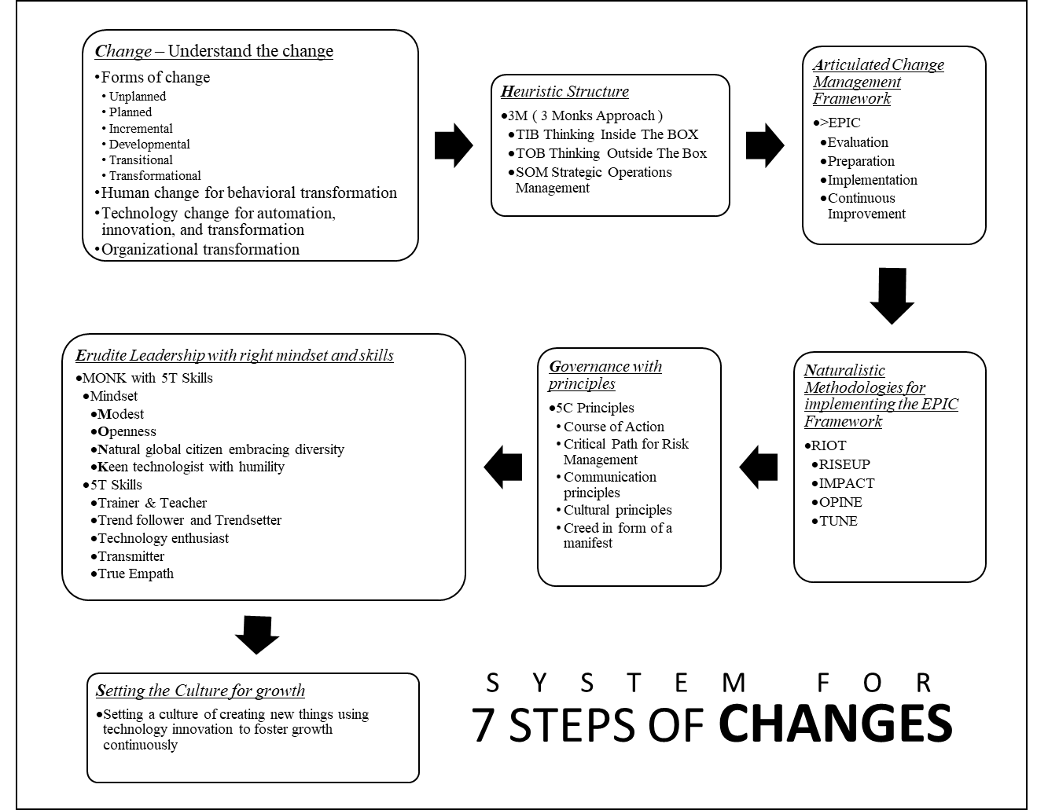
Change – Understand the change
- Forms of change
  - Unplanned
  - Planned
  - Incremental
  - Developmental
  - Transitional
  - Transformational
- Human change for behavioral transformation
- Technology change for automation, innovation, and transformation
- Organizational transformation

Heuristic Structure
- 3M – Using the 3 Monk Approach structure

Articulated Change Management Framework
- EPIC (Evaluation, Preparation, Implementation, Continuous Improvement)

Naturalistic Methodologies for implementing the EPIC Framework
- RIOT (RISEUP, IMPACT, OPINE, TUNE)

Governance with principles
- 5C Principles
  - Course of Action
  - Critical Path for Risk Management
  - Communication principles
  - Cultural principles
  - Creed in form of a manifest

Erudite Leadership with right mindset and skills
- MONK with 5T Skills
  - Mindset
    - Modest
    - Openness
    - Natural global citizen embracing diversity
    - Keen technologist with humility
  - 5T Skills
    - Trainer & Teacher
    - Trend follower and Trend setter
    - Technology enthusiast
    - Transmitter
    - True Empath

Setting the Culture for growth
- Setting a culture of creating new things using technology innovation to foster growth continuously. Creating co-partners who are worthy on the way to growth, giving an opportunity to the ones that deserve an equal platform to do so.
G and S imbibed all the suggestions in their Growth 2.0 mode. Their vision was further detailed out for this growth with a mission to create Co-Partners in SOUL, who have shown the same vigor and zeal for growth with their own passion which compliment that of SOUL.
This led SOUL to thrive in the new economy. G and S met their goal of creating a million individual and businesses, who became complimenting Co-Partners for SOUL, creating a large ecosystem of passionate businesses and individuals to make a difference to the world and serving nature and human kind in the best of their abilities.
G and S wanted to share these systems with the world so that everybody benefits from it. Hence, they created a set of tools, templates, and the systems that they shared with everybody for them to include these in their growth to thrive further.
The qualities and principles of TIB, TOB and SOM also became the imaginary elements of G and S’s life for personal interventions and achievement of goals in their own lives. They realized the importance of these as a guiding force like the three monks were during the journey of SOUL with G & S at its helm.
We all need to tap in to our TIB, TOB and SOM repeatedly to RISEUP to our future and remind us of our goals, repeatedly, to make our vision our reality, to grow and thrive in all aspects of our lives and our relationships, in best of time sensitive capabilities.

CHPT 9 : REFERENCE TOOLS & TEMPLATES

“We shape our tools,
Then our tools shape us”
- Marshal McLuhan

We need various tools and template while executing a change management process, whether it is simple change or a complex transformation. This section deals with some of the tools that can be referred to and customized as desired to carry on the respective process or a task using the mentioned templates and tools.
These template and tools should however follow the KISS principle, which is, Keep It Super Simple. The template demonstrated and mentioned in the section give a general view with extra information so that it is easy to shed unwanted elements for making it simpler for the purpose it is being used.

TEMPLATES

Governance framework template
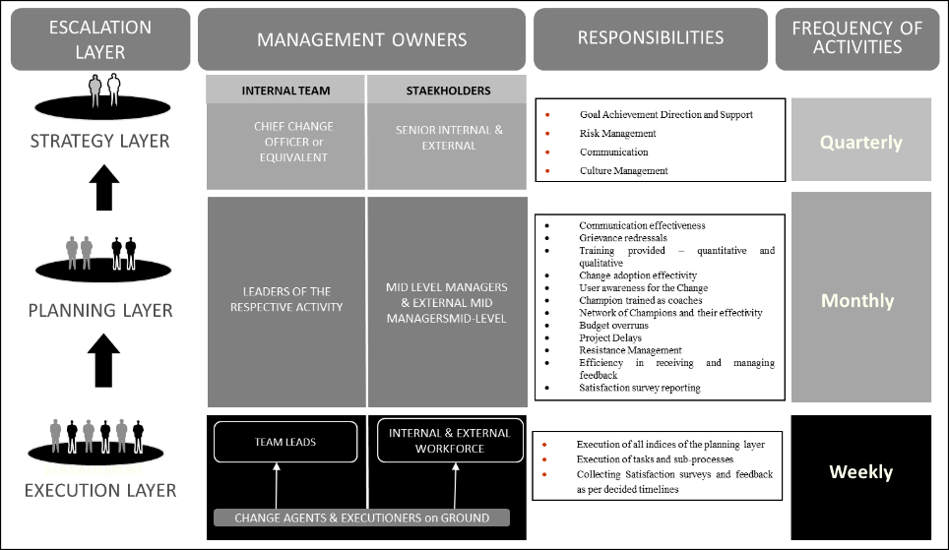
This template can be used as per the structure of operation to form a framework of operations and the allocated tasks with its frequency.
This template gives an overview of the requisite layer, taking the reference from the 3-layer structure discussed earlier. These showcase as performing particular tasks with management ownership of internal teams of the change management process and relationship with stakeholders.
Along with the escalation layer, the responsibilities and the frequency of the recurring tasks are detailed for better assimilation. This template has been used frequently and has been found to be very practical in executing the change management process.

Project Management Plan Template
This template is a sample template for the most relevant elements to be used in a change management program plan. This template can be customized as per required outcome for the nature of change in question. However, each sub task itself is a project undertaken under a larger umbrella of the program for change management. This program will include several smaller project plan templates as demonstrated to feed into the larger change management program plan to get a bird’s eye view on the overall program, as per its frequency, in the governance framework.
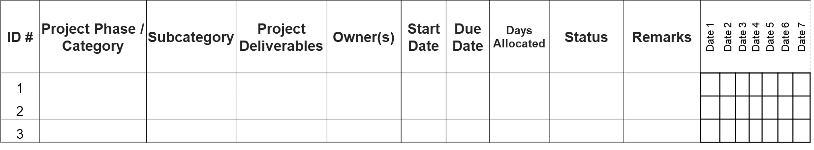

Resistance Management Template
The purpose of the resistance management template is to assess the touchpoints, points of resistance, approach to resistance, mitigation plan for resistance, insights, causes and remedies with respective ownership.
This template can have many tasks based on the nature of change and its management and is highly customizable. The following template lists a few tasks to give some samples of tasks that come into effect during a resistance management activity.
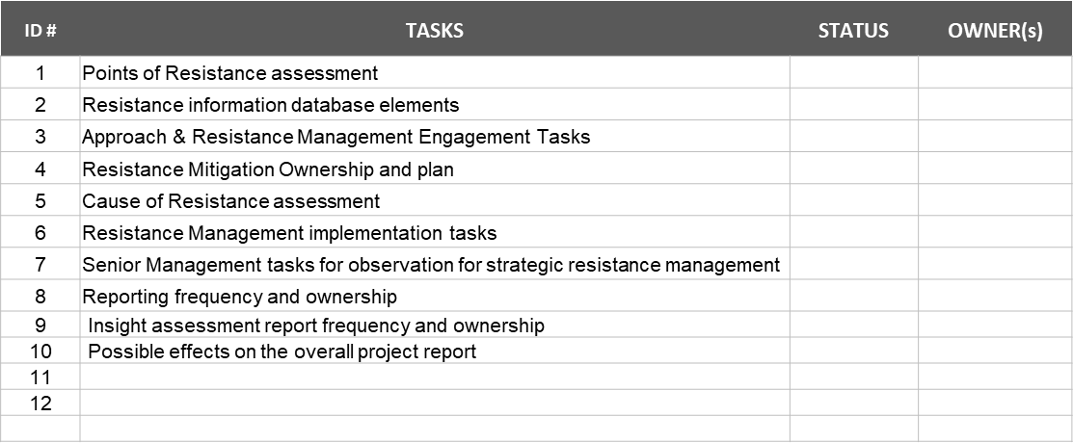

Communication Plan
The purpose of a communication plan is to create a detailed overview of various stakeholders who would receive the communication along with the owners of that communication. It details the frequency and the purpose for the task along with the medium of communication. These would be segregated as per the business, organization, project, unit, or the subdivision as the case may be. The overall communication plan is subdivided for all these during the planning exercise and discussed with the respective owners of that respective communication.
The basic principle for communication should, however, be governed by the principles laid out by the planning and the governance committee and should be in strict adherence to ensure uniformity in the overall communication and its plan. The following communication template lays out the essential topics to be covered in the communication activities and can be modified as per its usage and organization preference.
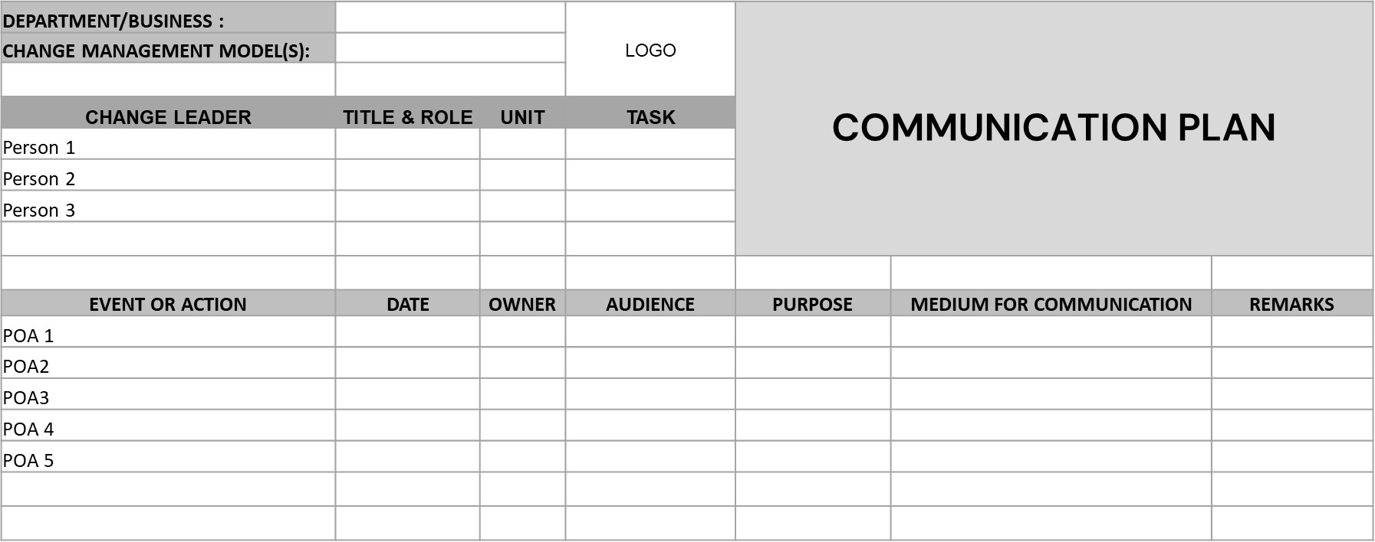

Issue Analysis Template
The purpose of an issue analysis template is to create a repository of various issues received for different tasks and the resolutions provided for each along with its time of resolution. Depending on the nature of change management required, be it human side of change or technology related change it can follow respective protocols to create the issue logs and convert them into a repository to automate recurring issues with the similar resolutions. Usually, ITIL 4.0 framework is used for both issues, but depends on the adoption of each organization. Hence this template can be customized as per its use to either create logs and then eventually create an online uploading system to automate its entry into a spreadsheet or similar document formats as a repository, to find resolutions for repeated issues accordingly.
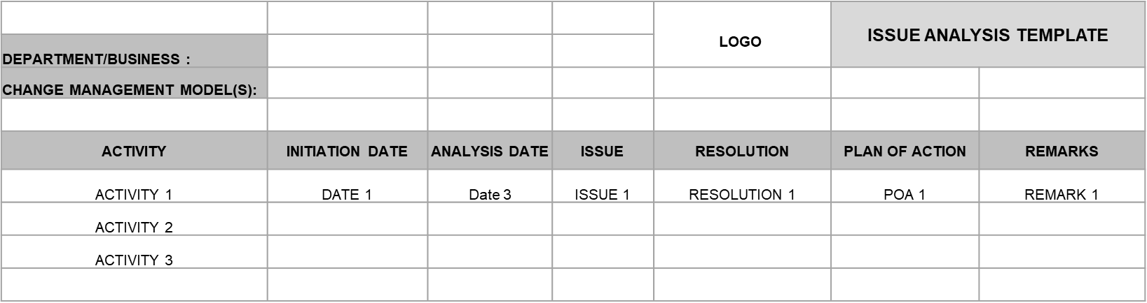

Feedback Analysis Template
Feedback analysis template is one of the most important templates that will be in use during the change management process. This can also be customized as per its usage and depends on the change activities in process at different phases. The feedback log is received through the execution layer for different activities along with its date and the nature of the feedback. This is then put in a repository of all feedbacks. Each of these should then be analyzed and demarcated for its repeatability and the resolutions provided.
The reasons along with the resolutions for each feedback is then put into action through a plan of action (POA) along with its owner. The loop for feedback is completed when the POA is executed, and the feedback received is concluded to its logical conclusion as per the POA and its outcome.
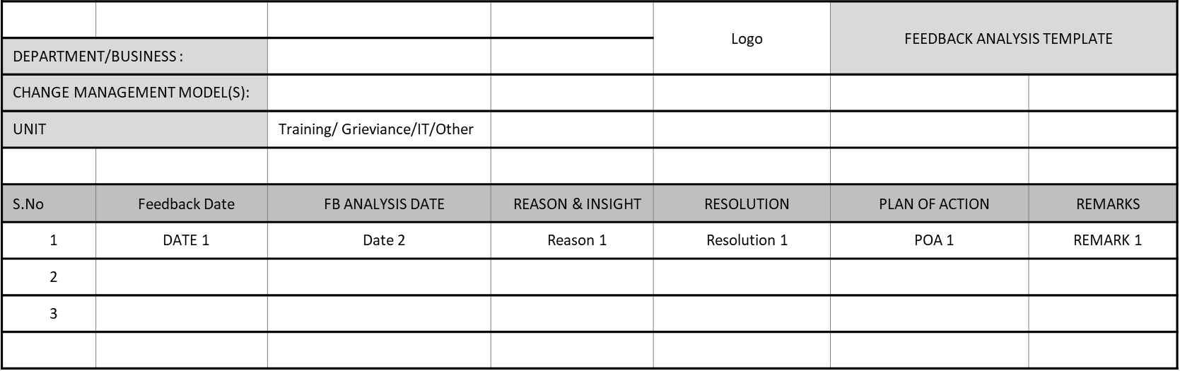

Training Template
Training template will be used for largely three purposes. Firstly, for training the end users and similar stakeholders, Secondly for Training the Trainers to train the end users, Thirdly to train and coach the champions to follow continuous improvement on an ongoing basis. This template can also be further customized for its use as per the nature and the required change management process.
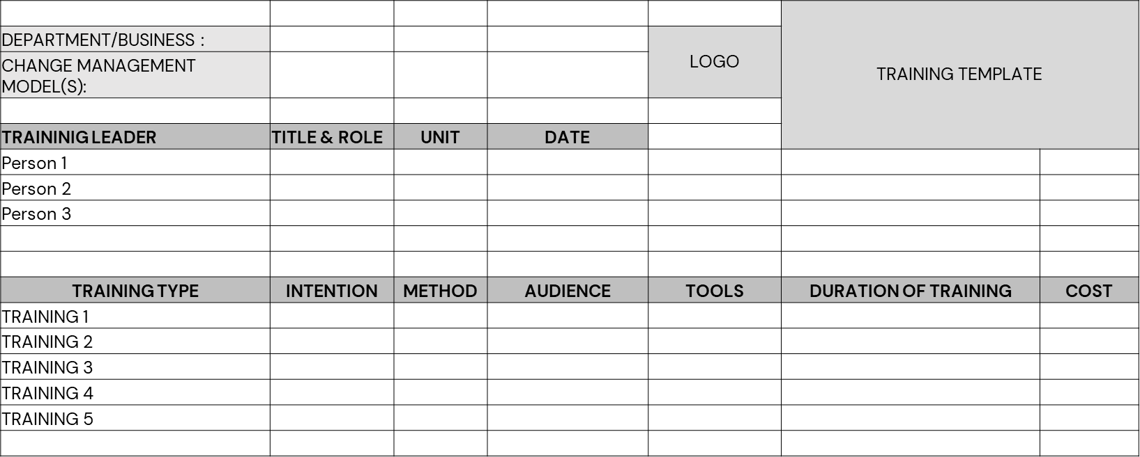
There would be various other templates that will be required for the entire process; however, the critical ones have been showcased for its usage. These can be used as references due to its practicality since it was used in various live projects, successfully.

TOOLS
There are many Change Management tools, software and platforms specific to change activities as well as a complete suite of automated tasks for IT management.
A few of them are discussed to understand the usage and extent of purpose for each, so that one can assimilate and determine these or the others out there for their usage for its specific purpose.
Some of the common features that should be part of the tool of choice should include the following key elements for its basic usage. These could be used for both human as well as technology related changes.
- Change policies to provide guidance to maintain the principles of change including process flow and execution
- Change risk assessments for enabling risk and its mitigation for the change requested.
- Change scheduling for managing the change process in time and so the budget
- Change requests for enabling a request for change and documenting it
- Change approval for automating a workflow for a decision on approval or disapproval for a change.
- Smart automation for automating repeated tasks for prompt resolutions and deliveries
- Integration with other platforms and software for real time data view and decision-making process.

ServiceNow Change Management
ServiceNow Change Management is a platform that helps manage all changes across technology teams. The software offers a great deal of functionality to help change submitters, change managers, and approvers. The goal of this system is to make it easy for changes to flow through the system without sacrificing audit control or increasing risk.
ServiceNow enables integrations with tools that allow for quick and easy root cause analysis for a broken process. The platform has built-in systems for repetitive tasks and uses machine learning that approves changes and makes it easy to integrate with vulnerability response, IT operations, and other IT processes. Additionally, it is ready for various environments for quick deliveries, including the DevOps environments.

Key Differentiators
- Risk intelligence uses machine learning algorithms to make risk predictions based on data.
- Conflict Scheduling provides a consolidated view of schedules to better manage time and resources
- Change managers can tailor change activities and flows to specific use cases, using templates configured for any environment through Multimodal change enablers.
- Mobile app experiences make the change process easier through mobile change request and agent views.
- Change success score helps automate approvals for low-risk changes and evaluates the probability of success
- AI-assisted capability helps to identify and suggest standard templates during the process
- Change approval policies can be customized to ensure principles of change are followed as part of the workflow
- The built-in analytics and reporting can help for ease of decision making through pre-configured dashboards and visualizations
- The system automatically notifies change owners of non-documented change activity through unauthorized change detection

BMC Helix ITSM
This tool is well established for technology related change management activities for Service oriented changes and related services. It offers comprehensive range of IT management services. The issues get automatically loaded while connected with an agile software tool ( like Azure DevOps or Jira). This tool ensures governance and compliance for service-oriented activities through agile and quality standards for DevOps (a set of practices to ensure high quality and quick delivery systems for IT related activities) organization.

Key Differentiators
- Highly automated with intelligent chatbots and similar systems
- Automatically creates change requests though its cognitive risk analysis module.
- Enables self-service inputs through its consolidated catalog approach.
- Provides impact analysis through web and mobile platforms with easy to use drag and drop methods.
- Provides easy to use decision support system through automating historic performance of product teams.
- Provides a single interface for multi service desk environments distributed across multi cloud services.

FreshWorks Freshservice
This tool is used for IT management and change functions, it improves visibility, costs, and time to resolution by integrating service management on a single platform. Freshworks Fresh service enables IT to transform employee engagement with integrated support channels and Artificial Intelligence driven service management as well as change management and other capabilities.

Key Differentiators
- Provides automation of repetitive workflows for better efficiency. It helps in customizations of workflows through a simple approach with no coding capabilities.
- It minimizes risk by integrating change controls with service desk and the central database.
- SLA violations are detected through automated escalation procedures based on priorities as per the rules configured in the system.
- It enables standardization and automation by implementing a change control process and extend the knowledge management activities to assist and enable end users and divert incidents
- Provides automated Root Cause Analysis
- Has capabilities in setting multiple Service Level Agreement policies for various business hours or incident categories
- Provides codeless change model workflows for business processes
- Has built in automation for collecting critical risk documentation with a capability to change record history.

Whatfix
This tool is used in adoption of large-scale programs for digital technologies. And is used for both human as well as technology sides of changes. It has high capabilities in areas of employee onboarding and offboarding. Whatfix has built in application for learning, training and support related content which provides real time and autonomous user guidance with contextual and interactive capabilities.

Key Differentiators
- Individual role customization with real time help built in the system
- Being contextual as a built-in feature, Whatfix makes learning more effective by keeping the users engaged with its in-app capabilities.
- Requires no coding for building content
- Has various global compliances and standards for global implementations.

TOPdesk
This software makes it easy to see what changes are being made, to diagnose problems, and to stay on schedule. TOPdesk helps service departments to cooperate, to connect with stakeholders, and to manage all aspects of service management and change management functions.

Key Differentiators
- TOPdesk has integrated IT change management and configuration management to enable IT changes at rapid speed.
- It enables standard operating procedures rapidly due to built-in templates and ease of change for recurring processes.
- It creates hierarchical work flows, easily, for enabling activities under specific authorities and editing them as desired at those levels
- It enables a bird’s eye view of all tasks and overview of the entire program based on the authority levels.
These tools can be used for multiple integrations for large transformations. These integrations can comprise of service desk management, release management, incident management, task management, project management, and many more. This improves decision capabilities and visibility across IT , human changes, and other enterprise assets.

ABOUT THE AUTHOR

My experience in working with various global leaders, people from diverse backgrounds, cultures, and countries, has enabled me to become a keen observer of people and their reactions to various situations and circumstances. One of the observations revealed that everybody has their unique way of responding to a particular situation in different circumstances. This suggested that everyone possesses their unique characteristics to respond to a particular situation as per their personal traits, behavior, and personality.
My quest in finding answers to work around the vicissitudes that life and work throw at us and to react undeterred in the best possible way to meet our personal goals and our organizational goals. Though our larger goals might be intact our short-term and near-term goals keep on shifting due to constant changes all around us. With, Technology, communication, the internet, and computing moving at a faster pace than ever before, Change seems to be the only constant in our ecosystems. With this, the old Change Management ways might not be applicable anymore. This has led me to author this second book in the tri-series to bring innovation in the Change Management processes and suggest frameworks, methods, and techniques that can be used in the Digital world to manage and continuously improve Changes in personal lives and in the organization that we work and are responsible for.
An Entrepreneur, Investor, Technologist, and Seeker, blessed with the fortune of holding various Global leadership positions in large conglomerates and MNC’s over the past three decades. An Electronics Engineer, and an alumnus of the Indian Institute of Management (IIM), accredited with executive-level certifications in building powerful teams and supply chain management from the Indian Institute of Technology (IIT) and India School of Business (ISB).
Privileged to create several technical papers and conduct various global transformational, change management projects to align people, processes, and purpose.
This being the second in the series of planned books, the subsequent ones will continue to focus on the topics of wellbeing and success in various phases of work and life, using the eastern spiritual wisdom and cutting-edge technology of the western world with modern methodologies in investing and creating a prosperous life for us and our loved ones.
For further details please visit www.jasvirsinghnagi.com

“
Thank you for adding this book to your collection !!
”

Changealization is part of a tri-series and the second one, in the series. The endeavor for the series was to encapsulate transformation in the change environments through personal change, organizational change, and, priming ourselves for creating environments for us to be successful in relationships, careers, and investments for a secured financial and prosperous future.
Since Changealization deals with a topic that required a regimen that is followed through a strict templatized format, which will be used repeatedly in its customized format, we have added an offer to this book for the benefit of the readers and practitioners.

This book comes with a 50% discount for a change management course along with free usable templates for your Change Management Program.

……………………

- Visit us at www.risedigitalhub.com/get-started/ to avail of this discounted offer. This discount is available until 31st March 2023, for the first 1000 registrants.

- Visit us at www.soulllp.com for our other services and references.

- Visit me at https://www.jasvirsinghnagi.com/ to be in touch for early releases and view my other books.

REFERENCES

Most of the details mentioned in the book have the quotes and the name of the respective authors mentioned besides them. All the quotes from various books have been credited by the authors of the book subsequently.
All the names of software, tools and references belong to the names of their respective companies. Any reference known or unknown have been used for their reference usage and author or its subsidiaries do not own any of those assets besides the 3M strategy and the ingredients mentioned therein.
Other references used are as detailed below:
https://medium.datadriveninvestor.com/how-investors-can-prepare-for-the-changing-world-order-feb0aa119c65
https://www.i-scoop.eu/industry-4-0/
https://frankdiana.net/2021/03/01/how-fast-will-the-world-change-in-ten-years/
Industry_5_0__A_Survey_on_Enabling_Technologies_and_Potential_Applications__Revision_submitted_to_the_Elsevier_JII
Welcome to the metaverse | McKinsey & Company
Nine keys to becoming a future ready company | McKinsey
A technology-transformation approach that works | McKinsey
https://www.huffpost.com/entry/our-world-is-changing-at-10x-speed-how-to-prepare_b_59a55415e4b0d6cf7f405027
https://www.youtube.com/watch?v=Ir_7a3fgpFQ
https://www.mckinsey.com/business-functions/transformation/our-insights/three-ways-transformations-have-changed-a-conversation-with-seth-goldstrom
https://real-leaders.com/five-steps-to-create-the-organization-of-the-future/
https://www.firstrand.co.za/perspectives/a-likely-successor-to-the-information-age/
https://www.fastcompany.com/1680127/8-ways-the-world-will-change-by-2052
https://uxdesign.cc/how-fast-is-the-world-changing-and-what-can-you-do-to-not-crumble-down-but-to-thrive-in-it-today-b3de8da58a49
https://edbrenegar.com/the-speed-of-change/
https://hbswk.hbs.edu/item/the-new-rules-for-remote-work-pandemic-edition
https://news.climate.columbia.edu/2011/02/02/the-red-queen-and-the-evolution-of-sex/
CHANGE_CHANGE_MGMT_Unit-3.pdf
https://www.youtube.com/watch?v=Mavsg19FDaE
(https://connecteam.com/top-10-change-management-activities/)
https://www.itiltraining.com/india/about?gclid=CjwKCAjwtcCVBhA0EiwAT1fY793FrbZJSAUsXUp0R--PiZY_Nbmo-_V5inM04RlXTjgMNyDtGAbeHRoCxfsQAvD_BwE
TopDesk_BestPractices_Changement_ebook.pdf
https://www.panorama-consulting.com/what-is-change-management/
https://www.youtube.com/watch?v=kBayu6BNIKw
https://www.panorama-consulting.com/what-is-change-management/
https://www.apty.io/blog/change-management-trends
Berkley_change_management_toolkit.pdf
https://www.prosci.com/resources/articles/change-management-best-practices
https://www.atlassian.com/itsm/change-management/best-practices
https://www.cio.com/article/222589/12-it-change-management-practices.html
https://www.mckinsey.com/business-functions/operations/our-insights/secrets-of-successful-change-implementation
https://whatfix.com/blog/10-change-management-models/
https://www.zendesk.com/in/blog/change-management-models/
https://www.airiodion.com/tracking-and-measurement/
https://www.forbes.com/advisor/business/principles-of-change-management/
https://www.affirma.com/blog/change-management-principles
https://www.prosci.com/resources/articles/5-tenets-of-change-management
https://www.mindtools.com/pages/article/newPPM_87.htm
https://www.cmcpartnership.sg/blog/prosci-change-management-scorecard-measuring-change-success#:~:text=The%20Prosci%20Change%20Management%20Scorecard,these%20can%20be%20equally%20challenging.
https://whatfix.com/blog/change-management-tools/
https://creately.com/blog/diagrams/change-management-tools-list/
https://whatfix.com/blog/change-management-exercises/
https://management30.com/practice/change-management-game/
https://insights.profitand.com/blog/real-life-examples-of-successful-change-management-in-business
https://www.apty.io/blog/change-management-examples
https://hbswk.hbs.edu/item/starbucks-reinvented
https://hbswk.hbs.edu/item/walmart-s-workforce-of-the-future
https://www.panorama-consulting.com/services/organizational-change-management/
https://insidesap.asia/axiata-transforms-eprocurement-with-bristlecone-and-sap/
https://www.bloomberg.com/press-releases/2016-01-27/axiata-group-berhad-drives-eprocurement-transformation-with-bristlecone-and-sap
https://www.forbes.com/sites/brentgleeson/2017/07/25/1-reason-why-most-change-management-efforts-fail/?sh=5f7071f9546b
https://www.workzone.com/blog/10-reasons-the-change-management-process-fails-and-how-you-can-succeed/
https://www.imd.org/research-knowledge/articles/10-reasons-why-organizational-change-fails/
https://www.panorama-consulting.com/change-management-failure/
Nine keys to becoming a future ready company | McKinsey
https://www.mckinsey.com/business-functions/people-and-organizational-performance/our-insights/organizing-for-the-future-nine-keys-to-becoming-a-future-ready-company
The organization of the future | Deloitte Insights
https://www.mastercontrol.com/gxp-lifeline/3-things-you-need-to-know-about-industry-5.0/#:~:text=The%20term%20Industry%205.0%20refers,pillars%20of%20automation%20and%20efficiency.
https://www.i-scoop.eu/industry-4-0/industry-5-0/
https://www.isa.org/intech-home/2018/march-april/features/welcome-to-industry-5-0
https://hbswk.hbs.edu/item/walmart-s-workforce-of-the-future
https://hbswk.hbs.edu/item/the-new-rules-for-remote-work-pandemic-edition
Organizing for the Future: Why now? | McKinsey & Company
Mckninsey_metaverse_ebook_Value-creation-in-the-metaverse
https://www.forbes.com/sites/benjaminlaker/2020/08/05/this-is-what-leadership-will-be-in-2030/?sh=1c6821cf7722
https://real-leaders.com/five-steps-to-create-the-organization-of-the-future/
Berkley_change_management_toolkit.pdf
https://whatfix.com/blog/change-management-plan-template/
https://www.airiodion.com/free-templates/
https://www.smartsheet.com/free-change-management-templates
[1] F. Aslam, W. Aimin, M. Li, K. Ur Rehman, Innovation in the era of IoT and industry 5.0: Absolute innovation
management (AIM) framework, Information 11 (2) (2020) 124.
[2] Y. Lu, Industry 4.0: A survey on technologies, applications and open research issues, Journal of industrial information
integration 6 (2017) 1{10.
[3] S. Echchakoui, N. Barka, Industry 4.0 and its impact in plastics industry: A literature review, Journal of Industrial
Information Integration (2020) 100172.
[4] O. A. ElFar, C.-K. Chang, H. Y. Leong, A. P. Peter, K. W. Chew, P. L. Show, Prospects of industry 5.0 in algae:
Customization of production and new advance technology for clean bioenergy generation, Energy Conversion and Management:
X (2020) 100048.
[5] Q.-V. Pham, K. Dev, P. K. R. Maddikunta, T. R. Gadekallu, T. Huynh-The, et al., Fusion of federated learning and
industrial internet of things: A survey, arXiv preprint arXiv:2101.00798.
[6] L. D. Xu, Industry 4.0 { frontiers of fourth industrial revolution, Systems Research and Behavioral Science 37 (4) (2020)
531{534.
[7] L. D. Xu, The contribution of systems science to industry 4.0, Systems Research and Behavioral Science 37 (4) (2020)
618{631.
[8] L. Li, China's manufacturing locus in 2025: With a comparison of \made-in-china 2025" and \industry 4.0", Technological
Forecasting and Social Change 135 (2018) 66{74.
[9] H. Lasi, P. Fettke, H.-G. Kemper, T. Feld, M. Ho
mann, Industry 4.0, Business & information systems engineering 6 (4)
(2014) 239{242.
[10] V. Priya, I. S. Thaseen, T. R. Gadekallu, M. K. Aboudaif, E. A. Nasr, Robust attack detection approach for IIoT using
ensemble classier, Computers, Materials & Continua 66 (3) (2021) 2457{2470.
[11] I. de la Pe~na Zarzuelo, M. J. F. Soeane, B. L. Bermudez, Industry 4.0 in the port and maritime industry: A literature
review, Journal of Industrial Information Integration (2020) 100173.
[12] M. Azeem, A. Haleem, M. Javaid, Symbiotic relationship between machine learning and industry 4.0: A review, Journal
of Industrial Integration and Management (2021) 2130002.
[13] C. Zhang, Y. Chen, A review of research relevant to the emerging industry trends: Industry 4.0, iot, blockchain, and
business analytics, Journal of Industrial Integration and Management 5 (01) (2020) 165{180.
[14] S. Nahavandi, Industry 5.0 { a human-centric solution, Sustainability 11 (16) (2019) 4371.
[15] K. A. Demir, G. Doven, B. Sezen, Industry 5.0 and human-robot co-working, Procedia Computer Science 158 (2019)
[16] M. S. Knudsen, J. Kaivo-oja, T. Lauraeus, Enabling Technologies of Industry 4.0 and Their Global Forerunners: An
Empirical Study of theWeb of Science Database, in: L. Uden, I.-H. Ting, J. M. Corchado (Eds.), Knowledge Management
in Organizations, Springer International Publishing, Cham, 2019, pp. 3{13.
[17] A. Martinelli, A. Mina, M. Moggi, The Enabling Technologies of Industry 4.0: Examining the Seeds of the Fourth
Industrial Revolution, in: A. Martinelli, A. Mina, M. Moggi (Eds.), LEM Papers Series, Laboratory of Economics and
Management (LEM), Pisa, Italy, 2019, pp. 1{100.
[18] T. Ruppert, S. Jasko, T. Holczinger, J. Abonyi, Enabling Technologies for Operator 4.0: A Survey, Applied Sciences
URL https://www.mdpi.com/2076-3417/8/9/1650
[19] J.-Q. Li, F. R. Yu, G. Deng, C. Luo, Z. Ming, Q. Yan, Industrial Internet: A Survey on the Enabling Technologies,
Applications, and Challenges, IEEE Communications Surveys Tutorials 19 (3) (2017) 1504{1526. doi:10.1109/COMST.
[20] M. Hu, X. Luo, J. Chen, Y. C. Lee, Y. Zhou, D.Wu, Virtual reality: A survey of enabling technologies and its applications
in IoT, Journal of Network and Computer Applications 178 (2021) 102970.
[21] Y. Lu, Industry 4.0: A survey on technologies, applications and open research issues, Journal of industrial information
integration 6 (2017) 1{10.
[22] G. Aceto, V. Persico, A. Pescape, Industry 4.0 and health: Internet of things, big data, and cloud computing for healthcare
4.0, Journal of Industrial Information Integration 18 (2020) 100129.
[23] G. Aceto, V. Persico, A. Pescape, A survey on information and communication technologies for industry 4.0: state-ofthe-
art, taxonomies, perspectives, and challenges, IEEE Communications Surveys & Tutorials 21 (4) (2019) 3467{3501.
[24] M. Wollschlaeger, T. Sauter, J. Jasperneite, The future of industrial communication: Automation networks in the era of
the internet of things and industry 4.0, IEEE industrial electronics magazine 11 (1) (2017) 17{27.
[25] M. Compare, P. Baraldi, E. Zio, Challenges to IoT-enabled predictive maintenance for industry 4.0, IEEE Internet of
Things Journal 7 (5) (2019) 4585{4597.
[26] Y. Liu, X. Ma, L. Shu, G. P. Hancke, A. M. Abu-Mahfouz, From industry 4.0 to agriculture 4.0: Current status, enabling
technologies, and research challenges, IEEE Transactions on Industrial Informatics.
[27] K. Tange, M. De Donno, X. Fafoutis, N. Dragoni, A systematic survey of industrial internet of things security: Requirements
and fog computing opportunities, IEEE Communications Surveys & Tutorials 22 (4) (2020) 2489{2520.
[28] M. Serror, S. Hack, M. Henze, M. Schuba, K. Wehrle, Challenges and opportunities in securing the industrial internet of
things, IEEE Transactions on Industrial Informatics.
[29] B. Bajic, A. Rikalovic, N. Suzic, V. Piuri, Industry 4.0 implementation challenges and opportunities: A managerial
perspective, IEEE Systems Journal.
[30] J. Leng, S. Ye, M. Zhou, J. L. Zhao, Q. Liu, W. Guo, W. Cao, L. Fu, Blockchain-secured smart manufacturing in industry
4.0: A survey, IEEE Transactions on Systems, Man, and Cybernetics: Systems.
[31] S. Nahavandi, Industry 5.0 a human centric solution, Sustainability 11 (2019) 4371.
[32] P. Skobelev, S. Y. Borovik, On the way from industry 4.0 to industry 5.0: from digital manufacturing to digital society,
Industry 4.0 2 (6) (2017) 307{311.
[33] F. Longo, A. Padovano, S. Umbrello, Value-oriented and ethical technology engineering in industry 5.0: a human-centric
perspective for the design of the factory of the future, Applied Sciences 10 (12) (2020) 4182.
[34] U. Al Faruqi, Future service in industry 5.0, Jurnal Sistem Cerdas 2 (1) (2019) 67{79.
[35] V.  Ozdemir, N. Hekim, Birth of industry 5.0: Making sense of big data with articial intelligence, \the internet of things"
and next-generation technology policy, Omics: a journal of integrative biology 22 (1) (2018) 65{76.
[36] P. Sachsenmeier, Industry 5.0-the relevance and implications of bionics and synthetic biology, Engineering 2 (2) (2016)
[37] O. A. ElFar, C.-K. Chang, H. Y. Leong, A. P. Peter, K. W. Chew, P. L. Show, Prospects of industry 5.0 in algae:
Customization of production and new advance technology for clean bioenergy generation, Energy Conversion and Management:
X 10 (2021) 100048.
[38] P. K. Sharma, N. Kumar, J. H. Park, Blockchain-based distributed framework for automotive industry in a smart city,
IEEE Transactions on Industrial Informatics 15 (7) (2018) 4197{4205.
[39] D. He, M. Ma, S. Zeadally, N. Kumar, K. Liang, Certicateless public key authenticated encryption with keyword search
for industrial internet of things, IEEE Transactions on Industrial Informatics 14 (8) (2017) 3618{3627.
[40] I. H. Khan, M. Javaid, Role of internet of things (iot) in adoption of industry 4.0, Journal of Industrial Integration and
Management (2021) 2150006.
[41] J. H. Kim, A review of cyber-physical system research relevant to the emerging it trends: industry 4.0, iot, big data, and
cloud computing, Journal of industrial integration and management 2 (03) (2017) 1750011.
[42] H. Chen, Theoretical foundations for cyber-physical systems: a literature review, Journal of Industrial Integration and
Management 2 (03) (2017) 1750013.
[43] L. D. Xu, E. L. Xu, L. Li, Industry 4.0: state of the art and future trends, International Journal of Production Research
56 (8) (2018) 2941{2962.
[44] M. Rada, Industry 5.0 denition (May 2020).
URL https://michael-rada.medium.com/industry-5-0-definition-6a2f9922dc48
[45] F. Longo, A. Padovano, S. Umbrello, Value-oriented and ethical technology engineering in industry 5.0: a human-centric
perspective for the design of the factory of the future, Applied Sciences 10 (12) (2020) 4182.
[46] B. Friedman, D. G. Hendry, Value sensitive design: Shaping technology with moral imagination, Mit Press, 2019.
[47] P. J. Koch, M. K. van Amstel, P. Debska, M. A. Thormann, A. J. Tetzla, S. Bgh, D. Chrysostomou, A skill-based
robot co-worker for industrial maintenance tasks, Procedia Manufacturing 11 (2017) 83{90.
[48] Y. K. Leong, J. H. Tan, K. W. Chew, P. L. Show, Signicance of industry 5.0, in: P. L. Show, K. W. Chew, T. C. Ling
(Eds.), The Prospect of Industry 5.0 in Biomanufacturing, CRC Press, 2020, Ch. 2.2, pp. 1{20.
[49] M. Sanchez, E. Exposito, J. Aguilar, Autonomic computing in manufacturing process coordination in industry 4.0 context,
Journal of Industrial Information Integration 19 (2020) 100159.
[50] A. Majeed, Y. Zhang, S. Ren, J. Lv, T. Peng, S. Waqar, E. Yin, A big data-driven framework for sustainable and smart
additive manufacturing, Robotics and Computer-Integrated Manufacturing 67 (2020) 102026.
[51] A. Haleem, M. Javaid, Additive manufacturing applications in industry 4.0: a review, Journal of Industrial Integration
and Management 4 (04) (2019) 1930001.
[52] T. Zonta, C. A. da Costa, R. da Rosa Righi, M. J. de Lima, E. S. da Trindade, G. P. Li, Predictive maintenance in the
industry 4.0: A systematic literature review, Computers & Industrial Engineering (2020) 106889.
[53] H. Yets, M. Karakose, Optimization of mass customization process using quantum-inspired evolutionary algorithm in
industry 4.0, in: 2020 IEEE International Symposium on Systems Engineering (ISSE), IEEE, 2020, pp. 1{5.
[54] Y. Lu, Cyber physical system (cps)-based industry 4.0: A survey, Journal of Industrial Integration and Management
2 (03) (2017) 1750014.
[55] L. D. Xu, L. Duan, Big data for cyber physical systems in industry 4.0: a survey, Enterprise Information Systems 13 (2)
(2019) 148{169.
[56] C. S. de Oliveira, C. Sanin, E. Szczerbicki, Visual content representation and retrieval for cognitive cyber physical systems,
Procedia Computer Science 159 (2019) 2249{2257.
[57] O. A. Topal, M. O. Demir, Z. Liang, A. E. Pusane, G. Dartmann, G. Ascheid, G. K. Kur, A physical layer security
framework for cognitive cyber-physical systems, IEEE Wireless Communications 27 (4) (2020) 32{39.
[58] S. Wang, H. Wang, J. Li, H. Wang, J. Chaudhry, M. Alazab, H. Song, A fast cp-abe system for cyber-physical security
and privacy in mobile healthcare network, IEEE Transactions on Industry Applications 56 (4) (2020) 4467{4477.
[59] X. Chen, M. A. Eder, A. Shihavuddin, A concept for human-cyber-physical systems of future wind turbines towards
industry 5.0 (2020).
URL 10.36227/techrxiv.13106108.v1
[60] Repsol, una compania energetica global (Dec 2020).
URL https://www.repsol.com/en/energy-and-innovation/technology-lab/industry/index.cshtml
[61] Buga wood pavilion 2019.
URL https://www.itke.uni-stuttgart.de/research/built-projects/buga-wood-pavilion-2019/
[62] Standards for automation - isa.
URL https://www.isa.org/standards-and-publications/isa-standards
[63] T. Hasegawa, H. Hayashi, T. Kitai, H. Sasajima, Industrial wireless standardization scope and implementation of ISA
SP100 standard, in: SICE Annual Conference 2011, 2011, pp. 2059{2064.
[64] N. Deepa, B. Prabadevi, P. K. Maddikunta, T. R. Gadekallu, T. Baker, M. A. Khan, U. Tariq, An AI-based intelligent
system for healthcare analysis using ridge-adaline stochastic gradient descent classier, Journal of Supercomputing.
[65] T. Reddy, S. Bhattacharya, P. K. R. Maddikunta, S. Hakak, W. Z. Khan, A. K. Bashir, A. Jolfaei, U. Tariq, Antlion
re-sampling based deep neural network model for classication of imbalanced multimodal stroke dataset, Multimedia
Tools and Applications (2020) 1{25.
[66] A. Haleem, M. Javaid, Industry 5.0 and its expected applications in medical eld, Current Medicine Research and Practice
9 (4) (2019) 167{169.
[67] I. C. Reinhardt, J. C. Oliveira, D. T. Ring, Current perspectives on the development of industry 4.0 in the pharmaceutical
sector, Journal of Industrial Information Integration 18 (2020) 100131.
[68] H. Abid, M. Javaid, Industry 5.0 and its applications in orhaleem thopaedics, Journal of clinical orthopaedics and trauma
10 (4) (2019) 807{808.
[69] M. Javaid, A. Haleem, R. P. Singh, M. I. U. Haq, A. Raina, R. Suman, Industry 5.0: Potential applications in COVID-19,
Journal of Industrial Integration and Management.
[70] I. Priadythama, L. Herdiman, S. Susmartini, Role of rapid manufacturing technology in wearable customized assistive
technology for modern industry, AIP Conference Proceedings 2217 (1) (2020) 030076.
[71] H. Akbaripour, M. Houshmand, T. Van Woensel, N. Mutlu, Cloud Manufacturing Service Selection Optimization and
Scheduling with Transportation Considerations: Mixed-integer Programming Models, The International Journal of Advanced
Manufacturing Technology 95 (1-4) (2018) 43{70.
[72] Y. Liu, X. Xu, L. Zhang, F. Tao, An Extensible Model for Multitask-oriented Service Composition and Scheduling in
Cloud Manufacturing, Journal of Computing and Information Science in Engineering 16 (4).
[73] P. Helo, D. Phuong, Y. Hao, Cloud Manufacturing{Scheduling as a Service for Sheet Metal Manufacturing, Computers
& Operations Research 110 (2019) 208{219.
[74] F. Tao, Y. Zuo, L. Da Xu, L. Zhang, IoT-based Intelligent Perception and Access of Manufacturing Resource Toward
Cloud Manufacturing, IEEE Transactions on Industrial Informatics 10 (2) (2014) 1547{1557.
[75] B.-H. Li, L. Zhang, S.-L.Wang, F. Tao, J. Cao, X. Jiang, X. Song, X. Chai, Cloud Manufacturing: A new Service-oriented
Networked Manufacturing Model, Computer integrated manufacturing systems 16 (1) (2010) 1{7.
[76] F. Tao, L. Zhang, V. Venkatesh, Y. Luo, Y. Cheng, Cloud Manufacturing: A Computing and Service-oriented Manufacturing
Model, Proceedings of the Institution of Mechanical Engineers, Part B: Journal of Engineering Manufacture
225 (10) (2011) 1969{1976.
[77] X. Xu, From Cloud Computing to Cloud Manufacturing, Robotics and computer-integrated manufacturing 28 (1) (2012)
[78] L. Li, Education supply chain in the era of industry 4.0, Systems Research and Behavioral Science 37 (4) (2020) 579{592.
[79] J. A. Marmolejo-Saucedo, M. Hurtado-Hernandez, R. Suarez-Valdes, Digital twins in supply chain management: a brief
literature review, in: International Conference on Intelligent Computing & Optimization, Springer, 2019, pp. 653{661.
[80] D. Ivanov, A. Dolgui, New disruption risk management perspectives in supply chains: Digital twins, the ripple eect,
and resileanness, IFAC-PapersOnLine 52 (13) (2019) 337{342.
[81] N. Simchenko, S. Tsohla, P. Chyvatkin, IoT & digital twins concept integration eects on supply chain strategy: Challenges
and eect, International Journal of Supply Chain Management 8 (6) (2019) 803{808.
[82] T. Defraeye, G. Tagliavini, W. Wu, K. Prawiranto, S. Schudel, M. A. Kerisima, P. Verboven, A. Buhlmann, Digital twins
probe into food cooling and biochemical quality changes for reducing losses in refrigerated supply chains, Resources,
Conservation and Recycling 149 (2019) 778{794.
[83] T. Greif, N. Stein, C. M. Flath, Peeking into the void: Digital twins for construction site logistics, Computers in Industry
121 (2020) 103264.
[84] J. A. Marmolejo-Saucedo, Design and development of digital twins: a case study in supply chains, Mobile Networks and
Applications (2020) 1.
[85] A. C. Sim~oes, A. L. Soares, A. C. Barros, Factors in
uencing the intention of managers to adopt collaborative robots
(cobots) in manufacturing organizations, Journal of Engineering and Technology Management 57 (2020) 101574.
[86] M. D. Kent, P. Kopacek, Do we need synchronization of the human and robotics to make industry 5.0 a success story?,
in: The International Symposium for Production Research, Springer, 2020, pp. 302{311.
[87] M. Yli-Ojanpera, S. Sierla, N. Papakonstantinou, V. Vyatkin, Adapting an agile manufacturing concept to the reference
architecture model industry 4.0: A survey and case study, Journal of industrial information integration 15 (2019) 147{160.
[88] M. Javaid, A. Haleem, Critical components of industry 5.0 towards a successful adoption in the eld of manufacturing,
Journal of Industrial Integration and Management 5 (03) (2020) 327{348.
[89] C. Sherburne, Textile industry 5.0? ber computing coming soon to a fabric near you, AATCC Review 20 (6) (2020)
[90] H. Kagermann, W.-D. Lukas, W. Wahlster, Industrie 4.0: Mit dem internet der dinge auf dem weg zur 4. industriellen
revolution, VDI nachrichten 13 (1).
[91] F. Longo, A. Padovano, S. Umbrello, Value-oriented and ethical technology engineering in industry 5.0: a human-centric
perspective for the design of the factory of the future, Applied Sciences 10 (12) (2020) 4182.
[92] F. G. Sukmono, F. Junaedi, Towards industry 5.0 in disaster mitigation in lombok island, indonesia, Jurnal Studi
Komunikasi 4 (3) (2020) 553{564.
[93] W. Shi, J. Cao, Q. Zhang, Y. Li, L. Xu, Edge computing: Vision and challenges, IEEE internet of things journal 3 (5)
[94] Q.-V. Pham, F. Fang, V. N. Ha, M. J. Piran, M. Le, L. B. Le, W.-J. Hwang, Z. Ding, A survey of multi-access edge
computing in 5G and beyond: Fundamentals, technology integration, and state-of-the-art, IEEE Access 8 (2020) 116974{
[95] N. Deepa, Q.-V. Pham, D. C. Nguyen, S. Bhattacharya, T. R. Gadekallu, P. K. R. Maddikunta, F. Fang, P. N. Pathirana,
A survey on blockchain for big data: Approaches, opportunities, and future directions, arXiv preprint arXiv:2009.00858.
[96] M. Abdirad, K. Krishnan, D. Gupta, A two-stage metaheuristic algorithm for the dynamic vehicle routing problem in
industry 4.0 approach, Journal of Management Analytics 8 (1) (2021) 69{83.
[97] Y. Lu, C. Liu, I. Kevin, K. Wang, H. Huang, X. Xu, Digital twin-driven smart manufacturing: Connotation, reference
model, applications and research issues, Robotics and Computer-Integrated Manufacturing 61 (2020) 101837.
[98] Z. Jiang, Y. Guo, Z. Wang, Digital twin to improve the virtual-real integration of industrial iot, Journal of Industrial
Information Integration 22 (2021) 100196.
[99] F. Tao, J. Cheng, Q. Qi, M. Zhang, H. Zhang, F. Sui, Digital twin-driven product design, manufacturing and service
with big data, The International Journal of Advanced Manufacturing Technology 94 (9-12) (2018) 3563{3576.
[100] S. Y. Teng, M. Tous, W. D. Leong, B. S. How, H. L. Lam, V. Masa, Recent advances on industrial data-driven energy
savings: Digital twins and infrastructures, Renewable and Sustainable Energy Reviews 135 (2021) 110208.
[101] J. Van, Mechanical Advantage, https://www.chicagotribune.com/news/ct-xpm-1996-12-11-9612110101-story.html
(December 11 1996).
[102] K. Sowa, A. Przegalinska, L. Ciechanowski, Cobots in knowledge work: Human{ai collaboration in managerial professions,
Journal of Business Research 125 (2020) 135{142.
[103] X. Li, L. Da Xu, A review of internet of things { resource allocation, IEEE Internet of Things Journal 8 (11) (2021)
8657{8666. doi:10.1109/JIOT.2020.3035542.
[104] S. P. RM, S. Bhattacharya, P. K. R. Maddikunta, S. R. K. Somayaji, K. Lakshmanna, R. Kaluri, A. Hussien, T. R.
Gadekallu, Load balancing of energy cloud using wind driven and re
y algorithms in internet of everything, Journal of
parallel and distributed computing 142 (2020) 16{26.
[105] S. Higginbotham, What 5G hype gets wrong - [Internet of everything], IEEE Spectrum 57 (3) (2020) 22{22.
[106] Y. Cheng, K. Chen, H. Sun, Y. Zhang, F. Tao, Data and knowledge mining with big data towards smart production,
Journal of Industrial Information Integration 9 (2018) 1{13.
[107] G. T. Reddy, M. P. K. Reddy, K. Lakshmanna, R. Kaluri, D. S. Rajput, G. Srivastava, T. Baker, Analysis of dimensionality
reduction techniques on big data, IEEE Access 8 (2020) 54776{54788.
[108] M. Javaid, A. Haleem, R. P. Singh, R. Suman, Signicant applications of big data in industry 4.0, Journal of Industrial
Integration and Management (2021) 1{19.
[109] E. Hamalainen, T. Inkinen, Industrial applications of big data in disruptive innovations supporting environmental reporting,
Journal of Industrial Information Integration 16 (2019) 100105.
[110] A. Mitra, On the capabilities of cellular automata-based mapreduce model in industry 4.0, Journal of Industrial Information
Integration 21 (2021) 100195.
[111] K. Fukuda, Science, technology and innovation ecosystem transformation toward society 5.0, International Journal of
Production Economics 220 (2020) 107460.
[112] A. Majeed, Y. Zhang, S. Ren, J. Lv, T. Peng, S. Waqar, E. Yin, A big data-driven framework for sustainable and smart
additive manufacturing, Robotics and Computer-Integrated Manufacturing 67 (2021) 102026.
[113] W. Viriyasitavat, D. Hoonsopon, Blockchain characteristics and consensus in modern business processes, Journal of
Industrial Information Integration 13 (2019) 32{39.
[114] W. Viriyasitavat, L. Da Xu, Z. Bi, A. Sapsomboon, Blockchain-based business process management (bpm) framework
for service composition in industry 4.0, Journal of Intelligent Manufacturing (2018) 1{12.
[115] B. Prabadevi, N. Deepa, Q.-V. Pham, D. C. Nguyen, M. Praveen Kumar Reddy, G. Thippa Reddy, P. N. Pathirana,
O. Dobre, Toward blockchain for edge-of-things: A new paradigm, opportunities, and future directions, IEEE Internet
of Things Magazine.
[116] S. He, W. Ren, T. Zhu, K.-K. R. Choo, Bosmos: A blockchain-based status monitoring system for defending against
unauthorized software updating in industrial internet of things, IEEE Internet of Things Journal 7 (2) (2019) 948{959.
[117] N. Mohamed, J. Al-Jaroodi, Applying blockchain in industry 4.0 applications, in: 2019 IEEE 9th Annual Computing and Communication Workshop and Conference (CCWC), IEEE, 2019, pp. 0852{0858.
[118] L. Da Xu, Y. Lu, L. Li, Embedding blockchain technology into iot for security: A survey, IEEE Internet of Things
Journal.
[119] A. V. Barenji, Z. Li, W. M. Wang, Blockchain cloud manufacturing: Shop
oor and machine level, in: Smart SysTech
2018; European Conference on Smart Objects, Systems and Technologies, VDE, 2018, pp. 1{6.
[120] A. Mushtaq, I. U. Haq, Implications of blockchain in industry 4.0, in: 2019 International Conference on Engineering and
Emerging Technologies (ICEET), IEEE, 2019, pp. 1{5.
[121] Y. Zhang, X. Xu, A. Liu, Q. Lu, L. Xu, F. Tao, Blockchain-based trust mechanism for IoT-based smart manufacturing
system, IEEE Transactions on Computational Social Systems 6 (6) (2019) 1386{1394.
[122] W. Wang, H. Xu, M. Alazab, T. R. Gadekallu, Z. Han, C. Su, Blockchain-based reliable and e
cient certicateless
signature for iiot devices, IEEE Transactions on Industrial Informatics.
[123] M. Z. Chowdhury, M. Shahjalal, S. Ahmed, Y. M. Jang, 6G wireless communication systems: Applications, requirements,
technologies, challenges, and research directions, IEEE Open Journal of the Communications Society 1 (2020) 957{975.
[124] F. Tariq, M. R. Khandaker, K.-K. Wong, M. A. Imran, M. Bennis, M. Debbah, A speculative study on 6G, IEEE Wireless
Communications 27 (4) (2020) 118{125.
[125] Y. Lu, X. Zheng, 6G: a survey on technologies, scenarios, challenges, and the related issues, Journal of Industrial
Information Integration (2020) 100158.
[126] C. Huang, S. Hu, G. C. Alexandropoulos, A. Zappone, C. Yuen, R. Zhang, M. Di Renzo, M. Debbah, Holographic MIMO
surfaces for 6G wireless networks: Opportunities, challenges, and trends, IEEE Wireless Communications 27 (5) (2020)
[127] C. De Alwis, A. Kalla, Q.-V. Pham, P. Kumar, K. Dev, W.-J. Hwang, M. Liyanage, Survey on 6G frontiers: Trends,
applications, requirements, technologies and future research, IEEE Open Journal of the Communications Society 2 (2021)
836{886. doi:10.1109/OJCOMS.2021.3071496.
[128] H. Yang, A. Alphones, Z. Xiong, D. Niyato, J. Zhao, K. Wu, Articial-intelligence-enabled intelligent 6G networks, IEEE
Network 34 (6) (2020) 272{280.
[129] I. Afolabi, T. Taleb, K. Samdanis, A. Ksentini, H. Flinck, Network slicing and softwarization: A survey on principles,
enabling technologies, and solutions, IEEE Communications Surveys & Tutorials 20 (3) (2018) 2429{2453.
[130] S. Wijethilaka, M. Liyanage, Survey on network slicing for internet of things realization in 5G networks, IEEE Communications
Surveys & Tutorials.
[131] S. Wijethilaka, M. Liyanage, Realizing internet of things with network slicing: Opportunities and challenges, in: 2021
IEEE 18th Annual Consumer Communications & Networking Conference (CCNC), IEEE, 2021, pp. 1{6.
[132] H. Wu, G. T. Nguyen, A. K. Chorppath, F. Fitzek, Network slicing for conditional monitoring in the industrial internet
of things, Transport 2018.
[133] H. Wu, I. A. Tsokalo, D. Kuss, H. Salah, L. Pingel, F. H. Fitzek, Demonstration of network slicing for
monitoring in industrial IoT networks, in: 2019 16th IEEE Annual Consumer Communications & Networking Conference
(CCNC), IEEE, 2019, pp. 1{2.
[134] M. Baddeley, R. Nejabati, G. Oikonomou, S. Gormus, M. Sooriyabandara, D. Simeonidou, Isolating SDN control tra
c
with layer-2 slicing in 6TiSCH industrial IoT networks, in: 2017 IEEE Conference on Network Function Virtualization and Software Dened Networks (NFV-SDN), IEEE, 2017, pp. 247{251.
[135] E. N. Tominaga, H. Alves, O. L. A. Lopez, R. D. Souza, J. L. Rebelatto, M. Latva-Aho, Network slicing for embb and
mmtc with noma and space diversity reception, arXiv preprint arXiv:2101.04983.
[136] Y. Siriwardhana, P. Porambage, M. Liyanage, M. Ylinattila, A survey on mobile augmented reality with 5G mobile edge
computing: Architectures, applications and technical aspects, IEEE Communications Surveys & Tutorials.
[137] S. H.-W. Chuah, Why and who will adopt extended reality technology? literature review, synthesis, and future research
agenda, Literature Review, Synthesis, and Future Research Agenda (December 13, 2018).
[138] 3GPP, Study on Communication for Automation in Vertical Domains (CAV), Technical Report (Dec 2018).
URL https://portal.3gpp.org/desktopmodules/Specifications/SpecificationDetails.aspx?specificationId=3187
[139] R. Masoni, F. Ferrise, M. Bordegoni, M. Gattullo, A. E. Uva, M. Fiorentino, E. Carrabba, M. Di Donato, Supporting
Remote Maintenance in Industry 4.0 through Augmented Reality, Procedia Manufacturing 11 (2017) 1296{1302.
[140] X. Wang, S. K. Ong, A. Y. Nee, A Comprehensive Survey of Augmented Reality Assembly Research, Advances in
Manufacturing 4 (1) (2016) 1{22.
[141] ImmersiveTouch, Comprehensive Surgical Training using the power of Augmented and Virtual Reality (2020).
URL https://www.immersivetouch.com/immersivesim-training
[142] S. Roy, C. Chowdhury, Remote health monitoring protocols for iot-enabled healthcare infrastructure, in: Healthcare
Paradigms in the Internet of Things Ecosystem, Elsevier, 2021, pp. 163{188.
[143] A. Damala, P. Cubaud, A. Bationo, P. Houlier, I. Marchal, Bridging the Gap between the Digital and the Physical: Design
and Evaluation of a Mobile Augmented Reality Guide for the Museum Visit, in: Proceedings of the 3rd international
conference on Digital Interactive Media in Entertainment and Arts, ACM, 2008, pp. 120{127.
[144] M. Ding, Augmented Reality in Museums, Museums & augmented reality{A collection of essays from the arts management
and technology laboratory (2017) 1{15.
[145] P. Fockler, T. Zeidler, B. Brombach, E. Bruns, O. Bimber, PhoneGuide: Museum Guidance Supported by On-Device
Object Recognition on Mobile Phones, in: Proceedings of the 4th international conference on Mobile and ubiquitous
multimedia, ACM, 2005, pp. 3{10.
[146] D. Sportillo, A. Paljic, L. Ojeda, On-road Evaluation of Autonomous Driving Training, in: 2019 14th ACM/IEEE
International Conference on Human-Robot Interaction (HRI), IEEE, 2019, pp. 182{190.
[147] L3HARRIS, Blue Boxer Extended Reality (BBXR) Training System (2020).
URL https://www.l3t.com/link/assets/uploads/pdf/datasheets/L3Harris_Collateral_BBXR_SellSheet_0719.pdf
[148] F. De Crescenzio, M. Fantini, F. Persiani, L. Di Stefano, P. Azzari, S. Salti, Augmented Reality for Aircraft Maintenance
Training and Operations Support, IEEE Computer Graphics and Applications 31 (1) (2010) 96{101.
[149] AR Based Drone Pilot Training.
URL https://dronoss.com/
[150] M. Zikky, K. Fathoni, M. Firdaus, Interactive Distance Media Learning Collaborative based on Virtual Reality with Solar
System Subject, in: 2018 19th IEEE/ACIS International Conference on Software Engineering, Articial Intelligence,
Networking and Parallel/Distributed Computing (SNPD), IEEE, 2018, pp. 4{9.
[151] J. G. Tromp, D.-N. Le, C. Van Le, Emerging Extended Reality Technologies for Industry 4.0: Early Experiences with
Conception, Design, Implementation, Evaluation and Deployment, John Wiley & Sons, 2020.
[152] A. Prasad, Z. Li, S. Holtmanns, M. A. Uusitalo, 5G micro-operator networks{a key enabler for new verticals and markets,
in: 2017 25th Telecommunication Forum (TELFOR), IEEE, 2017, pp. 1{4.
[153] P. Ahokangas, M. Matinmikko-Blue, S. Yrjola, V. Seppanen, H. Hammainen, R. Jurva, M. Latva-aho, Business models
for local 5G micro operators, IEEE Transactions on Cognitive Communications and Networking 5 (3) (2019) 730{740.
[154] Y. Siriwardhana, P. Porambage, M. Ylianttila, M. Liyanage, Performance analysis of local 5G operator architectures for
industrial internet, IEEE Internet of Things Journal 7 (12) (2020) 11559{11575.
[155] B. Barua, M. Matinmikko-Blue, M. Latva-aho, On emerging contractual relationships for local 5G micro operator networks,
in: 2019 16th International Symposium on Wireless Communication Systems (ISWCS), IEEE, 2019, pp. 703{708.
[156] R. De Silva, Y. Siriwardhana, T. Samarasinghe, M. Ylianttila, M. Liyanage, Local 5G operator architecture for delay
critical telehealth applications, in: 2020 IEEE 3rd 5G World Forum (5GWF), IEEE, 2020, pp. 257{262.
[157] M. Latva-aho, Micro operators for vertical specifc service deliver in 5G (2017).
[158] J. Backman, S. Yrjola, K. Valtanen, O. Mammela, Blockchain network slice broker in 5G: Slice leasing in factory of the
future use case, in: 2017 Internet of Things Business Models, Users, and Networks, IEEE, 2017, pp. 1{8.
[159] N. Weerasinghe, T. Hewa, M. Liyanage, S. S. Kanhere, M. Ylianttila, A novel blockchain-as-a-service (BaaS) platform
for local 5G operators, IEEE Open Journal of the Communications Society 2 (2021) 575{601.
[160] M. Matinmikko, M. Latva-aho, P. Ahokangas, V. Seppanen, On regulations for 5G: Micro licensing for locally operated
networks, Telecommunications Policy 42 (8) (2018) 622{635.
[161] E. G. Carayannis, J. Draper, B. Bhaneja, Towards fusion energy in the industry 5.0 and society 5.0 context: Call for a
global commission for urgent action on fusion energy, Journal of the Knowledge Economy (2020) 1{14.
[162] G. S. King, J. R. Rameshwar, C. S. Syan, Industry 4.0 in a small commodity-based economy: A vehicle for stimulating
innovation, Journal of Industrial Integration and Management 5 (03) (2020) 365{391.
[163] V. Choudhary, A. Mishra, Analyzing the critical success enablers of industry 4.0 using hybrid fuzzy ahp{cocoso method,
Journal of Industrial Integration and Management (2021) 2150018.
[164] M. Javaid, A. Haleem, R. P. Singh, M. I. U. Haq, A. Raina, R. Suman, Industry 5.0: Potential applications in covid-19,
Journal of Industrial Integration and Management (2020) 2050022.
[165] F. Longo, A. Padovano, S. Umbrello, Value-oriented and ethical technology engineering in industry 5.0: a human-centric
perspective for the design of the factory of the future, Applied Sciences 10 (12) (2020) 4182.
[166] F. Aslam, W. Aimin, M. Li, K. Ur Rehman, Innovation in the era of IoT and industry 5.0: Absolute innovation
management (AIM) framework, Information 11 (2) (2020) 124.
[167] M. Javaid, A. Haleem, Critical components of industry 5.0 towards a successful adoption in the eld of manufacturing,
Journal of Industrial Integration and Management 5 (03) (2020) 327{348.
[168] B. Ozkeser, Lean innovation approach in industry 5.0, The Eurasia Proceedings of Science, Technology, Engineering &
Mathematics 2 (2018) 422{428.
[169] O. A. ElFar, C.-K. Chang, H. Y. Leong, A. P. Peter, K. W. Chew, P. L. Show, Prospects of industry 5.0 in algae:
Customization of production and new advance technology for clean bioenergy generation, Energy Conversion and Management:
X (2020) 100048.
[170] C. Sherburne, Textile industry 5.0? ber computing coming soon to a fabric near you, AATCC Review 20 (6) (2020)
[171] P. Porambage, G. Gur, D. P. M. Osorio, M. Liyanage, A. Gurtov, M. Ylianttila, The roadmap to 6G security and privacy,
IEEE Open Journal of the Communications Society.
[172] M. Liyanage, A. Braeken, P. Kumar, M. Ylianttila, IoT Security: Advances in Authentication, John Wiley & Sons, 2020.
[173] N. V. Korneev, Intelligent complex security management system FEC for the industry 5.0, IOP Conference Series:
Materials Science and Engineering 950 (2020) 012016.
[174] Z. Kotianova, Aspects of safety and security in industry 4.0, Industry 4.0 4 (6) (2019) 319{321.
[175] P. Porambage, G. Gur, D. P. M. Osorio, M. Liyanage, M. Ylianttila, 6g security challenges and potential solutions, in:
2021 Joint European Conference on Networks and Communications (EuCNC) and 6G Summit. IEEE, 2021, pp. 1{6.
[176] L. Bilge, T. Dumitras, Before we knew it: an empirical study of zero-day attacks in the real world, in: Proceedings of
the 2012 ACM conference on Computer and communications security, 2012, pp. 833{844.
[177] Y. Siriwardhana, P. Porambage, M. Liyanage, M. Ylianttila, AI and 6G security: Opportunities and challenges, in: 2021
Joint European Conference on Networks and Communications (EuCNC) and 6G Summit. IEEE, 2021, pp. 1{6.
[178] C. Cheng, R. Lu, A. Petzoldt, T. Takagi, Securing the internet of things in a quantum world, IEEE Communications
Magazine 55 (2) (2017) 116{120.
[179] C. Esposito, A. Castiglione, B. Martini, K.-K. R. Choo, Cloud Manufacturing: Security, Privacy, and Forensic Concerns,
IEEE Cloud Computing 3 (4) (2016) 16{22.
[180] L. J. Wells, J. A. Camelio, C. B. Williams, J. White, Cyber-physical Security Challenges in Manufacturing Systems,
Manufacturing Letters 2 (2) (2014) 74{77.
[181] B. C. Stahl, Ethical issues of ai, Articial Intelligence for a Better Future (2021) 35.
[182] L. Vesnic-Alujevic, S. Nascimento, A. Polvora, Societal and ethical impacts of articial intelligence: Critical notes on
european policy frameworks, Telecommunications Policy 44 (6) (2020) 101961.
[183] E. Pauwels, The new geopolitics of converging risks: The UN and prevention in the era of AI, United Nations University-
Centre for Policy Research. https://i. unu. edu/media/cpr. unu. edu/attachment/3472/PauwelsAIGeopolitics. pdf.
[184] R. Guidotti, A. Monreale, S. Ruggieri, F. Turini, F. Giannotti, D. Pedreschi, A survey of methods for explaining black
box models, ACM computing surveys (CSUR) 51 (5) (2018) 1{42.
[185] A. Adadi, M. Berrada, Peeking inside the black-box: a survey on explainable articial intelligence (xai), IEEE access 6
(2018) 52138{52160.
[186] M. E. Peck, S. K. Moore, The blossoming of the blockchain, IEEE Spectrum 54 (10) (2017) 24{25.
[187] D. Tosh, O. Galindo, V. Kreinovich, O. Kosheleva, Towards security of cyber-physical systems using quantum computing
algorithms, in: 2020 IEEE 15th International Conference of System of Systems Engineering (SoSE), IEEE, 2020, pp.
[188] T. B. Sheridan, Human{robot interaction: status and challenges, Human factors 58 (4) (2016) 525{532.
[189] D. Kiran, I. Sharma, I. Garg, Industry 5.0 and smart cities: A futuristic approach, European Journal of Molecular &
Clinical Medicine 7 (8) (2020) 2750{2756.
[190] M. Schwalbe, Additive manufacturing scalability, implementation, readiness, and transition, in: Predictive Theoretical
and Computational Approaches for Additive Manufacturing: Proceedings of a Workshop, The National Academic Press,
Washington, DC, 2016, Ch. 10, pp. 81{102.
[191] D. Paschek, A. Mocan, A. Draghici, et al., Industry 5.0-the expected impact of next industrial revolution, in: Thriving on
Future Education, Industry, Business, and Society, Proceedings of the MakeLearn and TIIM International Conference,
Piran, Slovenia, 2019, pp. 15{17.
[192] S. Sanghi, M. Subbiah, R. M. Reddy, S. Ganguly, G. S. Gupta, J. Unni, S. Sarkar, A. Sarin, V. S. Chand, M. Vasavada,
Preparing a globally competitive skilled workforce for indian economy: emerging trends and challenges, Vikalpa 37 (3)
[193] F. Lima, C. N. De Carvalho, M. B. Acardi, E. G. Dos Santos, G. B. De Miranda, R. F. Maia, A. A. Massote, Digital manufacturing tools in the simulation of collaborative robots: towards industry 4.0, Brazilian Production Management 16 (2) (2019) 261{280. Journal of Operations &

______

